Configuring and using the viewer program for RDA conversion reports
Gary L. Strawn
October 10, 2012; revised June 3, 2015

Introduction

The program used to make RDA-related changes to bibliographic and authority records (described in other documents) prepares a suite of report files describing its work. One of these files, the "before and after" file, shows the state of each record before and after the RDA-related changes, with differences highlighted. (In truth, for handling convenience the program produces a series of sequentially-numbered before-and-after files, with a predetermined number of reports in each file. These files have the extension ".bna".) A special program presents each record changed by the program with differences highlighted; reviewers vote "OK" or "Not OK" on each record. This viewer program can be used locally, to evaluate changes to be made to a local database; or it can be used in a distributed manner, to spread the review of larger numbers of changes amongst a widely-scattered review panel. The program keeps track of the results of the evaluation of each record, and either prepares a file showing the results, or an e-mail message describing the results. (The e-mail message can be sent to any number of recipients.)

The present document describes this program for viewing before-and-after reports. Other documents describe the RDA conversion program that produces the reports.

Restrictions on use

The program described in this document is available for non-commercial use only. Any institution may use the program to manipulate records, and may freely distribute the program to others, as long as all of the following conditions are satisfied:

- No charge is made for the program
- No charge is made for the program's documentation
- No charge is made for the work done by the program

Use of the program under other conditions is subject to prior agreement with Northwestern University's Technology Transfer Program (1801 Maple Avenue, Evanston, IL 60208; 847/491-3005).

In all cases, use of the program is entirely at the risk of the user.

Installation

The installation package is a ZIP file called RdaViewer.ZIP available in this folder at the Northwestern University Library download site: http://files.library.northwestern.edu/public/RdaConversion/

The ZIP file contains the following three files:

- setup.exe
- setup.lst
- RdaViewer.CAB

To install the program, unzip the file to some folder and then run setup.exe. If you are told that a given module in the installation package (such as a DLL) has an earlier date than a module of the same name currently installed on the workstation, always select the choice that means "retain the module already installed on this workstation".

After you install the RDA viewer program, it will be available from the Windows Start menu in the listing of all programs; look in the "Northwestern University Library" folder. You can copy this shortcut to the desktop, or any other convenient location.

Configuration

You should establish appropriate values for the program's options carefully before you use it. The program's options are available from the "Options" choice on the program's menu.

There are two sets of options to consider; the program presents each set on a separate tab. The following paragraphs describe each options tab.

General tab

These options control the program's general behavior.

- Folder for reports: The name of a folder into which the program can write its reports and output files. The folder name should end with a reverse slash.
- Font size for text display: A value that controls the size of the text in the program's displays. It is probably best if you start out with the default value of 20; if this is too small (or too large), you can change it once you see how the number translates into a display.
- Before-and-after review file: With a selection here you indicate whether you prefer to view the "before" version on the left and the "after" version on the right; or the "before" version on top and the "after" version on the bottom.

E-mail tab

The program prepares a summary of actions taken during the review of each before-and-after file. If you configure the program appropriately, the program will e-mail this report to one or more recipients. If you do not configure the program to e-mail its reports, it will create a report file instead. Some of the options on this tab are required by the program; options that are not required by the program may nonetheless be required by your local SMTP service. It should be clear enough that in order for this feature to work, you must have access to an SMTP service.

- Your complete e-mail address (required): Your complete e-mail address, including stuff to the right of the "@" symbol.
- Your display name (required): A displayable version of your name
- SMTP server (required): The name of the SMTP server the program can use to send an e-mail message
- Port number (optional): The number of the port number at the SMTP server, if other than the default port number of 25.
- Signon (optional): The signon used to identify oneself to the SMTP server
- Password (optional): The password associated with the signon
- Local folder for program to use for scratch files (required; must NOT contain any spaces): The name of a folder that the program can use for temporary files related to e-mail messages. Because of a limitation in the DLL that the program uses to send messages, this folder name must not contain any internal spaces. Include a reverse slash at the end of the folder name.
- Recipient(s) of e-mail reports: The full e-mail addresses (including stuff to the right of the "@" symbol) for each person to whom the program should sent its reports. If you include more than one address, separate each address from its neighbors with a semicolon (and perhaps a space as well). Do not include the display name of the recipients.

Examples of recipients (each line shows one possible complete value for this box on the options panel):
frammis@myuniversity.ed
mrsmith@northwestern.edu; pccahitg@gmail.com

Using the program

Before you use the program to review results, set the program's options to appropriate values, as described above. You must also have a "before and after" file created by the RDA conversion program (with the extension ".bna") for the program to inspect.

Use the File|Open dialog available on the program's menu to find a "before-and-after" file (with the extension ".bna"). After you do so, the program reads through the file (how long this takes depends on the size of the file), and then shows you the before and after versions for the first record in the file.

Here is a typical presentation of the before and after versions of a record. In this case, the operator has selected the side-by-side display.

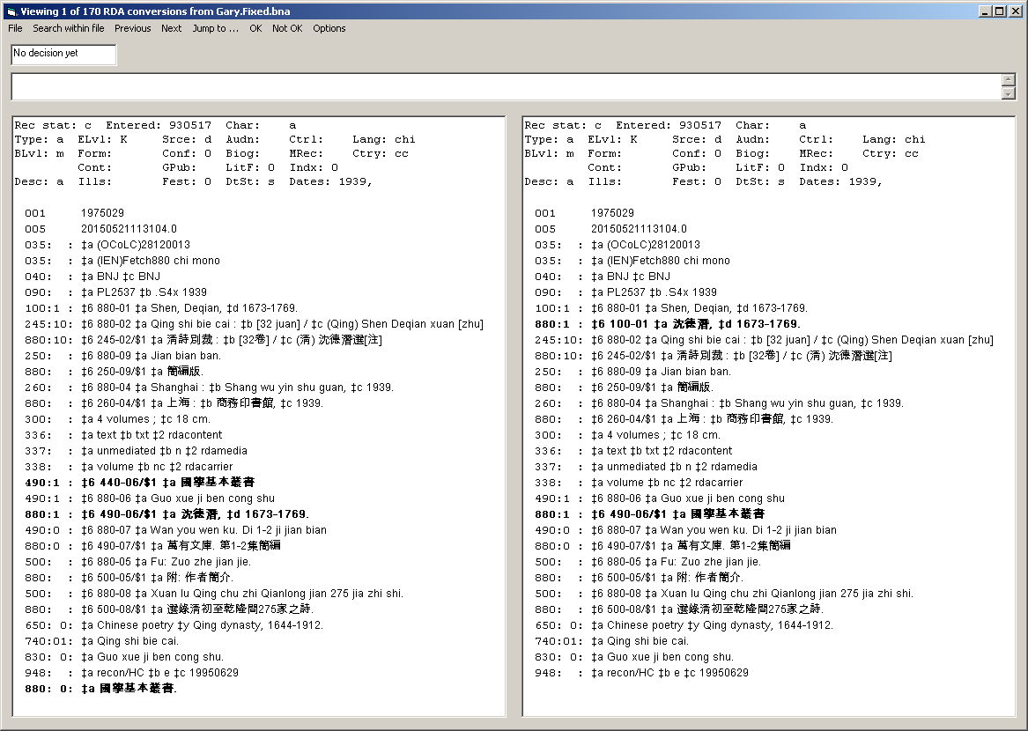
If the program has previously shown you this record and you have expressed your opinion as to its correctness, the drop-down box above the "before" version of the record will display your opinion; if you have not yet expressed an opinion, the box will say "Not yet rated." If you have declared some aspect of the change to be unacceptable, your description of the problem will appear in the long box just above record display.

When the program is presenting you with any record from the file, you have several courses of action, all of which are available from the program's menu. All of the menu items have keyboard shortcuts.

- If you want to change the program's display (most notably, the size of the text), select Options (CTRL-I) from the menu.
- If you want to search the file for records with certain characteristics, select Search within file (CTRL-S) from the menu. Searching within the file is described below.
- If you want to move to the next record in the file without expressing an opinion about the current record, select Next (CTRL-N) from the menu.
- If you want to move to the previous record in the file without expressing an opinion about the current record, select Previous (CTRL-P) from the menu.
- If you believe that the RDA-related changes were made correctly, select OK (CTRL-O) from the menu.
- If you believe that the RDA-related changes were not made correctly, type into the long box just above the record display your description of the problem, and then select Not OK (CTRL-T) from the menu. You cannot declare a record to be incorrect unless you also provide a description of the problem.
- When you have finished your review of the file (or as much of the review as you wish to perform at the moment) and wish to quit, select File|Exit from the menu (CTRL-F, then X). The program will prepare a report of the work you have performed so far on this file (and e-mail the report if you have configured the program to do so), and then quit.
- If you have finished your review of the file (or as much of the review as you wish to perform at the moment) and wish to work on another file, select File|Open from the menu (CTRL-F, then O). The program will prepare a report of the work you have performed so far on this file (and e-mail the report if you have configured the program to do so), and then show you the standard dialog box that allows you to find the next review file.

Searching within the file

The program offers a limited number of options for searching a large file to find records of interest. To search a file of records, select Search within file from the program's menu. The program shows you its search dialog box:

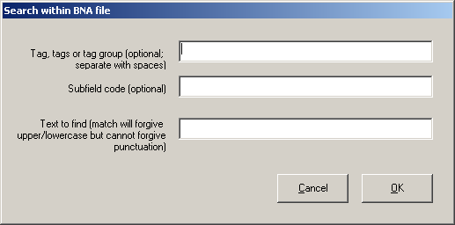

A search within a BNA file must always include a piece of text to find; so the third of the three boxes must always contain something; but you can include information in either the tag and subfield code boxes (either one, or both) as you prefer.

- Tag box: You can specify a tag group with "X" as the first character plus two numeric characters; or a tag group with a numeral as the first character and "XX" as the second and third characters, or you can supply a full 3-character tag. You can put as many different specifications into this box as you wish. Separate each specification from its neighbors with a space.
- Subfield code box: Give up to one subfield code. Give just the code itself (numeral or alphabetic character), without anything to represent the subfield delimiter.
- Text box: Give the text you wish to find. The program will forgive differences in capitalization, but it cannot forgive differences in punctuation. The MARC records are represented in the BNA file in RTF format; unless you know the RTF equivalents for diacritics and special characters, you will not be able to search for text containing those characters.

When the search specification meets your needs, click the OK button. The program will examine each pair of records in the current file for records with the matching text anywhere in the record, or the matching text in a particular subfield, or the matching text in a particular field and subfield, or the matching text in a particular field without regard to subfield, depending on the information you have provided.

When the program completes its work, it will show you its results.

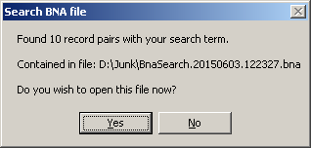

If the program found any matches, it wrote them to a separate BNA file. You can click the "Yes" button to view this file immediately (which causes the program to stop work on the file you started with), or you can open it later, at your convenience.

E-mail report

Whenever you declare that you have finished work for the moment on any file, the program prepares a report showing your "votes" on each record. The picture at the end of this section shows a typical message, as displayed by Microsoft™ Outlook ™.

The body of the message identifies the file being reviewed, and lists each record declared to be acceptable. If you declared any record to be unacceptable, the program prepares an attachment in the "before and after" format showing the record, with your description of the problem inserted into it. The recipient of such a message may be expected to take appropriate action, depending on the contents of the message.

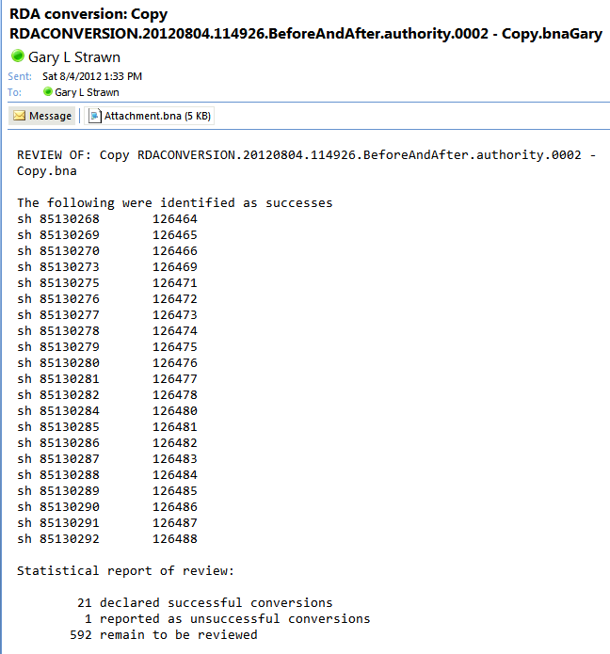

The "bna" files are, at bottom, text files and can be viewed with Notepad (although they won't make much sense). Each line in the file represents the display of a single state of a single record. The lines come in pairs: a line representing the before version of the record, followed immediately by a line representing the after version of the same record. Each of the lines in this file is a complete document in the RTF schema (which is why the file doesn't make a lot of sense when viewed with Notepad). RTF allows for a great deal of control over the display, and provides an easy way to represent diacritics and non-roman characters.
The disposition of the current record (in this illustration it's "Not yet rated") appears in the upper left hand corner. In this illustration this message appears in a drop-down box, but this is changed in more recent versions to a plain text box.

