RDA and the cataloger's toolkit
Gary L. Strawn
June 6, 2013

Outline of this document

- Summary of features
- BAM button
- Linking fields button
- RDA button
- Romanization/Capitalization button
- What happens when you click the $XX, 643 or 670 button?
- Working with multi-language access points: BAM, and the '$l' button
- Libretto button

Appendixes:

- Handling of abbreviations in bibliographic records during BAM
- Generate 336-338 fields during BAM
- Configuration files for romanization and capitalization
- Parsing the 502 field\
- Additional configuration for multi-lingual subfield $l
- Additional configuration for classical and modern Greek authors
- Changes made to a bibliographic before the toolkit displays the record
- Configuration files for RDA
- Generate 368 field during authority creation or BAM

1. Summary of features

This document describes features added and changes made to the cataloger's toolkit program to support Resource description and access (RDA). The descriptions given here are stated in terms of the various "buttons" on the toolkit's main keypad. Although all of the features described here had their origin in work done to support RDA, many if not all of these features will be found to have uses beyond the strict bounds of cataloging under RDA.

Summary of RDA-related features for bibliographic records:

- Expand abbreviations in the 245, 255, 260, 300 and 5XX fields during BAM
- Re-tag the 260 field as 264
- Supply the 336-338 fields based on clues in the bibliographic record during BAM
- Reformat a thesis note (502 field) in RDA style (with separate subfields instead of just subfield $a) during BAM
- Complete a linking field (76X-78X field) during BAM when subfield $t is not present
- Add a linking field to one record based on another Voyager record (new button)
- Create individual access points for non-RDA access points with two languages in subfield $l, or with "Polyglot" in subfield $l (new button)
- Reconfigure a pre-RDA bibliographic record for a separately-published libretto (composer as main entry and librettist as added entry) so that the record has the librettist as main entry, and there is a name/title 700 for the opera as a related work (new button). The same feature assists in the conversion of pre-RDA bibliographic records for sound recordings with separate libretto booklets, and pre-RDA bibliographic records for scores with an added entry for the libretto. There is special handling for the exceptional case where the composer is also the librettist.

Summary of RDA-related features for authority records:

- Automatically add 046, 338, 368, 370, 372, 376, 377, 378, 380, 381, 382, 383, 384 and 510 fields to new (and BAMmed) authority records
- Manually add 338, 370, 371, 372, 373, 374, 375 and 377 fields to an existing authority record, based on information in a bibliographic record (new button)
- Coerce new AACR2 authority records into RDA records
- Control the behavior of the "4xx", "643" and "670" buttons
- Convert some 5XX $w codes to RDA equivalents
- Convert bibliographic 7XX fields showing relationships to a work, manifestation or item into authority 5XX fields that describe the same relationship.

Summary of features useful in all kinds of records:

- The "romanization/capitalization" button contains new features to help in the bulk manipulation of upper-case and lower-case characters.

Summary of new options to consider:

- BAM button, "General, pt. 3" tab: options for RDA-related changes to bibliographic records
- BAM button, "Authority-related" tab: the "Get started" sub-tab, and the entire "RDA" sub-tab
- BAM button, "Changes, pt. 2" tab, "Linking fields" frames. A button on the "Linking fields" frame leads to a panel of options that tell the toolkit how to fill out an incomplete linking field during BAM.
- BAM button, "Changes, pt. 4" tab, the "RDA-related bibliographic changes " frame
- Options for the new "RDA" button
- Options for the new "linking fields" button
- Options for the new "libretto" button
- Options for 4XX, 643 and 670 buttons: use the new editing form, or continue to behave as in the past

2. BAM button

General options for 336-338 fields

The frame on the "Changes, pt. 4" tab of the BAM options panel has the title "RDA-related bibliographic changes." These options control the toolkit's handling of data in bibliographic records—whether those records are coded as 'RDA' records, as AACR2 records, or anything else. Depending on the context, the toolkit applies these options both to fields that it creates and to fields that it finds in a bibliographic record.

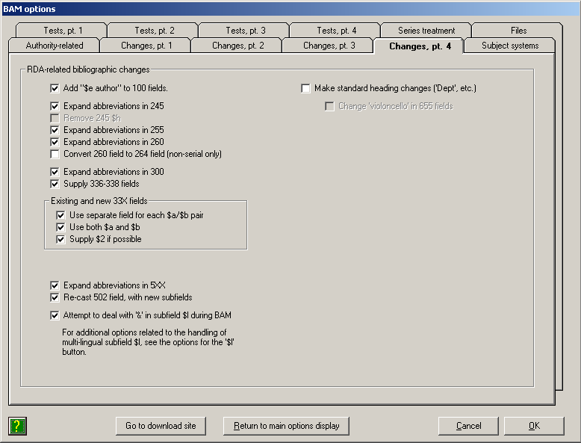

- Add "$e author" to 100 fields: If you check this box, the toolkit will add subfield $e with the text "author" to all bibliographic 100 fields that do not already contain subfield $e. The toolkit will make the same change to an 880 field that parallels the 100 field. When making this change, the toolkit does not distinguish between RDA and non-RDA records.

Example. If you check this box, the toolkit will change this pair of bibliographic fields:

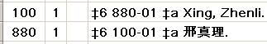

To this:

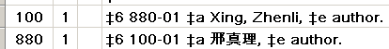

- Expand abbreviations in 245, Expand abbreviations in 255, Expand abbreviations in 260, Expand abbreviations in 300, Expand abbreviations in 5XX: These options have to do with the expansion of abbreviations in various bibliographic fields; there is a separate option to control the expansion of abbreviations in each field that the toolkit is allowed to examine for abbreviations. Check a box if you wish the toolkit to consider abbreviations in a field; un-check a box if you do not wish the toolkit to consider abbreviations in a field. Checking a box does not mean that toolkit will expand all abbreviations in a given field; its actions are in fact tightly restricted. (For example, in transcribed fields, the toolkit only considers abbreviations contained within square brackets.) The manner in which the toolkit identifies and handles abbreviations in each field is described in an appendix to this document.

- Remove 245 $h: This is a provision for a future option to remove subfield $h from the 245 field. This option is at present not available, but will be added to the toolkit when there is general agreement that subfield $h should be removed from the 245 field. (Subfield $h should not be removed from a record until the record contains 336-338 fields.)

- Convert 260 field to 264 field: If you check this box, the toolkit will re-tag the 260 field as a 264 field with second indicator "1". The toolkit will adjust the indicators and subfield $6 of any 880 field that parallels the 260 field. When making this change, the toolkit does not distinguish between RDA and non-RDA records.

Example. If you check this box, the toolkit will change this pair of bibliographic fields:

To this:

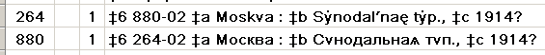

In doing this work, the toolkit does not make any attempt to "RDA-ize" the data; it simply changes the tag and indicators. For example, after the conversion, subfield $c of the 264 field with second indicator "1" may contain a copyright date.

- Supply 336-338 fields. This option instructs the toolkit to add a 336, 337 and/or 338 field to a bibliographic record. (The toolkit only adds one field of each tag, and only adds a field of a given tag if the record does not contain any field with that tag.) The logic that the toolkit uses to generate these fields is described in an appendix to this document. This logic will be the subject of substantial development over the next year or so. For the present, the option to generate the 336-338 fields should only be selected by catalogers who will pay attention to the results, correct the results as necessary, and report anomalies. The intention is that this logic will be expanded and improved, and eventually incorporated into a batch program to generate these fields retrospectively for records that lack them.

Example. If you ask the toolkit to supply the 33X fields, the toolkit will add the following fields to the bibliographic record for a print monograph:

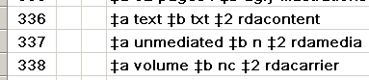

The work performed by this feature is further controlled by a new frame on the "General, pt. 3" tab of the BAM options, with the caption "RDA 33X fields." (This set of options controls both the handling of existing 33X fields, and the generation of new ones.)

Additional options control the toolkit's treatment of 33X fields:

- Use separate field for each $a/$b pair: It is possible for the 33X fields to be constructed with repeated instances of subfields $a and $b in one long string. If you prefer to have each piece of 33X in a separate field, check this box; the toolkit will split a field that contains multiple occurrences of $a and/or $b into a series of fields, one for each $a/$b pair.

- Use both $a and $b: If you check this box, the toolkit will supply the code in subfield $b for each text in subfield $a (if the $a is not already accompanied by its $b code), and will supply the text in subfield $a for each code in subfield $b (if the $b is not already accompanied by its $a text).

- Supply $2 if possible: If you check this box, and if the 33X fields lack subfield $2 but contain recognizable RDA terms, the toolkit will supply subfield $2 with the appropriate value.

- Re-cast 502 field, with new subfields: If you check this box, the toolkit will attempt to reformulate an old-style thesis note (502 field with just subfield $a) into an RDA-style thesis note (502 field with subfields $b, $c, $d and perhaps $g). (An appendix to this document describes the toolkit's method for parsing a single-subfield 502 field into the new subfields.) The BAM report will contain an indication if the toolkit is not able to parse a 502 field into separate subfields; whether or not it is a worthwhile exercise manually to convert the remaining 502 fields is a matter for local policy.

Example. If you check this box, the toolkit will change this 502 field in a bibliographic record:

To this 502 field:

Example: If you check this box, the toolkit will change this Northwestern-style 502 field in a bibliographic record:

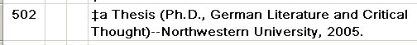

To this 502 field:

- Attempt to deal with '&' in subfield $l during BAM

NOTE: The automatic conversion of dual-language subfield $l during BAM has been turned off to allow for additional testing and development. For the present, use the '$l' button for all instances of dual-language subfield $l, as well as subfield $l containing 'Polyglot.'

Before RDA, a uniform title for a dual-language work contained both languages in subfield $l, joined by an ampersand; there was one access point for what are under RDA considered to be two separate expressions. For example:

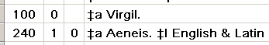

Similarly, in a pre-RDA bibliographic record, if an item contained expressions of a work in more than two languages subfield $l contained 'Polyglot' instead. For example:

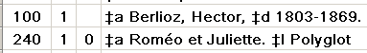

Under RDA, an access point is needed for each language expression contained in an item. The cataloger's toolkit has two features that help you reformulate a pre-RDA access point for more than one language expression into RDA-like access points. As part of its work during BAM, the toolkit can in many cases split a dual-language subfield $l into separate access points. A button on the cataloger's toolkit, the "$l" button, leads to a tab on a large editing panel that helps you tease apart access points with "Polyglot", as well as dual-language access points that the toolkit could not handle on its own during BAM (or that you for any reason wish to handle under your direct control).

If you check the 'Attempt to deal with '&' in subfield $l during BAM box, the toolkit will attempt to create two access points during its BAM work for each subfield $l that contains an ampersand.

The work performed on dual-language subfield $l during BAM is further controlled by a set of options that also apply to the '$l' button. These options are discussed in the description of the '$l' button.

- Make standard heading changes ('Dept.', etc.): If you check this box, the toolkit will perform all of the heading changes that were performed as part of the 'phase 2' RDA conversion. (This conversion was performed for both authority and bibliographic records, but for moving forward from that time the toolkit at present only performs this work on bibliographic records.) If you check this box (which is probably a very good idea) the toolkit will make a subsidiary check-box, with the caption Change 'violoncello' in 655 fields available; you will probably want to check this box, too.

The changes that the toolkit will make are described in detail in documentation initially prepared for the RDA conversion performed in March, 2013. For bibliographic records, the principal changes to be made include the spelling out of 'Dept.' in most corporate names (and in many parenthetical qualifiers), substantial changes to subfield $d of personal names, the spelling out or removal of the abbreviations 'O.T.' and 'N.T.' in Bible headings, the spelling out of the abbreviations 'arr.', 'acc.' and 'unacc.' in music headings, the insertion of 'Works' before 'Selections' at the start of uniform titles, the shifting of the location of the form subdivision 'Selections', and the replacement of 'violoncello' with 'cello' in many contexts. (Some of these changes overlap with changes also indicated by 4XX fields in authority records.)

If you check this box, the folder that contains the toolkit's configuration files must also contain the following files, which are available in the Configuration folder at the toolkit download site:

ConferenceWords.txt
RdaConversion.Rda7xxExtendedHeadingConsideration.txt
RdaSubfieldCConfig.NoParensAllTypes.txt
RdaSubfieldCConfig.NoParensForename.txt
RdaSubfieldCConfig.ParensAllTypes.txt

You can adjust the contents of these files to suit your needs. These files are briefly described in an appendix to this document, and are described in detail in the documentation prepared for the RDA conversion.

Options for completing linking fields

The toolkit can fill out most of the subfields in a linking field (76X-78X fields) during BAM, if the linking field does not contain subfield $t. The work controlled by these options is not strictly related to RDA, but applies to all records.

A new frame on the "Changes, pt. 2" tab of BAM options, with the caption "Linking fields," contains options that control the behavior of the toolkit when examining bibliographic linking fields that it deems less than complete.

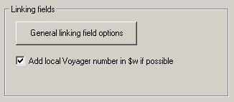

- If you check the "Add local Voyager number in $w if possible" box, the toolkit will add the Voyager bibliographic record ID to a linking field that does not already have such a number. The toolkit only does this if identifies one and only one candidate record.
- When you click the "General linking field options" button, the toolkit shows you a panel of options that control the construction of linking fields when a bibliographic linking field contains "numbers" of various kinds, but none of the transcribed data subfields. The following paragraphs describe this panel of options.

The toolkit uses the options on this separate panel when you BAM a bibliographic record that bears a linking field, if that linking field contains one or more numbers (Voyager record number, OCLC number, etc.) but does not contain subfield $t (title). The toolkit attempts to find the related record in your local database, and to supply subfield $t (and perhaps additional subfields) from the related record. This means that one way for you to build a linking field in a Voyager bibliographic record is to create a linking field with only number subfields, (such as $w, $x, $z) and then BAM the record; the toolkit will find the related record and transcribe the descriptive subfields from the related record into the linking field for you, saving you a lot of tedious copying. (For another way to generate a linking field in a bibliographic record, see the description of the linking fields button elsewhere in this document. The linking fields button has its own set of options for building linking fields.)

If you have defined a Z39.50 connection to OCLC within the toolkit, and if the toolkit is not able to find an appropriate record in your Voyager database, and if the incomplete linking field contains an OCLC number, the toolkit will retrieve the record from OCLC, and will use information pulled from the OCLC record to build the linking field.

The panel of options related to the filling-out of linking fields during BAM looks like this:

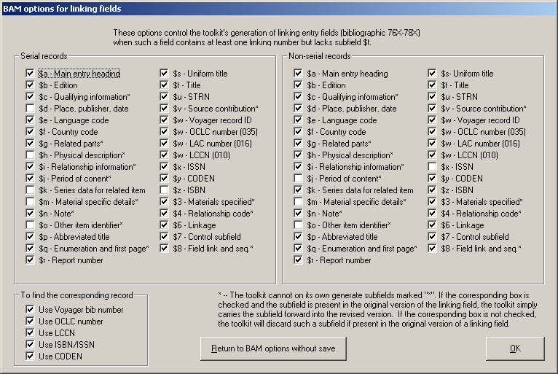

There are three broad areas on this panel. The two large areas across the top contain the same elements; one is for subfields to be included in linking fields in serial records, the other for subfields to be included in linking fields in non-serial records. Check the boxes that correspond to the subfields you wish to include in your linking fields; un-check the boxes that correspond to subfields that you do not wish to include in your linking fields.

The small area in the lower left corner of this panel has a set of options to tell the toolkit how to find the related record in your local database. You can of course set these check-boxes however you choose; but it may be best to leave all of the boxes checked.

The toolkit considers any linking field encountered during BAM that has no subfield $t as a candidate for enhancement. If a linking field does not contain subfield $t, the toolkit will attempt to complete the field for you; if a linking field contains subfield $t, the toolkit will not attempt to complete the field for you even if the linking field does not contain all possible subfields. (The toolkit does nothing if a linking field contains subfield $t, even if other subfields that might be required are not present.)

Example. Given the options shown above, and this linking field in a serial record (this field contains the Voyager system number for the related record, with the local institution code in parentheses):

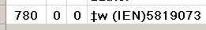

And given this information in bibliographic record 5819073 in the local Voyager database:

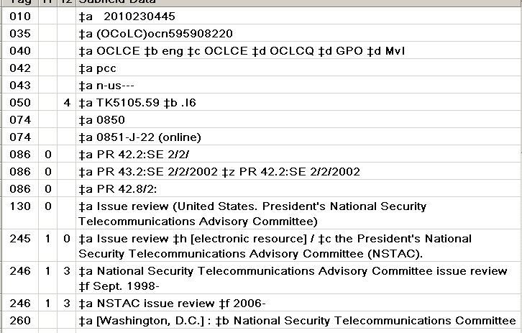

The toolkit will complete the linking field like this:

Note that the toolkit supplied subfield $7 in the linking field because the options panel requested subfield $7. Use of subfield $7 in linking fields may not reflect either local or cooperative cataloging standards.

Option for RDA-related fields in BAMmed authority records

The "Get started" sub-tab of the "Authority-related" tab on the options for the BAM button has a few options for the fields added to the authority format to contain elements defined for use under RDA, but also valid in non-RDA authority records.

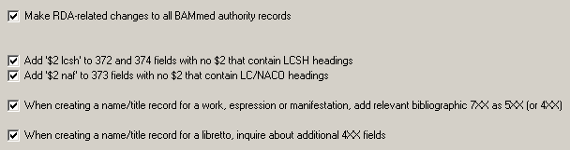

- Make RDA-related changes to all BAMmed authority records: If you check this box, the toolkit will attempt to add the "RDA fields" to any authority record you send to the BAM button. The toolkit only attempts to do the RDA-related work that you have chosen on the "RDA" sub-tab. (This option for adding RDA fields applies to existing authority records sent to the BAM button; there is a similar-sounding option on the "RDA" sub-tab, but that applies to new authority records.)
- Add '$2 lcsh' to 372 and 374 fields with no $2 that contain LCSH headings: During BAM, the toolkit may discover that the contents of a 372 or 374 field unlabeled with subfield $2 actually contains valid LCSH strings. (The toolkit only searches LCSH records in the local authority file.) If you check this box, the toolkit will label such a 372 or 374 field with the proper subfield $2 code.
- Add '2 naf' to 373 fields with no $2 that contain LC/NACO headings: During BAM, the toolkit may discover that the contents of a 373 field unlabeled with subfield $2 actually contain headings authorized in the LC/NACO Authority File (that is, in LC/NACO records in the local Voyager database). If you check this box, the toolkit will label such a 373 field with the proper subfield $2 code.
- When creating a name/title record for a work, expression or manifestation, add relevant bibliographic 7XX as 5XX (or 4XX): If the new authority record is not a series authority record and if the authority 1XX is a name/title field based on the bibliographic 1XX field plus the 240 field, and if the authority 1XX field does not contain subfield $v, $x, $y or $z, the toolkit examines the remaining subfields in the authority 1XX field to determine whether the field represents a manifestation (subfield $f is present), expression (subfield $l or $s is present) or work (none of the above). The tookit then examines the 7XX fields in the original bibliographic record. If subfield $i is present in a 7XX field, and if the label for work, expression or manifestation (as appropriate) is present in that subfield $i, the toolkit creates a corresponding 5XX field in the new authority record, with an appropriate subfield $i text. There is one interesting exception: If the text that precedes "for" in subfield $i is one of the texts defined on the options panel for the "libretto" button as identifying a libretto, the toolkit instead creates a 4XX field with no subfield $i, but with subfield $s containing "Libretto" at the end of the field. (This last oddity is exactly as described in RDA.)
- When creating a name/title record for a libretto, inquire about additional 4XX fields: If the new authority record contains subfield $s with "Libretto", and if the new authority record contains a 100 field with subfield $t but not subfield $s, the toolkit assumes that you're creating an authority record for the libretto itself. (The subfield $s must therefore occur in a name/title 400 field containing the name of the composer and the title of the work.) The toolkit presents you with a list of all 700 fields in the original bibliographic record that do not contain subfield $t. (Any joint authors named in the original bibliographic record should be present in this list; but beware that the list may also contain names of performers, editors, and other persons who are not joint authors of the libretto.) The toolkit will create a name/title 400 field in the new authority record for each name you select from this list.

Options for new authority records

The "Authority-related" tab of the BAM options contains a new sub-tab, with the caption "RDA." This sub-tab contains a number of options that the toolkit applies when you create a new authority record.

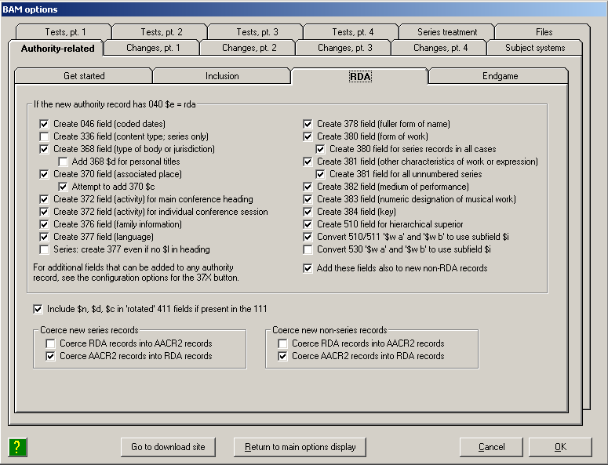

In the frame at the top is a large set of options that instruct the toolkit to attempt to generate the "RDA fields" (fields that were originally defined to contain elements needed for RDA), and perform other RDA-related work. Check the box for each RDA-related task that you wish the toolkit to perform. The toolkit contains its own logic for determining whether or not a given task possible and appropriate in a given context; except as noted immediately below, you should check all of these boxes. (The default value for these boxes is un-checked.)

- At the time of this writing, it was not clear whether or not it was considered desirable or appropriate to add the 336 field to RDA series authority records. You can of course choose to add this field to authority records in your local file; but since you should not contribute such records to the LC/NACO Authority File, it is probably best if you leave this box un-checked for the present.
- The toolkit originally had a hard-coded technique for determining when a 368 field for the type of jurisdiction or the type of corporate body was possible. This technique is still in place, but it can be overridden if you supply the appropriate configuration file. The generation of 368 fields is described in an appendix.
- At the time of writing, we are asked not to add 368 fields that contain subfield $d to authority records contributed to the NACO program. (The toolkit is equipped to create 368 subfield $d for certain recognizable titles of royalty.) If the NACO practice changes, or if you're creating authority records for your own local use (or for exchange with partners who are willing to accept 368 $d), check this box; otherwise, leave this box at its default value of "not checked." (Note that if the NACO practice changes, adjustments to the toolkit's code for supplying this subfield may need to be changed, too.)
- Whether or not you want the toolkit to add the 377 field to all series authority records (even if the 1XX field does not contain subfield $l) is largely a matter of taste: you can check this box, or leave it un-checked, as you see fit. (The current practice for LC/NACO records is not to include the 377 if there is no subfield $l in the 1XX field.)
- Whether you want the toolkit to convert the codes "a" and "b" in subfield $w of 5XX fields to their RDA equivalents is a matter for local policy. Check the boxes if you wish the toolkit to perform this work. (By default, the toolkit converts $w in 510 and 511 fields, but not in 530 fields.)

The toolkit can also add "RDA" fields to new non-RDA records. If you wish this to happen, check the "Add these fields also to new non-RDA records" box. (This option applies to new authority records; there is a similar-sounding option on the "Get started" sub-tab, but that option applies to existing records sent to the BAM button.)

Below this frame is a check-box that controls the addition of subfields $n, $d and $c to 411 fields in authority records for conferences. If you check this box, the toolkit will copy these subfields from the 111 field to any 411 fields it generates for new records; if this box is not checked, the toolkit will use only subfield $a in 411 fields it generates for new records.

At the bottom of this sub-tab is a pair of frames that control the "coercion" of new authority records: one frame for new series records, one frame for non-series records. "Coercion" in this case means the shifting of the "rules" of a new record from one value to another: from AACR2 to RDA, or from RDA to AACR2, and adjusting subfield $e of the 040 field to match. If you check the "Coerce RDA records into AACR2 records" box, the toolkit will re-code all RDA authority records that it creates as AACR2 records; if you check the "Coerce AACR2 records into RDA records" box, the toolkit will re-code new AACR2 authority records it creates as RDA records. You can check one box or the other, or you can leave both boxes un-checked; you cannot check both boxes. In general, you should elect to coerce AACR2 records into RDA records.

NOTE: The toolkit will not "coerce" a new pre-AACR2 authority record into an RDA record. If the toolkit's "coercion" feature does not appear to work as you expect, the first thing you should consider is the value of Leader/18 and 040 subfield $e in the original bibliographic record.

3. Linking fields button

The linking fields button can assist in the generation of 76X-78X fields in bibliographic records. The tool to which this button leads can also assist in the addition of 5XX fields to authority records. (Authority 5XX fields are another way to specify relationships.) You can use this button to create linking fields in one bibliographic or authority record that point to other records (involving change to just one record), and you can use this button to create mutual relationships between two records (involving changes to both records).

Options

The work performed by the linking fields button is controlled by a large set of options on a separate panel.

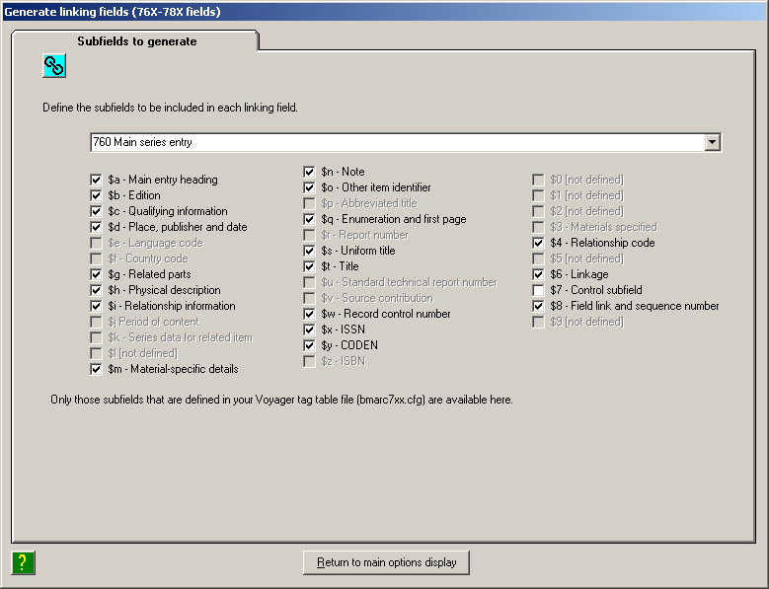

There is a separate set of options for each of the 76X-78X linking fields. Use the drop-down list near the top of the panel to select the linking field whose definition is currently displayed. The panel is set up to show all possible subfields in the linking fields (as defined in your Voyager tag table configuration files); subfields that are not available in a given field are disabled.

For each linking field, check the boxes for the subfields that you wish the toolkit to include when it creates a new linking field. (Naturally, the toolkit can only create a subfield if the appropriate information is available.)

Operation

To add a link to one record: To add a link to a Voyager record, display in the Voyager cataloging client a bibliographic record to which you wish to add a linking field, then click the linking fields button. The toolkit uses information from the record shown in Voyager to populate a multi-tabbed workform. The toolkit uses this workform for a number of different editing operations (working with diacritics, with parallel vernacular fields, with uppercase/lowercase transitions, as well as linking fields). If you start with the linking fields button, the toolkit starts you out on the "linking fields" tab, but you can move to other tabs to perform other operations on the same record.

Before the toolkit shows you this record, it may make a number of changes to it, depending on options you have selected.

Here is how the top part of this multi-tabbed editing form might look after you click the "linking fields" button:

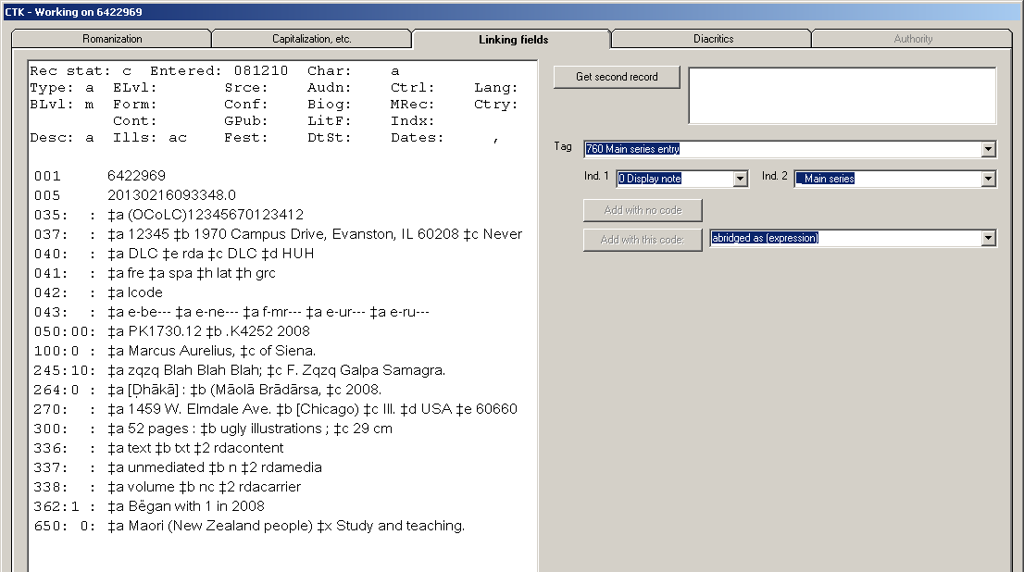

Once you've got the record that will serve as the focus of your linking fields, the next thing you need to do is identify the second record: the record to which the first record will be linked. Go to the Voyager cataloging client and display the record that the toolkit should use as the source of information for the linking field. When you have this second record, return to the toolkit's editing panel and click the "Get second record" button. The toolkit digests information from this second record. After you've shown the toolkit your two bibliographic records, the top part of this editing panel might look like this; information from the second record is summarized on the right side:

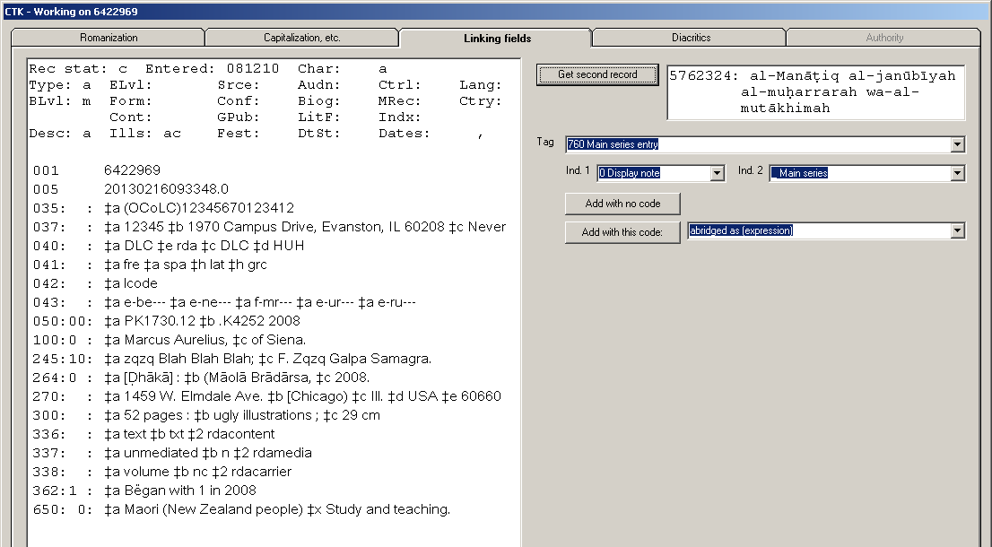

At this point, all that remains for you to do is to use the "Tag", "Ind. 1" and "Ind. 2" drop-down lists to select the kind of linking field you want to create. (The lists of indicators aren't available if there is only one choice.)

Once you have identified the base record and the secondary record, and set the tag and indicators:

- If you wish to include a subfield $i text in the linking field, use the remaining drop-down list to find the subfield $i text you want, then click the "Add with this code" button
- If you do not wish to include subfield $i in the linking field, click the "Add with no code" button.

The toolkit adds the field you have defined to the displayed version of the record. For example, if we have asked the toolkit to add a 775 field to our record, with no subfield $i, the lower part of the base record might look like this at this point:

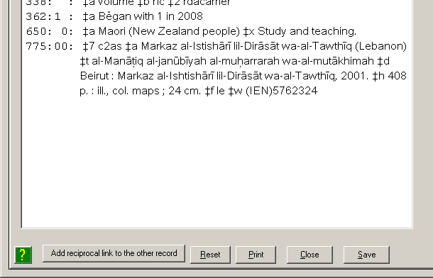

The toolkit has not yet updated the Voyager database with the record containing the new linking field. If you wish to save the record at this point, click the "Save" button. If you want to perform any of the operations made available on any of the other tabs, you might want to do that that work as well before you save the record. (You can always save the record more than once.)

Use the "Print" button to send a version of the record to the printer. Use the "Reset" button to discard any changes you have not yet saved, and return the display to the current state of the record in the Voyager database. When you're done with this editing panel, click the "Close" button. When you click the "Close" button, the toolkit discards any changes you have made but not saved.

If you need to add more than one linking field to the primary record, you can call up another record in Voyager, again click the "Get second record" button, and create the additional linking field.

To add reciprocal links between records. You can also use this button to create links both ways between your records. To do this, first create the link one way, as described above. Then click the "Add reciprocal link to the other record" button at the bottom of the editing panel. When you click this button, the toolkit will reverse the sense of the existing linking field, and add a linking field to the other record. For example, if you have used the toolkit to add a 780 field to the first record, a click of this button will cause the toolkit to add a 785 field to the second record. If the record contains more than one linking field, click first on the linking field of interest, then click this button.

Create a reciprocal link for an existing linking field: If any bibliographic record already contains a linking field and you want to put the reverse of this linking field into the "other" record in Voyager, you can call up the first record with the linking fields button, then simply click the "Add reciprocal link to the other record" button. In this case you don't need explicitly to identify the second record: it's already identified in the linking field.

4. RDA button

The RDA button can assist you in the addition of certain fields to an existing authority record, based primarily on information in a bibliographic record. These fields can be added to any authority record, not just to a record coded as RDA. (These fields can also be added automatically to new, and BAMmed, authority records; this is controlled by other options.)

Options

The behavior of this button is controlled by a number of options, on their own panel.

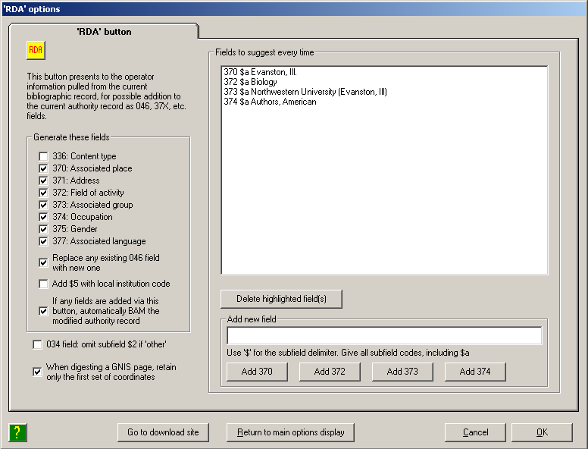

The check-boxes in the "Generate these fields" frame indicate the kinds of fields you wish the toolkit to help you with. In general, you should check all of these boxes except the box for the 336 field. (The use of the 336 field in authority records is not yet a decided question.)

There are additional options below the yes/no options for each tag:

- Replace any existing 046 field with new one: If you use the RDA button to create an 046 field and if the authority record already contains an 046 field, you can instruct the toolkit to replace the existing 046 field with a new one. (Otherwise, the toolkit simply adds one more 046 field.)
- Add $5 with local institution code: If you wish the toolkit to add subfield $5 to fields that it adds to authority records, check the "Add $5 with local institution code" box. (Note that subfield $5 may not be defined for these fields, unless you define it locally.)
- If any fields are added via this button, automatically BAM the modified authority record: If you use the toolkit to add fields to an authority record, it's a good idea to have the toolkit immediately BAM the record, so that it can make additional adjustments to the record, and report any problems.

The toolkit will not offer the possibility of creating an 034 field (from data found in a 670 field of an authority record), because of the difficulty of isolating coordinate information automatically. If you use the features of the RDA button to add an 034 field under your direction, the toolkit will attempt to assign a code for subfield $2, based on information it finds in subfield $a of the 670 field. If the toolkit is not able to assign a specific code, it will by default assign the code 'other.' If you prefer that the toolkit not assign the code 'other' in subfield $2 of the 034 fields it creates, check the 034 field: omit subfield $2 if 'other' box.

The toolkit can digest information found in GNIS (U.S. and Antarctica) and GeoNames (other places) into a 670 field, and in many cases also create an 034 field. For places in the U.S., the display will contain one set of coordinates for each map on which the place name appears. If you check the When digesting a GNIS page, retain only the first set of coordinates box, the toolkit will retain only the first set of coordinates in the 670 field; if you do not check this box, the toolkit will retain all sets of coordinates. (Whether the box is checked or not, the toolkit will use only the first set of coordinates to create an 034 field.)

Use the upper right side of this panel to define fields that you use frequently in your authority records. The toolkit will propose these fields every time you use the RDA button, in addition to any fields that are suggested by a second bibliographic or authority record. You can define as many 370, 372, 373 and 374 fields as you wish. To define a field, type the field's text (including subfield codes, using the "$" for the subfield delimiter) into the box, then click the "Add" button that corresponds to the field's tag.

Operation

To use this button, display in the Voyager cataloging client an authority record to which you wish to add one or more "RDA" fields. The toolkit retrieves the authority record and uses it to fill out information on an elaborate workform. (This is the same workform as the one that the toolkit uses when you click the linking fields button, but since you're starting from an authority record the toolkit starts you out on the "Authority" tab.) The next illustration shows an authority record as displayed in this workform.

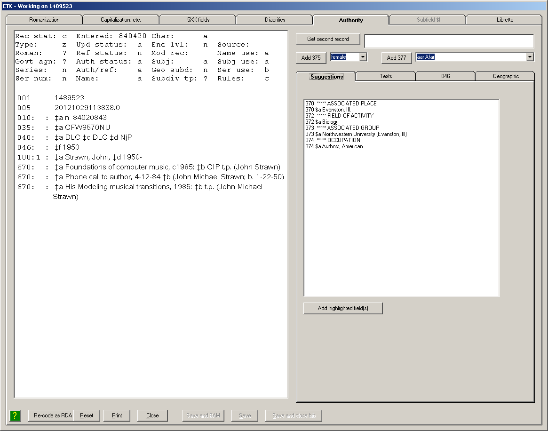

You can do quite a few things to authority records with this workform. Some of these editing tricks require that you call up a second record (which can be either an authority record or a bibliographic record); some of these features will work even if you don't identify a second record.

Let's look first at things you can do without identifying a second record:

- You can use the drop-down box next to the "Add 375" button to identify a person's gender, then click the "Add 375" button to add a 375 field to the authority record.
- You can use the drop-down box next to the "Add 377 field" to identify a language associated with the entity represented by the authority record, then click the "Add 377 field to add a 377 field to the authority record.
- You can use the "046" tab to build each subfield in an 046 field. (This can be very handy if you're unsure of the conventions of the "edtf" specification that's used to describe unusual conditions.) We'll come back to this tab in a bit.
- You can click the "Re-code as RDA" button to code a non-RDA record as an RDA record.
- You can use the work areas on the "Texts" tab to convert information in one field of authority record into information in another field. For example, you can highlight geographical coordinates in a 670 field, select the "034 Coordinates" radio button, and click the "Add text from record on left" button to create the 034 field.
- You can use the work areas on the "Geographic" tab to convert information found at the GNIS and GeoNames web sites into a 670 field, as well as 034 and 451 fields.

If you wish to draw on information in a second record to fill out the displayed authority record (this second record can be either a bibliographic record or an authority record), call up a different record in the Voyager cataloging client, and then click the "Get second record" button. The toolkit retrieves this record and puts information into various places on the editing form.

If the second record is a bibliographic record, the toolkit examines the record in detail and pulls out everything that might possibly be of use in an authority record (as controlled by options you have set), tags the information using MARC conventions, and lists all these fields on the "Suggestions" tab; the toolkit also puts the whole record on the "Texts" tab.

For example, if our second record is a bibliographic record, the "Suggestions" tab might look like this:

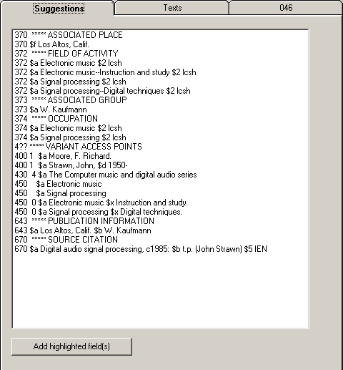

The toolkit doesn't attempt to guess whether a particular field is appropriate for the base authority record. (For example, the toolkit always generates a candidate 643 field from a 260 or 264 field, even if the authority record isn't a series record.) It's your responsibility to select things that are useful and move them to the authority record; just ignore the rest.

If you see anything in this list that would be of use in the authority record, simply highlight the line (or multiple lines) and click the "Add highlighted field(s)" button. The toolkit moves your fields to the displayed authority record.

The "Texts" tab contains the entire text of the second record.

For example, if you click the "Get second record" button when the Voyager cataloging client shows a bibliographic record, the "Texts" tab might look like this:

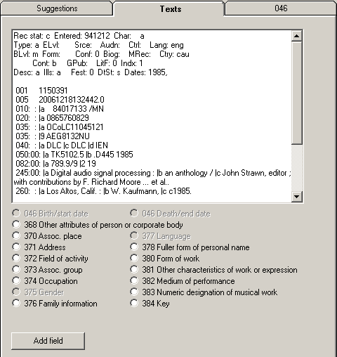

If you find text in this record display that can be used in one of the RDA fields in the authority record:

- Highlight the text
- Select the radio button that corresponds to the field's tag
- Click the "Add field" button.

Now, the neat thing about this particular record display is that you can edit this text: you can add stuff, remove stuff, and change stuff. So if there's something here that's almost but not quite what you want, you can modify the text to suit, then highlight it, select the tag, and add the field to the record. (Any changes that you make to the record in this display are not saved to your Voyager database!)

Under certain conditions when the second record is also an authority record, the toolkit will place one or more possible 4XX fields on the "Suggestions" tab; you can add these 4XX fields to your record if you think they're appropriate. Under other conditions there won't be anything on this tab when the second record is an authority record.

But wait, there's more. If the second record is an authority record, go to the "5XX fields" tab. This is actually the same as the "Linking fields" tab that you see when you start from a bibliographic record, but there are different possibilities for authority records.

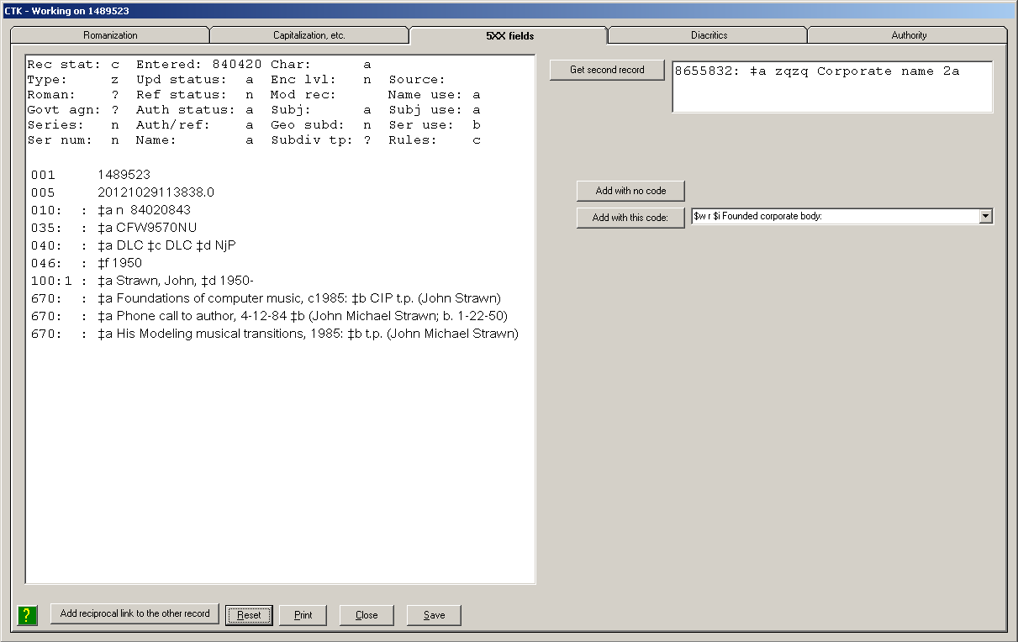

You can use this tab to create links between authority records; but instead of the 76X-78X fields, when you have two authority records, you use this tab to create 5XX fields. If you want to use the 5XX field to describe a particular kind of relationship, find the relationship in the drop-down box next to the "Add with this code" button, then click the "Add with this code" button. If you want just a plain 5XX field, click the "Add with no code" button.

As is the case with a bibliographic record to which you add linking fields, your change isn't saved to Voyager until you save it by clicking the "Save" button. And in parallel with the toolkit's behavior for bibliographic records, the "Add reciprocal link to the other record" button at the bottom of the "5XX fields" tab reverses the sense of the 5XX field in this record and creates a 5XX field in the other record.

But wait, there's more. If the primary record is an authority record, you can use some of the features of the 'Texts' sub-tab to create a field in the authority record based on information elsewhere in the same authority record. Most of the time this work will involve re-purposing information found in the 670 fields, but it can in truth involve any text anywhere in the record. To use this feature, select some text in the primary authority record, select the radio button for the kind of field you want to create, then click the "Add text from record on left" button. Here are some examples:

- If you select the name of a corporate body in a 670 field, select the "373 Assoc. group" radio button and then click the "Add text from record on left" button, the toolkit will create a 373 field from your selected text.
- If you highlight geographical coordinates in a 670 field, select the "034 Coordinates" button and then click the "Add text from record on left" button, the toolkit will create an 034 field from the selected text, modifying it as best it can. (The toolkit will not be able to create an 034 field in all cases, and its 034 field will not always be perfect, but you will I hope be pleased at how often it is correct.)

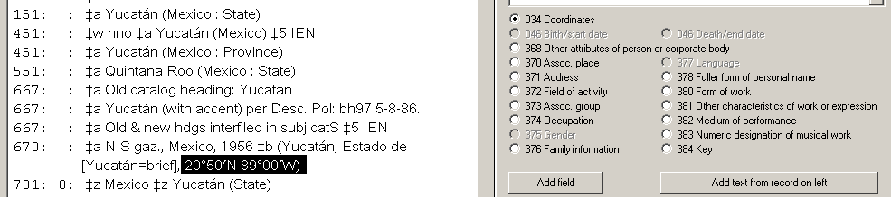

Here are some examples of 670 fields, and the 034 fields that the toolkit created from them. In the 670 fields, the text selected by the operator is shown in bold.

034: $dW1110036 $e W1110036 $f N0390940 $g N0390940 $2 gnis
670: $a GNIS, 24 Feb. 2010: $b (Castle Valley; Valley; Emery County, Utah; 39°09'40"N 111°00'36"W; other Castle Valleys in Utah)

034: $d W116.49999 $e W116.49999 $f N051.4999999 $g N051.4999999 $2 cgndb
670: $a Geographical names of Canada website, Aug. 14, 2012 $b (Yoho National Park of Canada; other official name: Parc national du Canada Yoho; British Columbia; Feature type: Conservation area; Generic: National Park; Location: Kootenay Land District; Latitude - Longitude: 51°30'N, 116°30'W; Latitude - Longitude (decimal): 51.4999999, -116.49999)

034 $e W0890000 $e W0890000 $f N0205000 $g N0205000 $2 other
670: $a NIS gaz., Mexico, 1956 $b (Yucatán, Estado de [Yucatán=brief], 20°50'N 89°00'W)

Cases where the toolkit is not able correctly to create an 034 field from text pulled from a 670 field include those where the hemisphere is not always stated explicitly, and where there is important text that describes the meaning of the coordinates. For example, although the toolkit will, if asked, attempt to create an 034 from the coordinate information in the following 670 field, that 034 field will not be free of problems.

The 046 sub-tab

Use the "046" sub-tab on the "Authority" tab to build each subfield for an 046 field. In general, you'll work through the 046 sub-tab from the top down and set controls that correspond to what you know about one of the dates associated with an entity.

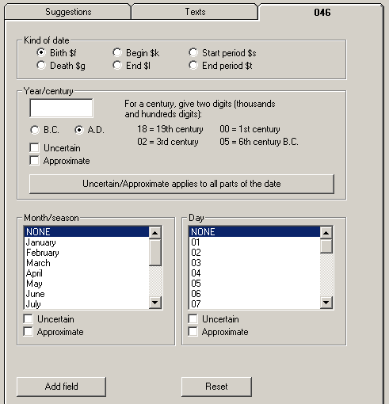

- Kind of date: Click the radio button for the kind of date (the radio buttons correspond to the MARC subfield codes available for dates in the authority 046 field)
- Year/century: Type into the box the four digits that represent the year, or the two digits that represent the century. (Remember that under the conventions used in the 046 field, a century is simply a year with the rightmost two digits chopped off. See the examples on the right side of the panel.) Select the "B.C." or "A.D." radio button, as appropriate. If the year/century is uncertain or approximate, check the corresponding box under the date. (You can check both boxes, if that's appropriate.) If there are more parts to the date than just the year (i.e., if there is a month, or month and day) and if this same uncertainty or approximateness applies to all parts of the whole date, click the "Uncertain/Approximate applies to all parts of the date" button. If you do this, the toolkit will copy the values of the Uncertain and Approximate boxes for the year, to the month/season and day parts of the workform.
- Month/season: If the date includes a month or season name, select the appropriate item from the list; else select "NONE." Set the Uncertain and Approximate check-boxes to appropriate values.
- Day: If the date includes a day, select the appropriate item from the list; else select "NONE." (Note that while this list is somewhat sensitive to the month you have already selected, it is not sensitive to leap years, so if you select February in the month box you will always have day 29 as a possibility in the day box.) Set the Uncertain and Approximate check-boxes to appropriate values.

When everything for one date is set to your satisfaction on this tab, click the "Add field" button. The toolkit adds this one date to your authority record. If the authority record already contains an 046 field with the same subfield as your new subfield (or if the authority record doesn't contain an 046 field at all), the toolkit creates a new 046 field; if the authority record already contains an 046 field but that 046 field doesn't contain the subfield you have just defined, the toolkit adds your subfield to the existing 046 field. After you've added one 046 subfield, you can proceed with a subfield for another date, if you have the necessary information.

The 'Geographic' sub-tab

Use the Geographic sub-tab when you have found information at the GNIS or GeoNames search sites that you wish to preserve in an authority record. The toolkit will help you preserve the information in a 670 field, and (depending on the available information) may create 451 and 034 fields for you, automatically.

In all cases, start by calling up an authority record for a place (an authority record with a 151 field) in the Voyager cataloging client, and pressing the toolkit's RDA button to get to the fancy editing form. (You can also use any of the other toolkit buttons that lead to the fancy editing form, then select the "Authority" tab.) In the multi-tab display at the right of the Authority display, select the "Geographic" sub-tab:

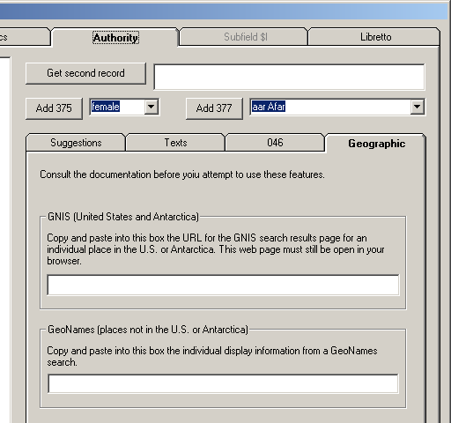

Because the GNIS and GeoNames sites present information in different ways, there are two different ways to get information from the sites into an authority record.

The GNIS site provides information about places in the United States, and in Antarctica. One of the features of this site, is that the display of information about a single place (the "feature detail report" page) is represented by a distinct URL. (This URL contains a "session" identifier, and so is only valid while the web browser is displaying the page.) The following illustration shows the first part of such a page.

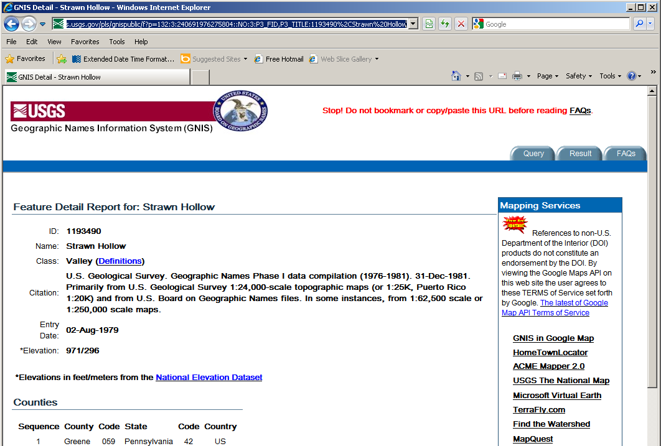

To capture information from a GNIS page for a single place, highlight the entire URL for the feature detail report and press Ctrl-C to copy the URL to the Windows clipboard. Go to the toolkit's fancy editing panel, click the cursor into the text box within the "GNIS" frame, and press Ctrl-V to paste the URL into the box. You don't have to press Enter or do anything else; just paste. (You probably won't actually see the URL in the box, because as soon as it appears, the toolkit reads it and then clears the box so you're ready for the next use.) As soon as you paste a URL into this box, the toolkit fetches the page on its own (this may take a few seconds), digests the page, and adds information from the page to the current authority record. For the GNIS page shown above, the toolkit picks up the name, category, elevation, county name, state, and coordinates. From this information it builds a 670 field, and also creates an 034 field.

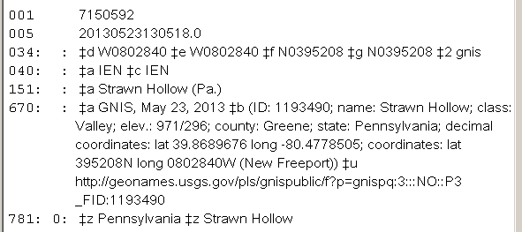

If the GNIS page had contained variant names, the toolkit would have captured them, too, and would have created 451 fields. In the following example, the GNIS page listed one variant, so the toolkit created on 451 field.

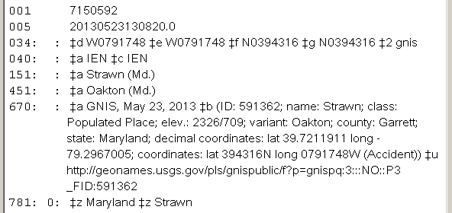

The only real trick to using GNIS information in this manner is that you have to keep the original web page open in your web browser, so that the session ID in the URL remains active. As part of its work, the toolkit constructs a "persistent" URL for the GNIS information, and adds it as subfield $u of the 670 field. This allows you (or anyone else) to return directly to the source information, without doing a search.

Unfortunately, the GeoNames web site is not as handy for machine use as is the GNIS site. To use capture information from GeoNanmes search results in authority records, you will have to do a bit more work; and just how much work depends on the information available. (Even so, this still beats copying everything yourself.)

Before you do a search in GeoNames, you should add at least the "Variant" line to the list of kinds of names to be returned in the search results. (Do not bother to include any of the "vernacular" choices, because for mysterious reasons vernacular data doesn't come through correctly anyway. And if you select any of the vernacular choices, all of the non-vernacular choices are instantly de-selected.)
After you've included "variant" in the search results, proceed with your search in the usual manner. What happens when GeoNames presents you with a results page depends on the information on the results page. If the display for the place of interest includes variant names, you're going to need to get information from GeoNames in two steps; if the display does not include any variant names, you can get information from GeoNames in a single step.

If the display for the place of interest includes variant names, select all of the names (preferred name, and variant names), and press Ctrl-C to copy this information to the Windows clipboard. Try to include just information in the box that contains the approved and variant names, and none of the information from adjacent boxes.

Go to the toolkit's fancy editing panel, click the cursor into the GeoNames text box, and press Ctrl-V to paste the information into the toolkit. The toolkit will digest this information into a 670 field, and will create 451 fields for the variants.

Whether or not there are any variant names, click on the name of the place to proceed to the little floating "names search results" panel, which gives full information about the place (except of course for the variant names). Select all of the text in this display, and press CTRL-C to copy the information to the Windows clipboard.

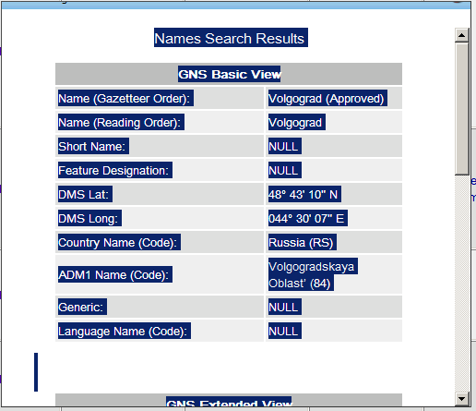

Go to the toolkit's fancy editing panel, click the cursor into the GeoNames box, and press Ctrl-V to paste the clipboard information to the toolkit. The toolkit will digest this information, and either add it to the existing 670 field, or create a new 670 field. The toolkit will also create an 034 field for the coordinates.

5. Romanization/Capitalization button

Introduction

This button leads to the same common editing panel as does the linking fields button. This button actually represents two different tabs on this form, the "Romanization" tab, and the "Capitalization, etc." tab.

There are no options on the toolkit's options panel that affect the behavior of this button. However, the behavior of this button is controlled by configuration files contained in the same folder as the toolkit's other configuration files.

- If you wish to use the "title case" feature on the capitalization tab, you must supply one or more language-based configuration files to list words that should not be given in uppercase
- If you wish to use any part of the "romanization" tab, you must supply one or more script/language-based configuration files

These configuration files are described in appendixes to this document. Sample configuration files are available at the toolkit's download site.

When you click this button, the toolkit gets a fresh copy of the authority or bibliographic record currently displayed in the Voyager cataloging client, makes certain changes to it, and loads it into the editing form's main window. The toolkit assumes that you want to start on the "romanization" tab; you can move to the "capitalization, etc." tab or any of the other tabs as required by the tasks you need to perform.

Romanization tab

Use the features on this tab to convert bibliographic data in a vernacular script into Romanized form, and to convert Romanized data into vernacular script.

The romanization tab is described in the toolkit's online documentation, but because that documentation is several years out of date, you should use the description here instead of the online description.

The next illustration shows what this tab might look like when you click the romanization/capitalization button. In this case, the record is a Romanized Russian record, and we're going to assume that you wish to create vernacular fields that parallel the Romanized fields.

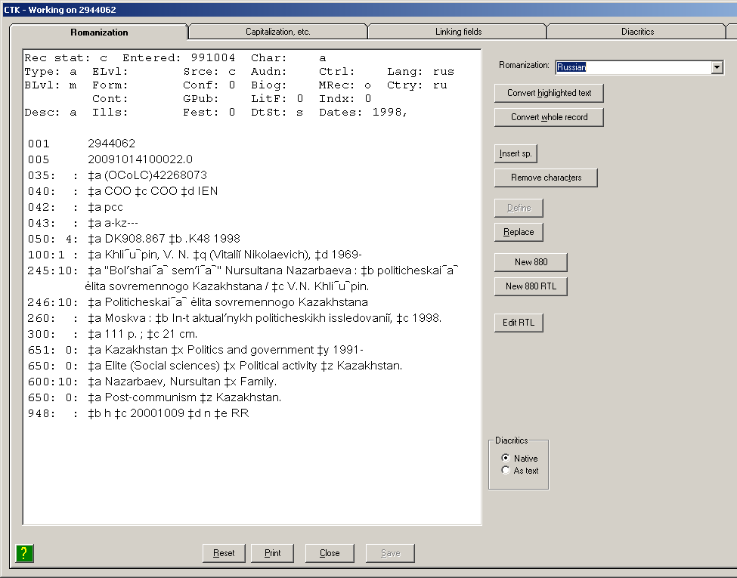

The radio buttons in the little "Diacritics" frame on this tab allow you to adjust the display of the record.

- The "native" choice shows diacritics and special characters in more or less the way they are shown in the Voyager cataloging client
- The "as text" choice substitutes English-language labels for diacritics and special characters. This allows you to see exactly what characters are contained in the record. For example, if the "as text" radio button is selected, the 245 field in the above record will look like this:

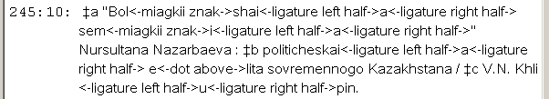

You can use these radio buttons to verify the contents of a record, but when you're actually manipulating text you must select the "Native" radio button.

The most important thing you must do, before you do anything else to your record, is use the drop-down "Romanization" list at the top of the record display, to select the Romanization table that you wish to use to manipulate the record. This list contains the language/script combinations that are defined in your configuration files. The toolkit will attempt to set this drop-down box for you, based on the language code in the bibliographic record, but even if this is correct for most of a record, it's always possible for different parts of a record represent different languages or scripts, so you may need to adjust this value as you work through a record.

Exactly what you can do with the "romanization" tab on the editing panel depends on the record, and the romanization table you've selected.

- If the romanization table allows conversion of Romanized text into vernacular text, you can highlight all or part of a Romanized variable field and then click the "Convert highlighted text" button. The toolkit will either create a new parallel 880 with the highlighted text converted into vernacular text, or (if there is already an 880 field) convert the text within the 880 field.
- If the romanization table allows conversion of vernacular text into Romanized form, you can highlight all or part of a vernacular variable field and then click the "Convert highlighted text" button. The toolkit will either create a parallel 880 field and then convert the highlighted text, or (if there is already an 880 field) convert the text in place.

Example: to create an 880 field to parallel the entire 245 field, first highlight the entire 245 field:

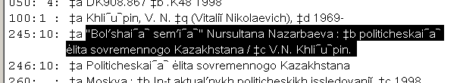

Then click the "Convert highlighted text" button. The toolkit creates an 880 field for you:

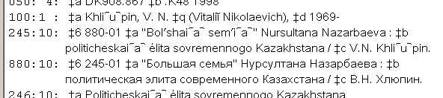

Example: to convert just subfield $a of the 600 field, highlight just the text of subfield $a:

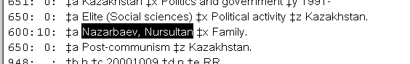

Then click the "Convert highlighted text" button. The toolkit creates an 880 field for you:

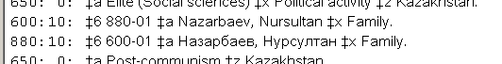

If the configuration file for the script/language contains appropriate definitions, you can instead click the "Convert whole record" button. The toolkit will create 880 fields with vernacular equivalents for each part of the record that is defined as being convertible in this manner.

Example: The next picture shows what happens if, instead of working through the record one field at a time, the operator clicks the "Convert whole record" button.

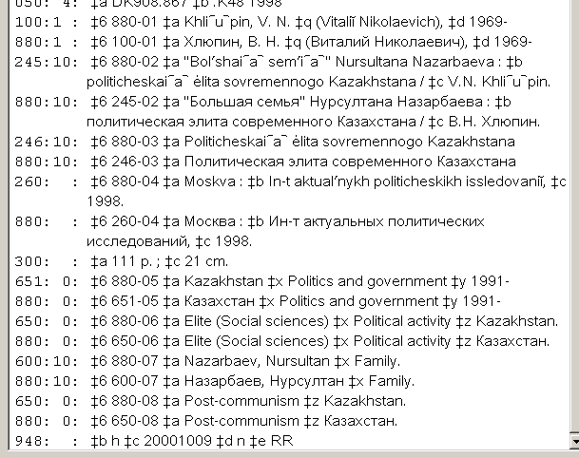

In some cases, there will not be a configuration file appropriate to a script or language represented in a record. Even in these cases, the "romanization" tab contains something that may be of use to you: the "new 880" button. Use this button to create an initial parallel field for a field in a MARC record; the principal advantage to allowing the button to help you in this work, is that the toolkit will construct subfield $6 in the original field and the 880 field for you, so you're spared that difficult and exacting task. After you save the modified record to Voyager, you will need to finish the parallel field in Voyager.

For example, to create an initial 880 field parallel to this 100 field, click anywhere in the 100 field. (You don't have to highlight a block of text; just click anywhere in the field.)

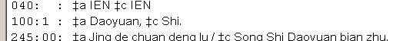

When you click the "New 880" button, the toolkit calculates the next sequence number for the pair of parallel fields (in this example, the new 880 field will be the first parallel field in the record), replaces subfield $a with an asterisk, and adds an 880 field to the record. After you save the changed record to Voyager, return to the Voyager cataloging client to finish work on the field.

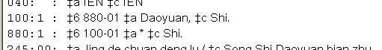

The "New 880 RTL" button does exactly the same thing as the "New 880" button, except that it adds "/r" to the end of the text of subfield $6 of the new 880 field.

To create a right-to-left 880 parallel to the 100 field in this record, click anywhere in the field, then click the "New 880 RTL" button.

The toolkit creates a new 880 field, with "/r" at the end of subfield $6. You can make additional changes to this field with the "Edit RTL" button. You can also work with the field in the Voyager cataloging client after you save the changed record to Voyager.

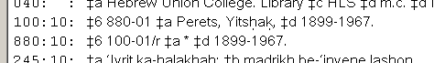

The "Edit RTL" button allows you to make very careful changes to an 880 field that contains right-to-left text. (Editing such text in either Voyager or OCLC can be a chore, as it's not always clear how to select text you want to change. If you want to modify an 880 field that contains right-to-left text, click the cursor anywhere in the field, then click the "Edit RTL" button. The toolkit copies the 880 field into a special editing window. The next illustration shows how this special editing window might look.

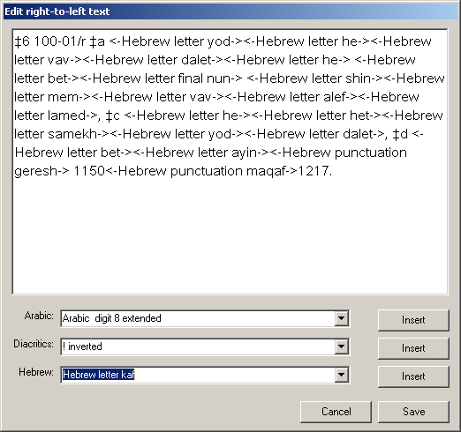

The important thing about this special editing window is that the toolkit has substituted names for each right-to-left character and each diacritic, but has left other characters as they stand in the field. The toolkit shows each character in input order, not in the order determined by any particular display convention.

When you have displayed a field in this editing panel, you can modify it, but you must be very careful.
- To remove a right-to-left character, highlight the character name and its containing angle brackets, and click your keyboard's "Delete" button, or click your keyboard's "Backspace" key.
- To insert a right-to-left character or a diacritic, click the cursor on the point at which you wish to insert the character. Be very careful not to insert a right-to-left character or diacritic into the display name of a character. Then select the character you wish to insert and click the corresponding "Insert" button.
- To insert left-to-right text into the field, simply place the cursor where you wish the text to go, and start typing. Be very careful not to insert text into the display name of a character.

Click the "Save" button to return to the main editing panel. The toolkit will insert your changed right-to-left field into the displayed record, but it has not yet saved the changed record to Voyager.

There are yet other buttons on the "romanization" tab:

- Insert sp.: Click on a point in the record at which you wish to insert a space, then click this button. The toolkit adds a space for you.
- Remove characters: To remove one or more characters, highlight the characters, then click this button.
- Define (this button is not always available): This button allows you to define a new replacement; it will most often come in handy for the Han (Chinese) script. You will discover the need to define a new replacement when you convert text, but the toolkit fails to replace a character. Highlight the vernacular character, then click this button. When you supply the Romanized equivalent for the vernacular character, the toolkit will make the replacement in the record, and also add the definition to the configuration file, so you won't need to do the same work again.
- Replace: Use this button to remove one or more characters from the record, and replace those characters with other characters. Highlight the characters to replace, then click this button. When you supply the replacement text, the toolkit makes the substitution for you.

Capitalization, etc. tab

Features on the "Capitalization, etc." tab allow you to manipulate the upper-case and lower-case appearance of character data in a record. This may be of use in a number of contexts, but may be of particular use when working with a MARC record that was created from non-MARC metadata, or a record that was created using options for transcription that are not considered desirable at your institution.

Display in the Voyager cataloging client a record that contains a number of characters whose capitalization needs to be adjusted, then click the romanization/capitalization button. When the toolkit shows you the record, select the "Capitalization, etc." tab. The next illustration shows how a typical record might appear when displayed on this tab.

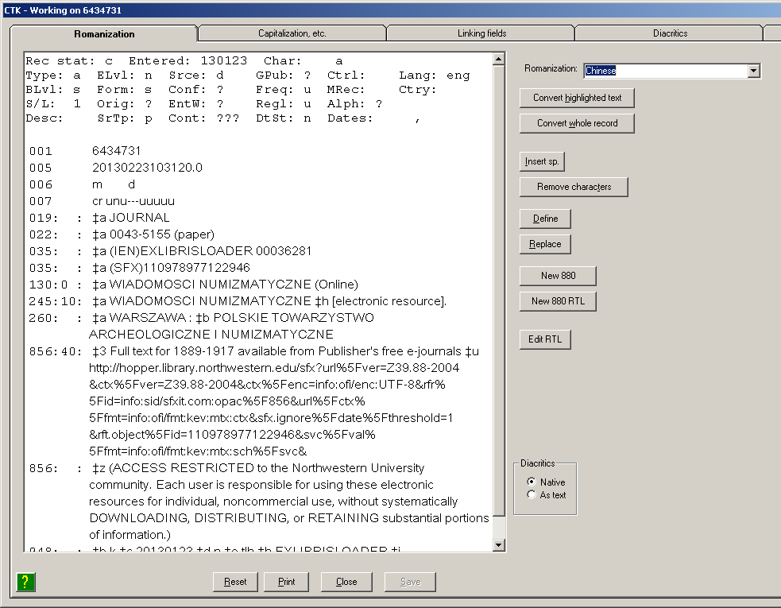

Before doing anything else: If you wish to use the "title case" feature, set the drop-down list next to the "Title case" label to an appropriate value. The drop-down list only contains those languages that are defined in a configuration file.

To manipulate text in the record (from one character to a whole field) highlight the text of interest, then click one of the buttons on the right.

- The "Clean up coordinates" button: this button only works on authority records. The toolkit attempts to make character substitutions in $b subfields of 670 fields that appear to contain coordinates; it replaces the angstrom and superscript zero with the degree sign, it replaces apostrophe and high comma centered with the miagkii znak, and it replaces the double quotation mark with the tverdii znak. When you click this button, the toolkit inspects all 670 $b subfields, regardless of what you may have highlighted.
- The "Title case" button: the toolkit converts the highlighted text to lowercase and then converts the first letter in each word to its uppercase equivalent unless the word list listed in the selected title case configuration file.
- The "Sentence case" button: the toolkit converts the highlighted text to lowercase and then converts the first character in the first word to its uppercase equivalent.
- The "Lowercase 1" button: the toolkit converts the initial character of the first highlighted word to its lowercase equivalent.
- The "Lowercase all" button: the toolkit converts all uppercase alphabetic characters to their lowercase equivalents.
- The "Uppercase 1" button: The toolkit converts the first character of the first highlighted word to its uppercase equivalent.
- The "Uppercase each" button: The toolkit converts the first character in each word to its uppercase equivalent.
- The "Uppercase all" button: the toolkit converts all lowercase alphabetic characters to their uppercase equivalents.

Example: to uppercase just the first word in subfield $a of the 130 field, highlight the text of subfield $a:

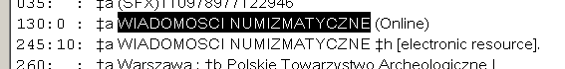

When you click the "Sentence case" button, the toolkit lowercases the highlighted text, and uppercases the first word:

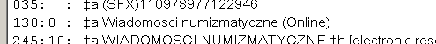

Example: to reduce the contents of the 260 field in this record to lowercase, with each word in uppercase, select the whole text of the 260 field:

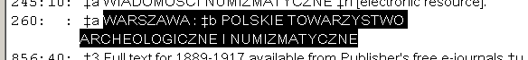

When you click the "Uppercase each" button the toolkit reduces the selected text to lowercase characters, then restores the first character in each word to uppercase:

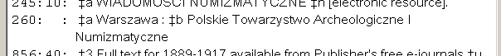

This button should work properly for all scripts that have separate uppercase and lowercase characters.

Example: you can use this button to change this 490 field:

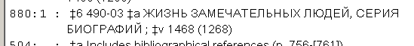

To this:

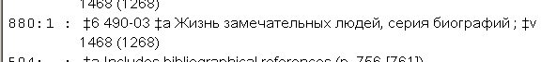

6. What happens when you click the 4XX, 643 or 670 button?

The toolkit has long contained three buttons (with the captions "4XX", "643" and "670") that help you add information to one authority record, based on information in a second record. These buttons do their work with just a few clicks of the mouse.

The tasks performed by these buttons are quite similar to tasks available on the elaborate record-editing panel now available from the "linking fields," "RDA" and "romanization" buttons. This means that you have a choice for the 4XX, 643 and 670 buttons. You can, if you wish, tell the toolkit that when you click one of these buttons, it uses the new elaborate editing form; or you can tell the toolkit to continue to use the simpler interface that has been available for years.

The options to control the behavior of these buttons are on the lower part of toolkit's options panel for these buttons:

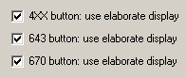

If you check a box for a button, the toolkit will present the elaborate display when you click the corresponding button. If you leave a box un-checked, the toolkit will use the existing simpler interface when you click the corresponding button.

The difference between the two operating modes for these buttons is one of convenience: the original, simpler interface allows you to accomplish a task with one or two fewer clicks than is possible with the elaborate editing form; the elaborate editing form allows you to accomplish more than just one task at a time. (If you leave these boxes un-checked, you can always get to the elaborate editing form with the "capitalization" or "romanization" button.)

7. Working with multi-language access points: BAM, and the '$l' button

Introduction

Before RDA, the bibliographic record for an item that contains expressions of a work in two languages (except in the case of the Bible) bore an access point that joined the names of the two languages in subfield $l with an ampersand ('&'). For example:

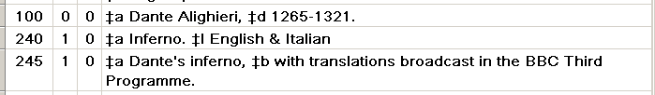

Before RDA, the bibliographic record for an item that contains expressions of a work in more than two languages bore an access point with the term "Polyglot" in subfield $l. For example:

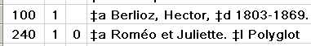

Under RDA, a bibliographic record should contain a separate access point for each language expression contained in the item represented by the bibliographic record. The cataloger's toolkit has two features that help you make non-RDA bibliographic records more RDA-like by teasing multi-language access points into separate access points for each language expression.

- During BAM operations, the toolkit can automatically tease apart many instances of dual-language subfield $l (those that contain an ampersand).
- The '$l' button allows you to work directly with access points that contain 'Polyglot' in subfield $l, and those access points with instances of dual-language subfield $l that the toolkit could not handle automatically during BAM operations. This button leads to a dedicated tab on the large editing panel (the same editing panel that allows for direct work with diacritics, linking fields, and capitalization, among other things).

Note: The toolkit's handling of instances of multi-language subfield $l is informed by the contents of subfields $a and $h in the 041 field of the bibliographic record. As described below, for the '$l' button the toolkit will suggest an 041 field for a simple bi-lingual record that does not contain an 041 field. The toolkit will refuse to handle a multi-language subfield $l in a record that does not contain a suitable 041 field, and for which one cannot be supplied. If the toolkit refuses to handle a record with a multi-lingual subfield $l, you should create a suitable 041 field and try again.

Options

The toolkit's handling of multi-language subfield $l is controlled by a set of options. There is an option for the BAM button, described elsewhere in this document, that tells the toolkit whether or not you wish the toolkit to attempt to split apart a dual-language subfield $l during BAM.

The toolkit uses an additional set of options to control its handling of subfield $l both during BAM, and when you use the '$l' button. These options are available from the 'Button details' tab of the toolkit's options panel by clicking on the '$l' button. The default value for all of these options is not checked.

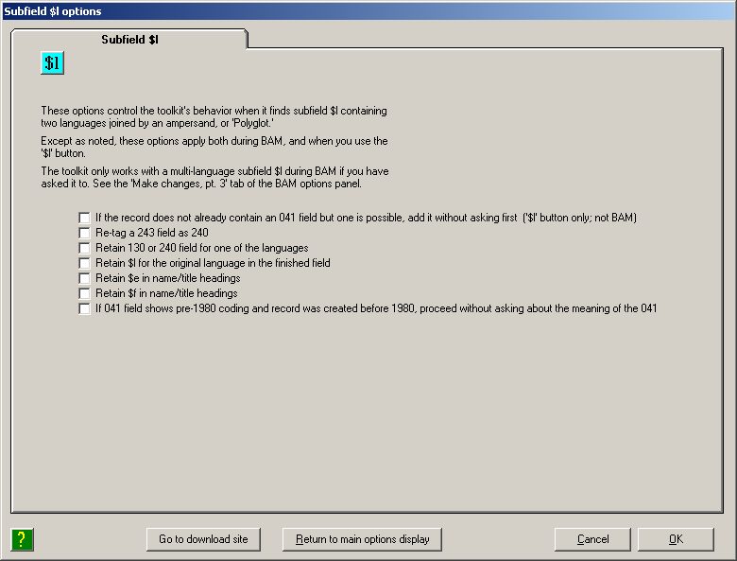

- If the record does not already contain an 041 field but one is possible, add it without asking first: The toolkit only considers the value of this check-box when you click the '$l' button; this option does not play a part during BAM options. The toolkit requires each bibliographic record presented to the '$l' button to contain an acceptable 041 field; in many cases for bi-lingual instances of subfield $l, if a bibliographic does not contain an 041 field, the toolkit can propose one for you. (To no great surprise, the toolkit cannot propose an 041 field if subfield $l contains 'Polyglot.') If you do not check this option box, the toolkit will show you its proposed 041 field in a separate message and ask you if it is acceptable. If you check this option box, the toolkit will simply add its proposed 041 field to the record under consideration, and display the 041 field in boldface. (The toolkit adds the 041 field to the version of the record that it keeps in its own memory space. As is the case with other changes made when you use the '$l' button, the toolkit does not save the modified record to Voyager until you click the 'Save' button.)

In the following illustration, the operator has selected this option, and then clicked the '$l' button. For the record under consideration, the toolkit was able to propose an 041 field, and has automatically added it to the record under consideration. At the outset, the toolkit shows its proposed 041 field in boldface. This boldface will disappear as the operator makes other changes to the record.
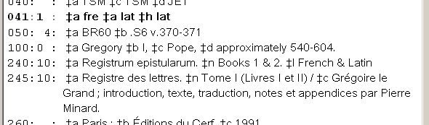

- Re-tag a 243 field as 240: If you check this box, the toolkit will pretend that a 243 field is actually tagged 240. This will allow the toolkit successfully to handle many older records (including batch-loaded records) which use the 243 field instead of the 240 for a collective uniform title.

- Retain 130 or 240 field for one language: If you do not check this option box and if the multi-lingual subfield $l occurs in a 130 field, the toolkit will by default create two 730 fields (one for each language expression) and remove the 130 field. Similarly, if you do not check this option box and if the multi-language subfield $l occurs in a 240 field, the toolkit will by default create two 7XX fields (one for each expression) and remove the 240 field. This default action (with this box not checked) is in keeping with the spirit of RDA. If you check this option box, the toolkit will create one 7XX field (for one of the expressions), and retain the 130 or 240 field with subfield $l adjusted to represent the other expression.

- Retain $l for the original language: If you do not check this option box and if one of the languages named in subfield $l is the original language of the work, the toolkit will by default create an access point for the original expression that does not contain subfield $l; the access point for translations will contain subfield $l for the languages of the translations. This default behavior (with this box not checked) is in keeping with the spirit of RDA as implemented by the Library of Congress. If you check this option box, the toolkit will use subfield $l in the access points for all expressions, even if one of the languages is the original language.

- Retain $e in name/title headings: If you check this option box, the toolkit will retain subfield $e in name/title access points. If you do not check this option box, the toolkit will remove any subfield $e that it finds in the name/title access points it creates during its work with multi-language instances of subfield $l. Under no circumstances will the toolkit create subfield $e if it is not already present in the record.

- Retain $f in name/title headings: If you check this option box, the toolkit will retain subfield $f in name/title access points. If you do not check this box, the toolkit will remove subfield $f from name/title access points. The toolkit will in all cases retain subfield $f in access points consist of a title (not preceded by a name). (The toolkit can in some circumstances also create subfield $f if it is not already present in the record.)

- If 041 field shows pre-1980 coding and record was created before 1980, proceed without asking about the meaning of the 041: Until 1980, the definition of the 041 field did not include subfield $l, and a different practice was used to indicate translations (all codes jammed into subfield $a). If you check this box, and if the bibliographic record was created before 1980, and if the 041 field appears to reflect this earlier coding practice, and if subfield $l indicates that two languages are present, the toolkit will assume that it can re-formulate the 041 field for you, without asking first. The matter of the earlier coding practice for the 041 field is described in more detail below, with an example.

The examples included in the following descriptions are based on these choices on the options panel (by default, none of these boxes is checked):

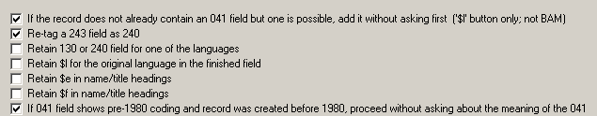

BAM: split apart dual-language subfield $l

NOTE: The automatic conversion of dual-language subfield $l during BAM described here has been turned off to allow for additional testing and development. For the present, use the '$l' button for all instances of dual-language subfield $l, as well as for subfield $l containing 'Polyglot.'

If you ask the toolkit to attempt to deal with a dual-language subfield $l during BAM, the toolkit will attempt to tease apart each dual-language subfield $l in each bibliographic record that it examines. For example, if you request this service and submit this record during BAM:

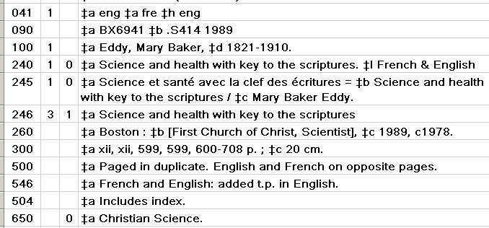

The toolkit will change the record like this (240 removed; two 700 fields added):

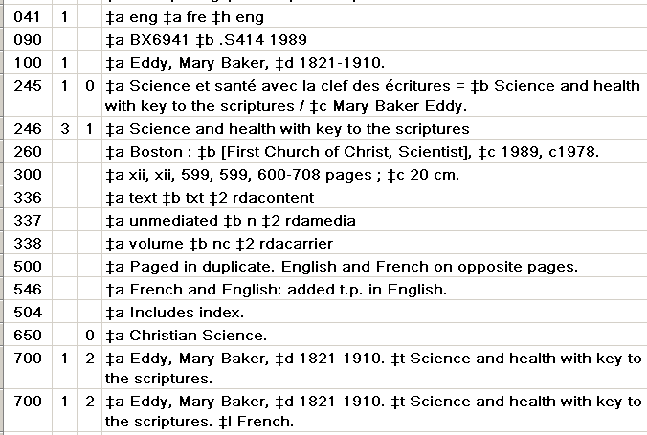

Here's an outline of what happens:

- The toolkit collects information from subfields $a and $h of the 041 field, if any. (These subfields may at this point be old-style subfields, with all of the language codes of a typed crammed together in one subfield, or they be new-style, with a separate subfield for each language code.
- The toolkit is interested in each access point (considering the 1XX+240 as a single access point) that does not contain subfield $6, contains exactly one instance of subfield $l, and contains an ampersand in that one instance of subfield $l. During BAM, the toolkit only considers the 130, 1XX+240 and 7XX fields; the toolkit does not consider subfield $l in series or subject access points.
- The toolkit divides the contents of subfield $l at the ampersand, and attempts to discover (by reading its configuration files) the corresponding language code.
- If the toolkit is not able to determine on its own whether one of the languages in subfield $l is the original language of the work, it pauses to ask a question about the original language.
- If the original field contains subfield $s, the toolkit asks about the appearance of version information in the single-language access points it is about to create.
- If the original access point is the 130 or 1XX+240: If you have told the toolkit not to retain the original 130 or 240, the toolkit deletes the 130 or 240, and creates two 7XX fields, one for each expression. If you have told the toolkit to retain the original 130 or 240, the toolkit modifies the field to represent one language expression, and creates a 7XX field for the other language expression.
- If the original access point is a 7XX field, the toolkit modifies the existing 7XX field to reflect one language expression, and creates a second 7XX field for the other language expression.
- If the bibliographic record does not already contain an 041 field, the toolkit will in some cases create an 041 field based on the information it has drawn from subfield $l, and from its interaction with you. This new 041 field may require adjustment.

The '$l button

The toolkit cannot in all cases automatically untangle a dual-language subfield $l during BAM, and you may in any case wish to control the splitting-apart of a dual-language subfield $l on your own, and not accept the default handling provided by the BAM button. In no case can the toolkit untangle subfield $l that contains 'Polyglot' via the BAM button: this must happen under your direct control. The toolkit's '$l' button offers an operator-mediated method for handling subfield $l that represents more than one language: either subfield $l containing two language names joined by '&', or subfield $l containing 'Polyglot'. With the '$l' button, you carefully instruct the toolkit (by selecting various options and setting various controls) how to tease apart access points with instances of multi-lingual subfield $l; the toolkit carries out your instructions.

To use this feature, call up a bibliographic record that contains one or more instances of subfield $l with an ampersand, or one or more instances of $l with 'Polyglot', then click this button. The toolkit may make certain changes to the record before it shows it to you.

The toolkit requires that what it considers to be a valid 041 field be present in a bibliographic record before you can use the '$l' button to split apart multi-lingual subfield $l. But this does not mean that you must put the 041 field into each record yourself. If the bibliographic record does not contain an 041 field, the toolkit will in many cases be able to suggest the correct one for you by working backwards from the languages named in subfield $l to the corresponding codes. In this work, the toolkit uses information in its codes.cfg file.

For example, when presented with a record containing these fields, but no 041 field:

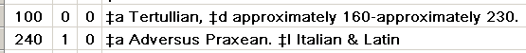

The toolkit finds the codes that correspond to the two named languages, assumes that the second language is the original language, and shows you what it believes to be the text of the proper 041 field for this record:

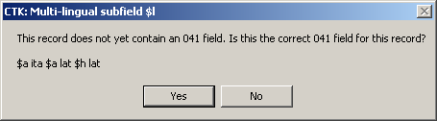

If you click the "Yes" button, the toolkit will add the 041 field to the record and continue as if its suggested 041 field were present in the record from the outset. If you click the "No" button, you will need to add an 041 field to the record yourself before you can use the toolkit's '$l' button.

If one of the languages named in subfield $l is "Greek", the toolkit will ask a preliminary question: is the language classical Greek? (Most of the time, for most of the things handled by most libraries, "Greek" in subfield $l means "classical Greek".) The toolkit remembers your answer for this author or title and writes it to a configuration file; so if the same author or work comes up again, you won't be asked the question a second time. (The toolkit stores your answers in a configuration file, which is described in an appendix.)

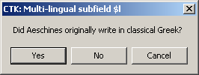

Although the toolkit contains yet other tricks for dealing with classical and modern Greek (and at least one trick for dealing with items that contain the same text in modern and pre-modern versions of the same language), and although the toolkit's tricks usually lead to the correct outcome, you are always well advised when dealing with any matter other than the most mundane to look over the toolkit's proposed results with the greatest of care before you approve any action.

Because the toolkit's proposed 041 field is almost always correct, you may wish to select an option on the panel that controls the '$l' button. This option tells the toolkit that if it is able to construct an 041 field for a record that lacks one, it should just go ahead and add the 041 field to the record, and tell you about it afterwards. Selecting this option saves you the click of an "OK" button that is often superfluous. If you select this option and the toolkit adds an 041 field to the record for you, it shows you the 041 field in boldface:

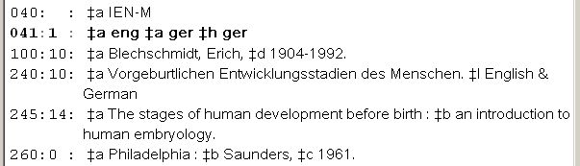

The toolkit's proposed 041 field (whether added automatically, or following your approval) is only present in the version of the bibliographic record in the toolkit's working memory. The toolkit does not save the record with any changes until you click the 'Save' button.

The toolkit will be able to suggest a correct 041 field for the vast majority of records with bi-lingual subfield $l, when there is not already an 041 field in the record. Note the following:

- The toolkit cannot suggest an 041 field if any subfield $l in the bibliographic record contains "Polyglot"
- The toolkit will not suggest subfield $l if it can't find a code that corresponds to any language named in subfield $l.
- The toolkit will not suggest an 041 field if there are different bi-lingual $l subfields in the record. For example, if every bi-lingual subfield $l in a record contains "French & English" the toolkit will suggest the appropriate 041 field; but if one subfield $l contains "French & English" and another contains "Spanish & English" the toolkit will not attempt to construct an 041 field.
- The toolkit assumes that the second-named language in subfield $l is the original language, but in a minority of cases this is not the correct assumption. For example, consider the following record:

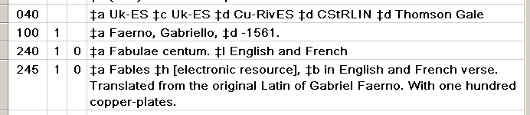

The 240 names the languages contained in the item but neither of these is the original language, which is identified in the 245 field. For a record such as this, you will need to create the 041 field yourself, and then use the '$l' button to split apart the bi-lingual subfield $l in the 240 field.

- There can only be one equivalent code defined in the configuration file for each language named in subfield $l. (As noted above, the toolkit makes an exception if the named language is Greek, and—as should be the case—the configuration file gives two equivalent codes.)
- For the kinds of things to be examined with the "$l" button, the toolkit requires that an 041 field contain at least two instances of subfield $a. Except as noted just below, the toolkit also requires that the 041 field contain at least one instance of subfield $h If the toolkit does not like the shape of an 041 field the toolkit will not attempt to suggest a modification. Exception: If the 041 field contains multiple instances of subfield $a but no instance of subfield $h, the toolkit asks if the item contains multiple language expressions of a work for which the original language cannot be determined; if you indicate that this is a correct description of the situation, the toolkit will proceed with the 041 field as given.

If the toolkit is not able to suggest an 041 field, or if you do not accept the toolkit's suggested 041 field, you will need to add a suitable 041 field to the record before you can use the '$l' button for this bibliographic record.

The toolkit will also modify an existing 041 field in a few cases. Most commonly, if the 041 field uses the old coding style, in which multiple codes were stuffed into a single subfield, the toolkit will put each code into its own subfield. But more importantly, the toolkit also helps deal with a subtler difference between current practice and earlier practice for the 041 field. Before subfield $h in the 041 field was defined (October 1980), the coding practice for a translation was to put all of the codes into subfield $a, in this order:

- the language of the translation
- the language from which the translation was made
- the original language

Because the second and third languages are commonly the same, the typical 041 field for a translation contained only two codes. This means that if the 041 subfield $a contains two codes and subfield $l contains two languages, then it's likely that the bibliographic record represents a bi-lingual edition.

For example, the following bibliographic record represents an edition of selected letters of Gregory Nazianzen, in the original Greek and French translation. The 041 field was constructed according to an earlier coding practice, before subfield $h was defined.

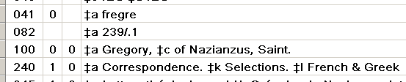

If the bibliographic record you present to the '$l' button is constructed along these lines, the toolkit asks you to confirm that the record represents this earlier coding practice. For example, when presented with the record for the correspondence of Gragory Nazianzen, the toolkit asks this question:

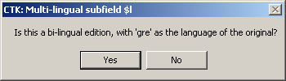

If you click the 'Yes' button, the toolkit remodels the 041 field to reflect current coding practice, and then continues with its work.

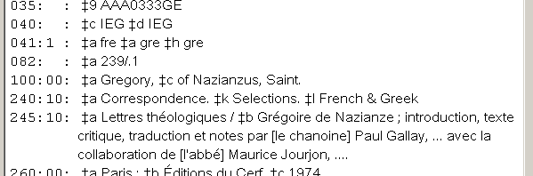

The toolkit's handling of what it detects to be an 041 field that reflects earlier coding practice depends on the value of one of the toolkit's options for the '$l' button. If you have selected this option, and if the 041 field appears to follow earlier coding practice, and if subfield $l contains '&' or 'and', and if the year portion of the date of record creation (bytes 00-01 in the 008 field) is between 60 and 80 (inclusive), then the toolkit will go ahead and re-configure the 041 field for you, without asking.

The generation or modification of the 041 field (either with or without operator approval, depending on your option) is not the only change that the toolkit can make to a record when you click the '$l' button. If main uniform title (240 subfield $a, or 7XX subfield $t) is "Selections", the toolkit will supply "Works" in subfield $a, and move "Selections" to subfield $k. For example, if the record in Voyager looks like this:

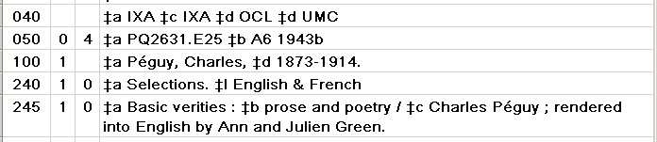

The toolkit will generate an 041 field, and modify the 240 field, then present you with the result:

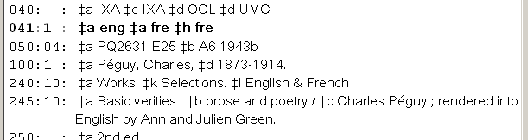

One more thing about the 041 field: if there is already an 041 field in the record, the toolkit can be misled if the 041 field is incorrect. (For example, an 041 field using older-style coding may have the original language first and the language of the translation second; or it may use the code 'gre' when 'grc' is needed.) The toolkit is pretty good at handling records that contain no 041 field at all, but it can be led down the wrong path by records that contain an incorrect 041 field. When a bibliographic record already contains an 041 field, it is a good practice always to compare the 041 field to the remainder of the record, and adjust the 041 field as necessary, before clicking the '$l' button.

So much for the preliminaries; let's see how this works on real examples. Here is a typical-enough bibliographic record with a dual-language subfield $l; this record already contains a suitable 041 field:

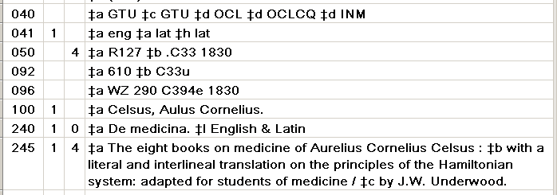

When you click the '$l' button, the toolkit will present this editing panel:

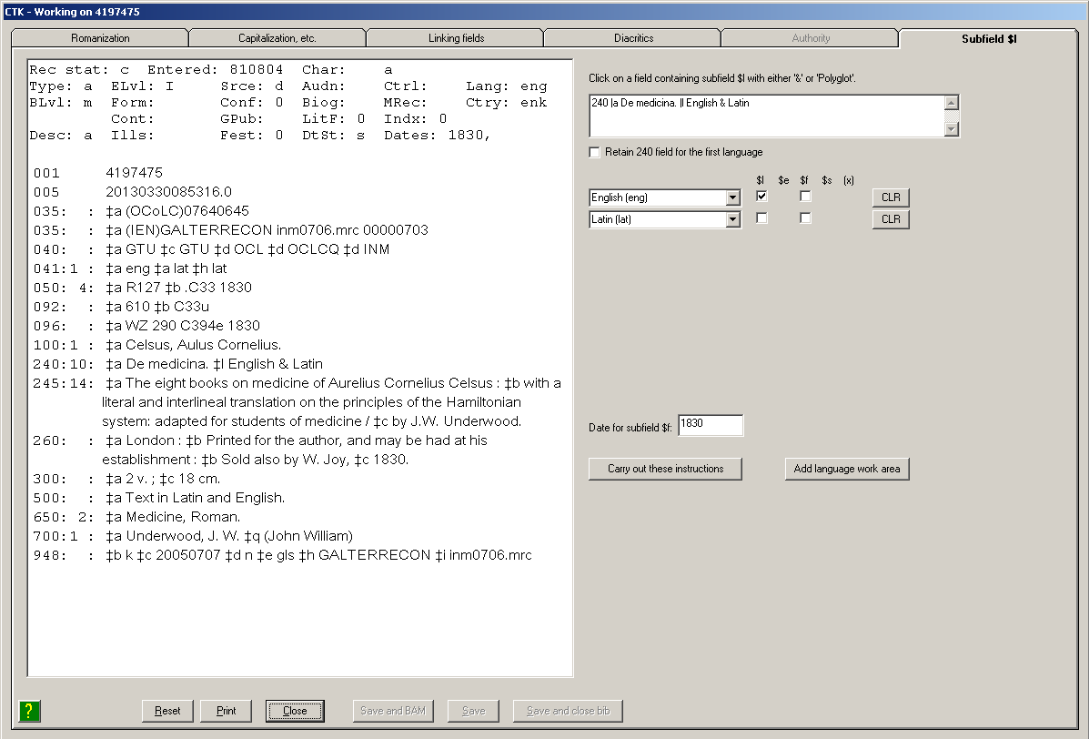

The toolkit has examined the record, and found the first field in the record that it believes to be of interest for this work (the 240 field). (You can also click directly on any field with a multi-language subfield $l; that field will become the focus of the toolkit's attention.) The toolkit shows you the current field of interest in the box in the upper right of the editing panel.

Because the field of interest is the 240 field, the toolkit presents a check-box related to the 240 field, just under the box that contains the text of the field itself. The toolkit takes the default value for this check-box from an option on the options panel. If this box on the 'Subfield $l' tab is checked, the toolkit will retain the 240 field, re-configured to represent one of the language expressions represented by the 240 field, and create a 7XX field for the other language expression(s); if this box is not checked, the toolkit will delete the 240 field, and create two 7XX fields. (If the field of interest is a 7XX field, the toolkit doesn't show this check-box, as it's clear that that toolkit will modify the existing 7XX field and add one or more new 7XX fields.)

The toolkit disassembles the information in subfield $l into work areas on the right, just below the box that shows the field. In this example, because the source field has a dual-language subfield $l, there are two language-based work areas. Each row in these work areas contains one or more check-boxes, depending on the contents of the field in question, the choices you have made on the options panel, and the contents of the 041 field. Because both of these languages is properly identified in the toolkit's configuration file (codes.cfg), the toolkit has been able to map both of the languages in subfield $l to the appropriate element at the beginning of each language work area on the right. For now, let's just consider the possibilities available for this simple case.

- The work area for each language represented by the original subfield $l contains a drop-down list of language names, pre-set in each case to the language from subfield $l. (If the language is defined in your codes.cfg file, the display will also include the corresponding language code. This code is just for your information, and does not end up in subfield $l of the finished access point.)
- The check-box under the caption '$l' tells the toolkit whether or not the language name should appear in subfield $l of the finished access point. If the box is checked, the access point contains subfield $l for the language; if the box is not checked, the access point does not contain subfield $l for the language. It is your first job to review the state of the '$l' boxes and make sure they reflect your wishes. Subfield $h of the 041 field identifies the original language as Latin, so the toolkit has un-checked the '$l' box for Latin, and has checked the '$l' box for English. This means that by default the access point that the toolkit will create for the original version will not contain subfield $l, and the access point that the toolkit will create for the English translation will contain subfield $l. If you have different wishes for the appearance of subfield $l in the finished access points, you can adjust the contents of the '$l' check-box for each language.

The toolkit draws the lists of languages from one of its configuration files. If the language named in subfield $l is not identified as such in the configuration file, the toolkit will use the text exactly as found in subfield $l (minus any terminal punctuation) as the language name. You can also type any text you want, if you need some language name that's not listed.

- The check-box under the caption '$f' tells the toolkit whether or not the access point should contain subfield $f. The rules that the toolkit uses for setting the initial value of this box are rather complicated. The toolkit checks the box if the original bibliographic field contains subfield $f and if one of the following conditions is true: you have checked the "retain subfield $f" option box and the bibliographic field is a name/title field (the toolkit considers the 240 field to be part of a name/title field), or if the original bibliographic field is not a bibliographic field. The toolkit also checks the box if the main title in the original bibliographic field is "Works." If this box in a given row is checked, the access point that the toolkit creates from the information in that row contains subfield $f; if this box is not checked, the access point does not contain subfield $f. The toolkit shows the date that the toolkit will use in subfield $f in a box just above the "Carry out these instructions" button. The toolkit takes this date from subfield $f of the access field, if there is one, or from Date 1 in the 008 field (008 bytes 07-10). If you wish to include subfield $f in access points, you can change the date in this box as needed.

- The 'CLR' button on the right of the row for each language sets the language box in that row to its default value—"NONE". The toolkit only creates access points for those rows of this display that show an actual language name; so clearing the language name in this manner means that the toolkit will not create an access point from the information in that row.

- The "Add language work area" button tells the toolkit to provide you with an additional language work area. For example, if there are already two language work areas and you click this button once because there are actually three languages involved, the toolkit gives you a third work area, set to its default value:

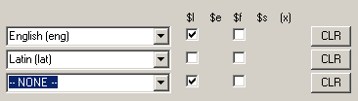

The toolkit can offer you a maximum of 10 language work areas. If you need more than 10, you will need to finish the record on your own.

- When you have set the language-based controls on the right side to contain their proper values, click the 'Carry out these instructions' button. The toolkit will modify the record in the editing panel as instructed. As is always the case with features on this editing panel, the changes you see in the display are not yet saved to the Voyager database. The toolkit only saves your changes to Voyager when you click the Save button.

For this record, following the operator's instructions, the toolkit deletes the 240 field and adds two new 7XX fields, one for each language expression. Per the operator's instructions, the 7XX field for the expression in the original language does not contain subfield $l:

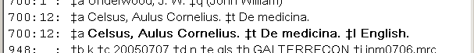

The toolkit searches your local authority file for each access field that it creates or modifies during this work. The toolkit compares the complete text of each such field against authority 1XX fields. If the toolkit does not find a matching authority 1XX field in the local authority file for the full text of the bibliographic field, the toolkit shows the text of the field in bold. In the preceding display, the toolkit is showing us that there is an authority record for the name+title by itself, but not for the English translation. In the next illustration, the toolkit tells us that there is no authority record for either of the new access points: not for the original language, and not for the translation.

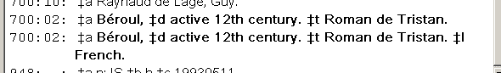

In the following illustration, the toolkit is telling us that there is no authority record for the name+title itself, but there is one for the English translation.

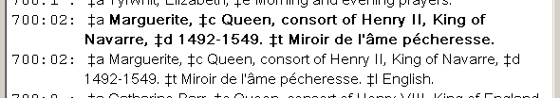

This bold-face labeling only appears for the most recent heading worked on via the '$l' button; any existing bold-face labeling for one heading disappears if you use the '$l' button for another heading in the same record. For example, in the following record, the toolkit has just been used to split a single heading for Godard with "English & French" into two; the second one is shown in bold because there is no matching authority record for the translation in the local Voyager authority file. If the toolkit is next used to split the Miéville heading into two as well, the bold-facing for the Godard will disappear, and any bold-facing will show only the status of the two Miéville headings.

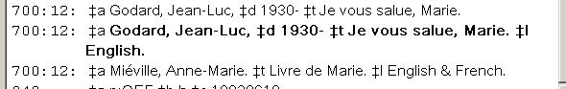

This bold-face presentation is your indication that further work (authority-related) work might need to be done. Probably the first thing you'll want to do after you finish work on the bibliographic record and save it, is BAM the bibliographic record to get a fuller report on headings and authority records.

If there is another access field in the record with a multi-lingual subfield $l, the toolkit will automatically find it for you, and present information about it in its work areas on the right side of the editing panel. When you have handled all of the multi-lingual instances of subfield $l in a record, click the 'Save' or 'Save and BAM' button to write the changed record to your Voyager database.

If the first change that you approve to a bibliographic record involves the 1XX field plus a bi-lingual 240 field, there's an additional possibility. When you click the "Carry out these instructions" button, the toolkit does a quick-and-dirty search for other bibliographic records that appear to have the same heading, and (if there are any) tells you how many other similar bib records there appear to be. If you ask the toolkit to look further into the matter, it retrieves each bib record, examines it, and presents you with the records as they would be changed. If you like what you see, the toolkit will change all of the records at once.

Here's an example. We've found a bibliographic record for a bi-lingual (English and Italian) edition of Dante's Paradiso, and we wish to RDA-ify the primary access point to eliminate the bi-lingual subfield $l:

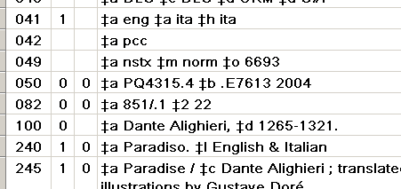

The '$l' button (correctly) surmises that we want to remove the 240 field and create two new analytical access points: one for the original language and one for the English translation. When you click the 'Carry out these instructions" button, the toolkit modifies the record on the left side of the big editing window to show the proposed change. The toolkit also does a search for similar records, and shows what it found:

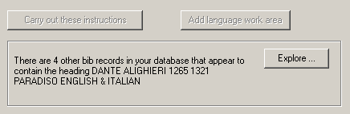

If you click the "Explore" button, the toolkit fetches each of the records, and applies to it the same transformation definition that it applied to the original record. The toolkit shows all of the transformed records in a new window; you can (and really should!) scroll around in the window to examine all of the records.

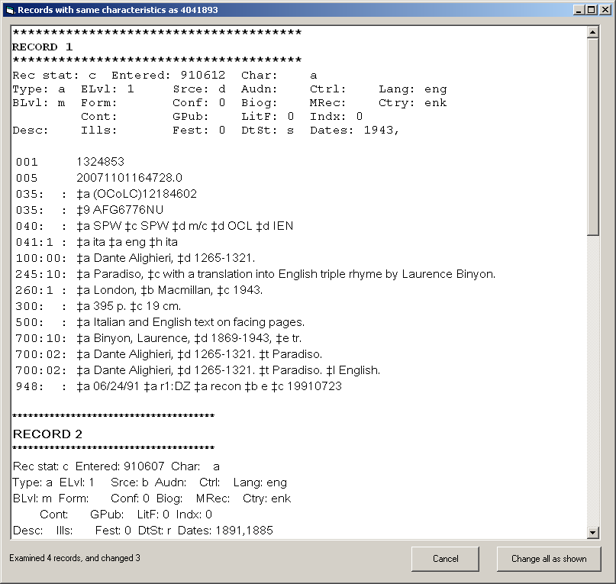

Note the message line at the very bottom of the frame: in this case, the toolkit examined 4 records, but only changed 3 of them. If you scroll to the bottom of the last record, the toolkit will show you the record(s) it couldn't change on its own:

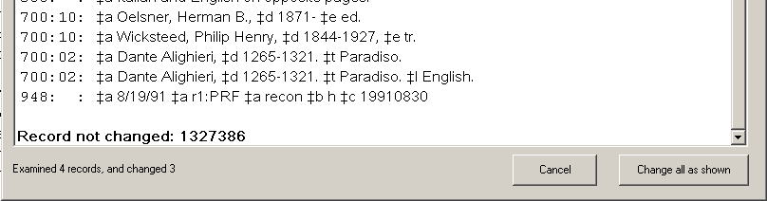

You'll need to call up that un-changed record and deal with it on your own. (The toolkit didn't change this particular record because the name/title combination appears in a 700 field, not as a100 with 240.)

You have two options at this point:

- If you click the 'Change all as shown' button, the toolkit changes all of the records as shown. This updates Voyager not only for the records in this secondary window, but also for the record in the primary window.
- If you click the 'Cancel' button, the toolkit closes this secondary window, and returns you to the original record. You can continue to work on this record, or abandon your work on it, or do whatever else seems appropriate.

Note: The toolkit will also present such a message regarding additional bibliographic records in the case of separately-published libretti, and libretto texts that accompany sound recordings. You should generally not follow up on the toolkit's suggestion that all of these can be handled at once, but should instead handle each according to its merits.

So far, we've been looking at subfield $l that contains two languages joined by '&' (or "and"). Things are slightly more elaborate for 'Polyglot' access points. Here's a sample original bibliographic record:

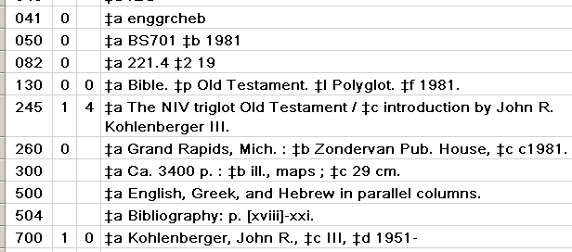

When the operator clicks the '$l' button, the toolkit notices the lack of subfield $h, and asks if it is true that the original language is not known. If you answer 'No', the toolkit refuses to work on the record; if you answer 'Yes' the toolkit continues to work on the record. In this case, the operator supplied subfield $h for the 041 field and then clicked the '$l' button again. The toolkit showed this display:

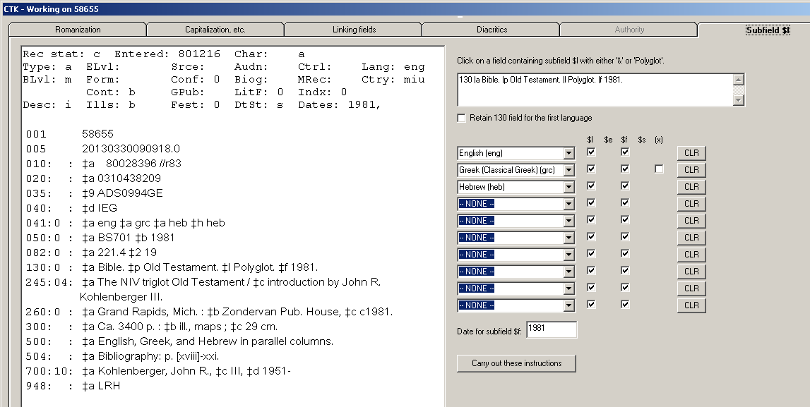

Because the field of interest is the 130 field, the toolkit presents a check-box just under the box for the text of the field, with a slightly different caption that it had when the field of interest is a 240 field. The toolkit takes the default value for this box from an option on the options panel. If this box is checked, the toolkit will retain the 130 field, re-configured to represent one language expression, and create 730 fields for the other language expressions; if this box is not checked, the toolkit will delete the 130 field, and create 730 fields for each language expression.

Because this subfield $l is "Polyglot", the toolkit starts out with all 10 possible language work areas. (If you need more than these 10 work areas, you will need to finish the record on your own.) The toolkit has primed the first three work areas by reference to the 041 field; if there had been no 041 field, all of the work areas would be set to their initial value of "None." All of the remaining work areas are set to their default value; the toolkit will only create access points if the language box shows something other than its default value.

This display shows additional check-boxes in the row for each language.

- $f: Once again the toolkit provides the option of including subfield $f in the finished access fields. Because the original field is not a name/title field and contains subfield $f, the toolkit has supplied a checkmark as the default value in each of the subfield $f boxes. The toolkit shows the text it will use in subfield $f in the box just above the "Carry out these instructions" button.
- (x): Because the language name "Greek (Classical Greek)" contains a set of parentheses, there is a check-box for that language under the caption "(x)"; this box (and similar boxes for other languages, when the language name contains parentheses) instruct the toolkit to retain (if the box is checked) or remove (if the box is not checked) the parenthesized expression from the language name in subfield $l of the access point.

It is your job to make sure that all of these language work areas accurately reflect the access points you wish to create. In this particular case, the toolkit's default actions are correct: we wish to delete the 130 field and create three new 730 fields, one for each language. Because this is a Bible heading, we will retain subfield $l and subfield $f in each of these access points. Because this item only contains one kind of Greek (i.e., it does not contain both classical and modern Greek), we don't need to retain the parenthesized expression after the basic language name.

When the operator clicks the "Carry out these instructions" button, the toolkit modifies the record in accordance with the instructions in the configuration:

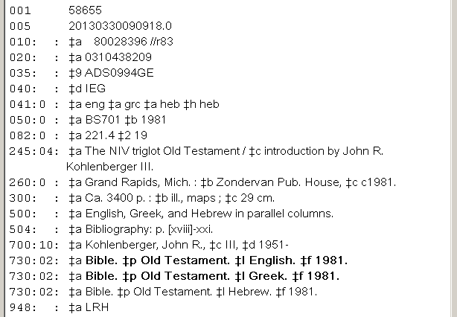

In this case, because the toolkit has removed the 1XX field, it also adjusted the first indicator of the 245 field. As was the case with the earlier record with the bi-lingual subfield $l, the toolkit has tested each of the new access fields against the local authority file; in this case it did not find matching 130 fields for either of the translations, but found a matching 130 field for the original language.

As was the case with dual-language subfield $l, after it has carried out your instructions the toolkit will inspect the record for another field with multi-language subfield $l. If there is such a subfield, the toolkit will prime its work areas to match. As is also the case with dual-language subfield $l (and, indeed, all of the tabs on this fancy editing panel), the toolkit does not write the changed record to the Voyager database until you click the 'Save' button.

One more thing, about Bible headings in particular: If subfield $s is present, the toolkit can include, or exclude, subfield $s from the new access fields, but it does not provide a means to add subfield $s if the original access point does not contain one. In the case of the above record, the operator will need to intervene in the finished record, and add subfield $s containing "New International" (as suggested by "NIV" in the 245 field) to the access field for the English translation.

Additional check-boxes for each language

The work areas for each language can have additional check-boxes beyond those described above, depending on the contents of the original field and on your options.

- $e: If the original field contains $e and if you have indicated on the options panel that you wish to retain subfield $e, the toolkit shows a check-box under the caption "$e" for each language. You can decide for each language whether you wish to include subfield $e
- $s: If the original field contains subfield $s, the toolkit shows a check-box under the caption "$s" for each language. You can decide for each language whether you wish to include the name of the version.

Additional configuration to support the toolkit's handling of multi-lingual subfield $l

A new stanza in the codes.cfg file gives the toolkit a little bit more information about languages whose names may appear in subfield $l in a form that does not correspond with forms defined elsewhere in the configuration. This new stanza is described in an appendix.

8. Libretto button

Introduction

NOTES: In the following description of the use of this button, the term opera is used generically for musical works that incorporate a text, and the term libretto is used generically for such texts that are part of musical works. These terms are to be understood as references to the broadest category of such works: the 'libretto' button is intended to work equally well for all musical works that incorporate text, and should work equally well for operas and Broadway-style musicals (for example).

In bibliographic records for musical works (printed or recorded), special considerations apply when the composer of the music is also the writer of the words. The toolkit's handling of this special case is described separately, after the description of the more usual cases.

Before RDA, the bibliographic record for a separately-published opera libretto (i.e., the text of an opera published as a separate book) had as its main entry the composer of the opera, with "Libretto" in the uniform title (in subfield $s, if you're lucky), and with an added entry for the author of the libretto. To add to the complexity of the situation, libretti are commonly published together with a translation, meaning that a multi-lingual subfield $l is often also present.

Here is a typical pre-RDA bibliographic record for a separately-published libretto, containing the original text and an English translation:

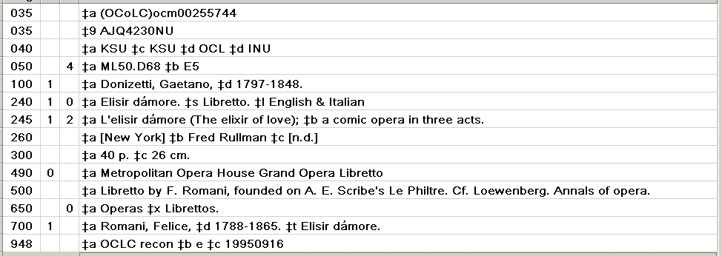

In contrast to previous practice, RDA recognizes that the librettist, and not the composer, is the author of the libretto. The libretto is one work, and the opera is a separate work. There is of course a special relationship between the two works, and this relationship needs to be expressed once the various responsibilities are sorted out.

The following illustration shows the above bibliographic record for a separately-published libretto as it might be remodeled to conform to the model used under RDA. (This illustration also shows other changes, not directly related to the RDA model for handling libretti.) The author of the libretto is now given in the 100 field, there are 700 fields for the two expressions contained within this item, and there is a third 700 field to describe the relationship of this work (the libretto) to some other work (the opera).

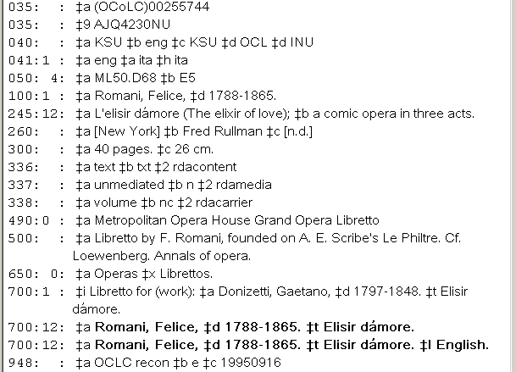

A sound recording of an opera is often accompanied by a separate libretto booklet, giving the text in one or more languages. Following the same line of thinking as was used for libretti, in a pre-RDA bibliographic record for a sound recording the libretto is identified by an added entry starting with the name of the composer (again, with "Libretto" in subfield $s). In the following illustration of part of a bibliographic record (for a sound recording of Elisir d'amore), the libretto is represented by the last 700 field. This particular bibliographic record does not identify the name of the librettist (Felice Romani) in 700 field or even in a note.

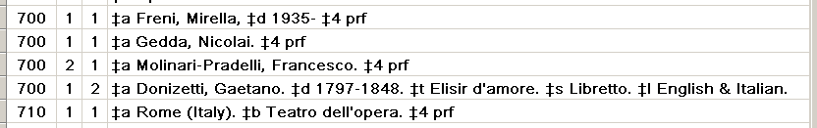

Here is the corresponding part of this bibliographic record, as it might be remodeled following RDA principles. Felice Romani is recognized as the author of the libretto, and there is a separate access point for each expression of the libretto.

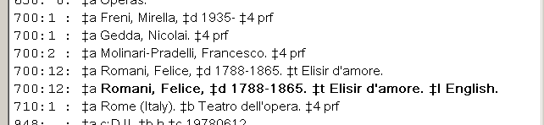

To convert a pre-RDA bibliographic record for a separately-published libretto into a record that follows the RDA model, the following things need to happen:

- The author of the libretto (commonly in a 700 field) needs to be identified
- The author of the libretto needs to become the 100 field
- The 240 field needs to be adjusted
- The bibliographic record needs a name/title 700 field for the related work (the opera)
- An 041 field may need to be created
- In many cases, a multi-lingual subfield $l needs to be dealt with, so that there is an access point for each expression contained in the manifestation.

In a similar vein, to convert a pre-RDA bibliographic record for a libretto that accompanies a sound recording into a record that better follows the RDA model, the following things need to happen:

- The author of the libretto needs to be identified, and a 700 field for the libretto needs to be created.
- An 041 may need to be created, or the existing 041 field adjusted
- The 700 field for the libretto as a creation of the composer needs to be deleted.
- In many cases, a multi-lingual subfield $l in the access field for the libretto needs to be dealt with, so that there is an access point for each expression of the text.

The cataloger's toolkit contains a button, the "libretto" button, which (together with other toolkit features) can make all of the necessary conversions to a pre-RDA bibliographic record for a libretto with just a few clicks of the mouse. This button is designed to be used for:

- Musical works and libretti written by individual persons. You're on your own when it comes to musical works and libretti written by corporate entities. (Yes, they do indeed exist.)
- Separately-published libretti, and libretti that accompany sound recordings of single works. The button is not designed for collections of libretti, whether all by one librettist, or several librettists; the button is also not designed for sound recordings that contain two or more works. The text of the libretto can be in one language, or multiple languages (none of these languages need be the original language).
- Libretti of individual operas (the button is not designed for texts of songs)
- Libretti of Broadway shows, and similar works. These are in essence the same as the libretti of operas; the complication is that there is typically an author of "lyrics" separate from the author of the "book", and often more than one of each. The selection of one of these persons as the primary access point for the words that accompany the music is a decision with which the toolkit cannot help you.
- Libretti that are written by known persons. If the libretto is anonymous, you're on your own.
- Bibliographic records in which the composer is named in the 100 field
- Bibliographic records that use subfield $6 to link to vernacular equivalents in 880 fields
- For a separately-published libretto, the 240 field names the opera, and contains "Libretto" in subfield $s; other subfields (such as subfield $l) may also be present in the 240 field. For a libretto accompanying a sound recording, the existing 700 field must have "Libretto" in it, and the name portion of that 700 field must be the same as the 100 field.
- For a separately-published libretto, the author of the libretto is given as a 700 field; if the libretto has its own title, that title appears in subfield $t. (If subfield $t is present in the 700 field, it may contain the same text as 240 subfield $a, or a different text.) For a libretto accompanying a sound recording, the author of the libretto is given as a 700 field.

It is possible that in the future the button's capabilities will be expanded to include additional similar things (such as the texts of songs); but for the present, it should only be used for those kinds of things for which it was designed. Although the functionality of this button is restricted, it should nonetheless be able to bring the majority of bibliographic records for separately-published libretti into a more RDA-like form.

It cannot be stated too firmly that the libretto button is not designed for use in creating new bibliographic records for libretti, or things that contain or refer to libretti. It is designed solely for the rearrangement of existing non-RDA bibliographic records into a more RDA-like shape.

Options

A number of options control the behavior of the toolkit's libretto button. These options are available if you click the 'libretto' button on the 'Button details' tab of the toolkit's options panel. The following picture shows the default values for these options.

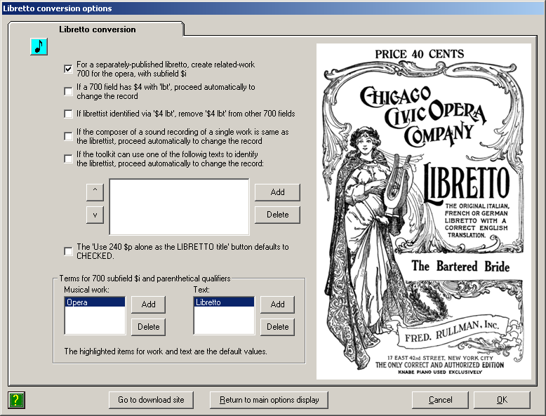

- For a separately-published libretto, create related-work 700 for the opera, with subfield $i: If this box is checked, when handling the bibliographic record for a separately-published libretto the toolkit will create a 700 field for the opera, with the text "Libretto for (work):" in subfield $. If this box is not checked, the toolkit will remove all trace of the composer from the bibliographic record. Default value: checked (create the 700 field for the composer).
- If a 700 field has $4 with 'lbt', proceed automatically to change the record: This box controls something that the toolkit will do to a record when you click the libretto button, before the toolkit shows you the record. If this box is checked, the toolkit will look for a 700 field in the record for a separately-published libretto that has the text "lbt" in subfield $f. If the toolkit finds such a 700 field, it will automatically flip the record around so that the librettist is in the 100 field and the composer is named in a 700 field. If this box is not checked, the toolkit will not make any assumptions about the record; it will wait for your instructions. Default value: not checked (do not look for "lbt" in subfield $4).
- If librettist identified via $4with ' lbt', remove '$4 lbt from other 700 fields: This option comes in handy when a separately-published libretto was written by two or more people. If this box is checked, and if the toolkit identifies the primary librettist by the code 'lbt' in subfield $4 of a 700 field, the toolkit will delete any subfield $4 that contains "lbt" from other 700 fields in the same record.
- If the composer of a sound recording of a single work is same as the librettist, proceed automatically to change the record: This box controls the toolkit's behavior in the case where the composer of the music is also identified in the bibliographic record as author of the libretto. In most cases, the libretto is not written by the composer, even though it appears so from the structure of a pre-RDA bibliographic record; but in some cases, the libretto is written by the composer. (Examples of operas with libretti written by the composer: Les Troyens by Hector Berlioz; Tannhauser by Richard Wagner.) If this box is checked, and if the conditions in the bibliographic record allow the toolkit o determine that the composer is the author of the text, the toolkit will automatically reconfigure the record following the RDA model. If this box is not checked, and if the composer is also the librettist, you will need to a bibliographic record for which the composer is also the librettist on your own. (For this reason, it will make sense that all of the bibliographic records for the operas of Wagner, and similar works, are converted as part of a concentrated project, and not interspersed with records for other things.) The toolkit's handling of bibliographic records for works for which one person has written music and text is described elsewhere in this document.
- If the toolkit can use one of the following texts to identify the librettist, proceed automatically to change the record: In older records for separately-published libretti, the 700 field for the librettist does not have subfield $4; but in many of these records, there is often text in subfield $c of the 245 field, or in a 500 field, that the toolkit can use to identify the librettist. If this box is checked, the toolkit will use texts that you define in the list just below the check-box, in an effort to identify the librettist; if this box is not checked, the toolkit will not undertake a search of the record for the librettist; it will wait for your instructions. Default value: not checked (do not examine the text of the record in an effort to identify the librettist). If you check this box, you also need to identify one or more texts in the list just below the check-box.
- The 'Use 240 $p alone as the LIBRETTO title' button defaults to CHECKED: The value of this option is only relevant if the preferred access point for an opera contains subfield $p. If you check this box, a related check-box on the toolkit's 'libretto' tab is by default also checked; if you do not check this box, a related check-box on the toolkit's 'libretto' tab is by default also not checked. (Regardless of the default value for the box on the libretto tab, you can of course change it to suit a particular case.) This option and the related check box on the 'libretto' tab of the fancy editing panel exists to ease the handling of bibliographic records for the operas of Richard Wagner (specifically, the four operas of Der Ring des Nibelungen), though it may find occasional use in other contexts. For this reason, the operation of this feature is described elsewhere in this document, in the discussion of the handling of libretti written by the composer.
- Terms for 700 subfield $i and parenthetical qualifiers: When so instructed, the toolkit add a 700 field to the bibliographic record for a separately-published libretto, pointing to the musical work for which the libretto serves as the text. Subfield $i in this 700 field contains a phrase describing the relationship. For operas a suitable phrase (given in RDA) is "Libretto for (work)", but other terms may be more appropriate for other kinds of musical works. Similarly, when the text and music of a work are created by the same person, a parenthetical qualifier needs to be added to the preferred access points for both the music and the text, to differentiate them. For operas, suitable texts are "(Opera)" and "(Libretto)" but for other kinds of musical works other terms may be more appropriate. This area of the options panel allows you to define terms for musical works and texts for the toolkit to use in 700 subfield $i and in parenthetical qualifiers, and to choose the default values for each. Use the "Add" and "Delete" buttons next to each list to modify the list to suit local conditions. Highlight a term in each list to provide the toolkit with default values. The toolkit will not allow these lists to be empty. If you delete everything from the musical work list, the toolkit will add "Opera" for you; if you delete everything from the text list, the toolkit will add "Libretto" for you.

Here are the configuration choices that lie behind the following description of the use of the libretto button. (These are not the default values for many of these options, but they are probably good ones for most typical cases.)

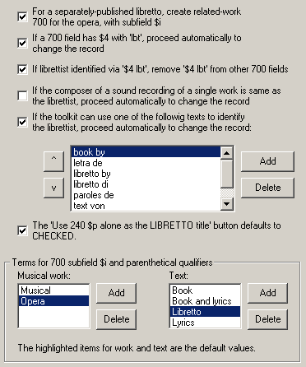

Separately-published libretti

When the Voyager cataloging client displays a bibliographic record for a separately-published libretto, you should first inspect the record to make sure that it fits the toolkit's criteria. Modify the existing 041 field, or create an 041 field, as appropriate. When the record appears to be in satisfactory form, click the libretto button. The toolkit reads the Voyager record, perhaps makes some initial changes to it, and then displays the record for you on the 'libretto' tab of its fancy editing panel.

Here is a typical bibliographic record for a separately-published libretto as it may initially be displayed on the 'libretto' tab of the fancy editing panel. The toolkit has not yet made any libretto-related adjustments to this record.

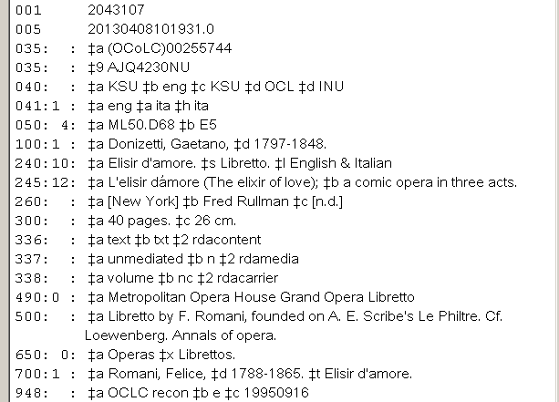

The toolkit was not able automatically to identify the librettist for you. Your initial task is therefore to identify the librettist. If the bibliographic record contains a 700 field for the librettist, carefully click anywhere on that 700 field; when you click on a 700 field, you are telling the toolkit that this 700 field identifies the librettist. (If there is more than one librettist, click on the principal one, or the first one named.) When you identify the librettist in this manner, the toolkit immediately swaps the positions of the 100 and 700 fields, and makes other changes to the record as well. The changes that the toolkit makes depend to some extent on options you have selected.

Here is the above record, as it might appear after the operator has clicked on the 700 field for Romani. Romani has become the 100 field, subfield $t from the 700 field has become subfield $a of the 240 field (they're the same, as they will be most of the time), and the toolkit has constructed a 700 field that identifies a related work: the opera for which this text serves as the libretto. (The toolkit takes the text "Libretto" from the currently-selected item in the list of accompanying text types.) The core of the 700 field consists of the former 100 field and the title from the original 240 field.

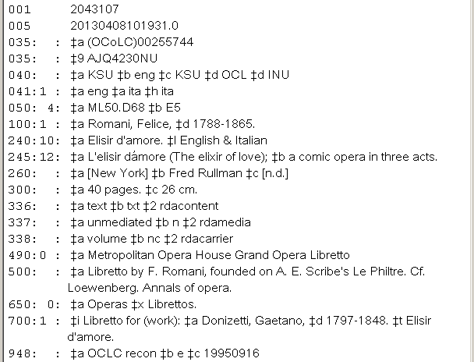

With this single click, the record has been reformulated so that the librettist and composer are in their proper places as specified by RDA.

Because this 240 field represents two separate expressions of the libretto (the original Italian text, and an English translation), the operator is not quite finished with this record. The operator needs to move over to the '$l' tab, click on the 240 field to identify it as being of interest, inspect and adjust the language-based controls on the right side, and finally click the "Carry out these instructions" button to create the 700 fields needed for each expression contained in the item. The next illustration shows how this record appears after the operator has performed these additional operations (on the '$l' tab).

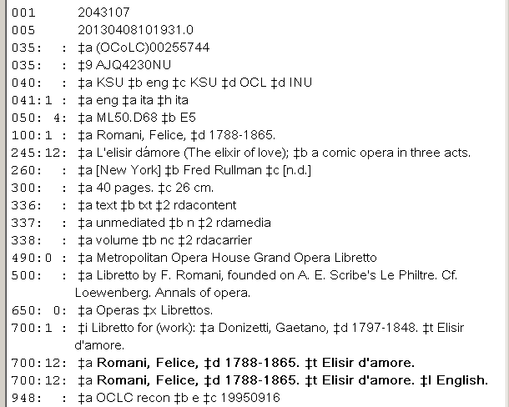

At this point, the operator can decide that the business of making this bibliographic record more RDA-like is complete, and can click the 'Save' button to write all of the changes back to Voyager.

On the '$l' tab, the toolkit shows the 700 field for the original text (the 700 field without subfield $l) in bold, which means that there is no authority record for the libretto by itself. (There is also no authority record for the English translation, so the toolkit shows it in bold, too.) If you wish to create an authority record for the libretto (highly recommended), click the 'Save and BAM' button instead of the plain 'Save' button, and then create the authority record for the libretto (or its translation) from the appropriate line in the BAM report. (Authority records that the toolkit creates for libretti are described elsewhere in this document.)

Depending on options you have set, and also on the content of the record, the toolkit may be able automatically to identify the librettist for you when you click the toolkit's 'libretto' button, and so will have reformulated the record before it shows you the record for the first time. For example, if you have told the toolkit that the text "libretto by" in a 500 field can be used to identify the librettist, the toolkit may have already flipped the record around for you. Your work is then to make sure that this rearrangement is correct, and to perform other operations (such as splitting apart a multi-lingual subfield $l into its individual components, and creating any authority records you might wish to create).

For example, if the option automatically to flip a record containing a 700 field with "lbt" in subfield $4 is selected, when you click the toolkit's 'libretto' button when the cataloging client displays this record:

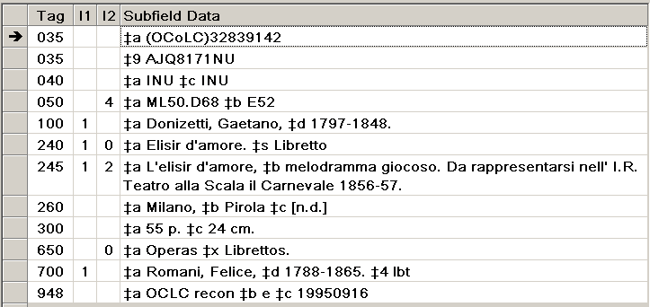

The toolkit will automatically reformulate the record like this:

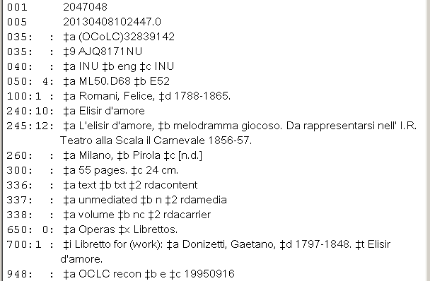

Libretti that accompany sound recordings, and libretti contained within scores

NOTE: The examples in this section assume that the "composer is also the librettist" option is not selected.

The toolkit handles pre-RDA bibliographic records for sound recordings and scores that have a 700 field for the libretto in a similar manner. We'll start with sound recordings (because they're the more common case) and then look briefly at scores.

Pre-RDA bibliographic records for sound recordings that are accompanied by a libretto often have a 700 field for the libretto (naming the composer as the author of the libretto). The actual author of the libretto may or may not be included amongst the 700 fields in the bibliographic record. This common case is the case for which the toolkit can offer the most assistance.

When the Voyager cataloging client shows a bibliographic record for a sound recording, with the composer named in the 100 field and also in a 700 name/title access point for the libretto, click the 'libretto' button. The toolkit will attempt to identify the librettist, and flip the record into an RDA-like configuration.

Example: Starting from a record for a sound recording of Donizetti's Elisir d'amore having these 7XX fields:

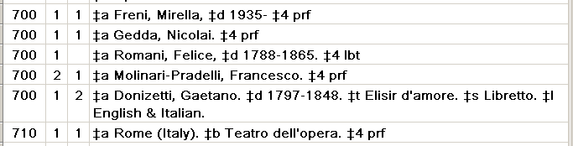

Because a 700 field contains subfield $4 with the text "lbt", the toolkit was able automatically to reconfigure the record in the following manner:

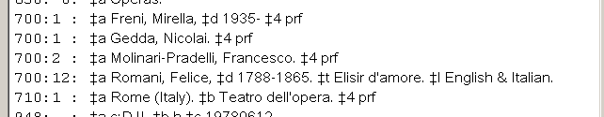

As is often the case, the libretto is in more than one language. The operator should now flip to the '$l' tab to split this single 700 field into two 700 fields, save the record, and create any authority records that may be wanted.
Example: Starting from a record with these 7XX fields:

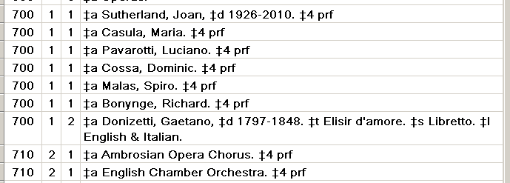

This bibliographic record does not contain a 700 field that identifies the librettist. As it happens, because of work performed earlier for a bibliographic record related to the same opera, the local authority file already contains an authority record for the libretto, with a 400 field for the composer:

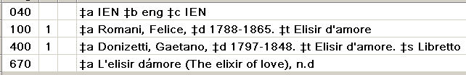

Because of this 400 field in a local authority record, the toolkit is able automatically to identify the librettist and reconfigure the 700 field into a more RDA-like shape:

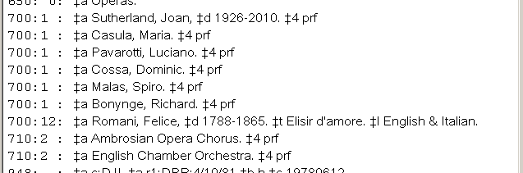

As is often the case, the libretto is in more than one language. The operator should now flip to the '$l' tab to split this single 700 field into two 700 fields and save the record. Because there is already an authority record for the libretto by itself, there is probably no need to create additional authority records.

If the toolkit is not able to identify the librettist on its own, the most likely cause is this: the librettist is not clearly identified in the bibliographic record and there is also no suitable authority record for the libretto in the local authority file. In such a case, the first thing you need to do is to identify the librettist (research is usually required).

Once you have identified the librettist, start from the bibliographic record and click the toolkit's 'libretto' button to display the bibliographic record on the 'libretto' tab of the fancy editing panel. If the local authority file contains an authority record for the librettist (name alone, not a name/title record), call up the authority record for the librettist in the cataloging client, then click the "Cataloging client shows authority record for librettist" button on the 'libretto' tab. The toolkit will use the 100 field from the authority record to reconfigure the bibliographic record.

If the local authority file does not contain an authority record for the librettist, you will need manually to add a 700 field for the librettist to the bibliographic record, with subfield $4 containing "lbt". When you have this, then click the toolkit's 'libretto' button to start the process.

Finishing up the bibliographic record

The toolkit offers a few tools on the libretto tab for the modification of a bibliographic record. (Similar tools are not available on other tabs).

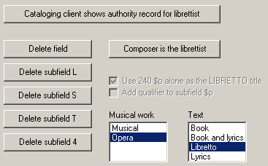

- Cataloging client shows authority record for librettist: In some cases, the bibliographic record that refers to a libretto will not contain any identification of the librettist. If you are able to identify the librettist, and if your local authority file contains a record for that person, call up the authority record in the Voyager cataloging client, then click this button. The re-configured record that the toolkit next shows you will be identical to the record you would see if the bibliographic record had contained a clear identification of the librettist at the outset.
- Delete field: If you click the cursor on a field in the bibliographic record and then click this button, the toolkit will remove the field from the bibliographic record.
- Delete subfield L: If you click the cursor on a field that contains subfield $l and then click this button, the toolkit will remove subfield $l from the field. Many bibliographic records for single-language libretti identify the language of the libretto in subfield $l, even if it is the original language. This subfield $l is not now considered to be appropriate, and should be removed.

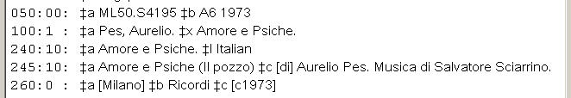

- Delete subfield S: If you click the cursor on a field that contains subfield $s and then click this button, the toolkit will remove subfield $s from the field for you.
- Delete subfield T: If you click the cursor on a name/title 700 field in the bibliographic record and then click this button, the toolkit will remove subfield $t and all following subfields from the 700 field.
- Delete subfield 4: If you click the cursor on a 700 field and then click this button, the toolkit will remove subfield $4 from the 700 field.
- Composer is the librettist: See the separate section that describes the toolkit's handling of bibliographic records for operas for which the composer of an opera is also the librettist.
- Use 240 $p alone as the LIBRETTO title: The value of this check-box is only relevant when the title of an opera contains subfield $p. Although the feature controlled by this option can be applied in any relevant case (such as libretti for Puccini's Il trittico) it was initially defined for use during the handling of records for Wagner's Der Ring des Nibelungen. The use of this check-box is described in the section pertaining to libretti written by the composer.
- Add qualifier to subfield $p: The value of this check-box is only relevant when the title of an opera contains subfield $p. If the toolkit needs to add a type-of-work qualifier to the heading for the opera, it is the case that sometimes the qualifier belongs on subfield $a, and sometimes on subfield $p:
240 10 $a Perfect lives (Opera). $p Lessons
240 10 $a Ring des Nibelungen. $p Rheingold (Opera)
It's too much to ask that the toolkit guess the correct location for the qualifier—instead you get to tell the tookit what to do. If this box is checked, the qualifier goes on subfield $p; if this box is not checked, the qualifier goes on subfield $a.
- Musical work and Text lists: Select in these lists the appropriate terms for the toolkit to use when constructing subfield $i in a 700 field, and when adding parenthetical qualifiers to uniform titles. The values you select here automatically become the default values (until you change them to something else). If you need to define new terms, you must do so on the toolkit's options panel.

The right side of the toolkit's 'libretto' tab also contains a frame that tells you whether or not there is an authority record for what the toolkit believes to be the heading for the libretto by itself (minus any languages or other extensions). If there is no such authority record, you may wish to create one after the bibliographic record is appropriately re-configured. The toolkit shows the access point for the libretto in uppercase, to grab your attention.

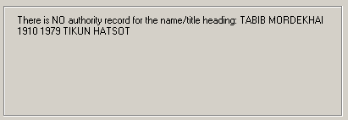

If there already exists an authority record for the libretto, he toolkit shows the libretto's preferred access field in lowercase, so it's less likely to catch your eye. The toolkit shows you subfield $a from each of the 400 fields in the record; this lets you know whether or not the record already contains a 400 field for the composer, and for any collaborators.

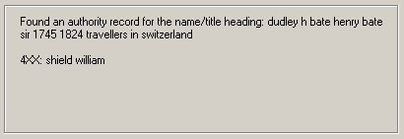

If the bibliographic record represents, or appears to represent, a work for which the composer serves also as librettist, this frame will contain a slightly different kind of information.

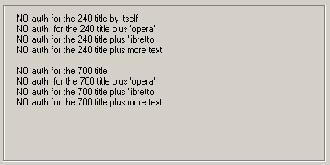

Use for the texts of scores

Bibliographic records for the scores of operas created before RDA can follow the same model as used for sound recordings: there can be a 700 field for the libretto, naming the composer as the author of the libretto. (It appears that this was most often done when the libretto occurs separately in the score, in addition to the words that are set to music. In some cases there is no 700 for the libretto, in which case the matter of the pre-RDA access point for the libretto does not generally come up at all.) The toolkit's handling of libretti associated with scores is quite similar to its handling of libretti for sound recordings; the toolkit doesn't care whether the libretto is in a separate booklet or not.

The following illustration shows a typical bibliographic record for a score, with a 700 for the librettist (without subfield $4), but the librettist is named in a note:

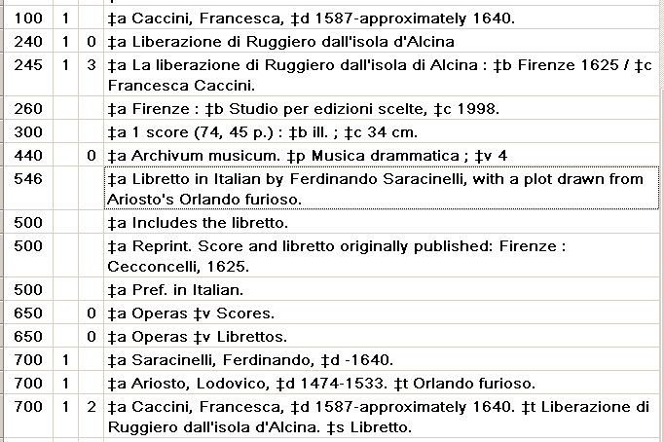

In this case, the toolkit is not able to use the text in the note to identify the librettist, because "in Italian" isn't defined as part of the recognized texts. However, as is the case for separately-published libretti and sound recordings, the operator can click on a 700 field for the librettist (if there is one) and the toolkit will take over. (If the librettist is not named in the bibliographic record at all, the operator can call up the authority record for the librettist, and click the "Cataloging client shows authority record for librettist" button.) In the case of this record, when the operator clicks on the 700 field for the librettist, the toolkit reconfigures the record so that the 700 for the librettist becomes a name/title access field for the libretto, and the 700 for the composer as author of the libretto disappears altogether:

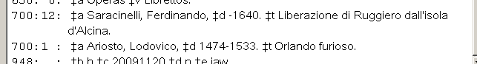

As is always the case, if the resulting access point for the libretto represents more than one language expression, you can finish the field by moving the "$l" tab; and then create any authority record for the libretto that may be wanted.

Authority records for libretti

The authority record for a libretto written by one or more known persons should have in its 1XX field the preferred access point for the libretto itself. There should also be a 400 field for the opera for which the libretto serves as text, with the text "Libretto" in subfield $s. (See RDA 6.27.4.2.)

The following illustration shows a typical authority record for a libretto written by a single person, with a 400 field naming the work for which the libretto serves as text.

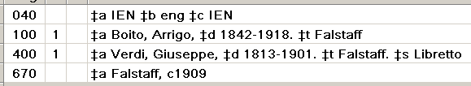

The following illustration shows a typical authority record for a libretto written by two or more people. Librettists other than the primary librettist are named in name/title 400 fields; in individual bibliographic records the joint librettists (if given access points at all) are given simple name access points, not name/title access points. (The same structure is used for the texts of Broadway shows and similar works: the primary author of the book and/or lyrics is identified in a 100 field, and other authors are given in name/title 400 fields.)

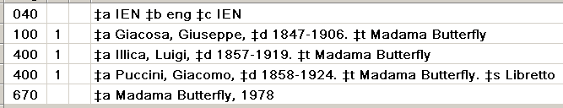

The toolkit contains several features to help you construct authority records for libretti with the least amount of manual intervention.

If the toolkit knows the librettist for a work (either because it was able to figure this out on its own, or because you told it), the toolkit will tell you whether or not there already exists an authority record for the libretto. If there is such an authority record, the toolkit shows you subfield $a from each 4XX field in the record. This latter feature tells you whether or not the authority record appears already to have the proper structure.

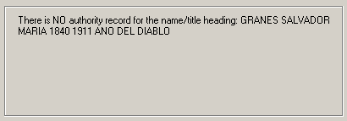

If there is no such authority record for the libretto, and if you wish to create an authority record, first get the bibliographic record into its correct final form, by using the 'libretto' button, the '$l' button, and any other feature of the fancy editing panel that seems appropriate. When the record is as good as it can be, click the 'Save and BAM' button. As is always the case, the BAM report will tell you which access fields have matching authority records, and which do not. Use the BAM report in the usual manner to create an authority record for the libretto by highlighting the access field for the libretto, and then clicking the "Create authority" button.

Example. The access field in the following record for the libretto that accompanies a sound recording originally named the composer; the operator has used the "libretto" button to re-configure the access field, and to create a separate access field for each language expression of the libretto. Because the 700 for the libretto is in bold, the operator knows that there is no authority record for this access point.

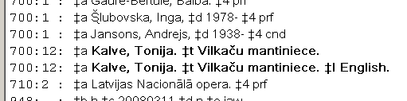

The BAM report again tells the operator that there is no authority record for the libretto by itself.

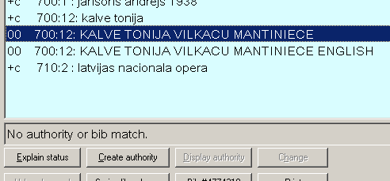

If the operator highlights the line for the libretto and then clicks the "Create authority" button, the toolkit creates an authority record for the libretto, with a 400 field for the libretto as an extension of the access field for the opera:

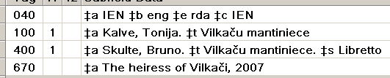

The toolkit is able automatically to create this 400 field most of the time, but not always. The toolkit can create this 400 field in the following circumstances:

- You create an authority record for the libretto of a sound recording or score, and the original 700 field identified the composer rather than the librettist. The toolkit only remembers that the original 700 field named the composer while you're working on this record. If you move to another bibliographic record and then come back to this record, the toolkit will have lost track of this interesting piece of information, and you'll need to construct the 400 field yourself.
- You create an authority record for a separately-published libretto, the bibliographic record contains a 700 field for the related work with the phrase "Libretto for (work):" in subfield $i, and you have selected the option that tells the toolkit to convert work-related 7XX fields into 5XX fields (or 4XX fields, depending on the context) in the authority record. This option is on the 'Get started" sub-tab of the "Authority-related" tab of the BAM options.

When you create the authority record for a libretto, the toolkit will (under your guidance) also create name/title 400 fields for joint authors of the libretto. The toolkit does this by collecting any 700 fields in the record, and allowing you to choose from them.

Example. Here is a pre-RDA bibliographic record for a separately-published libretto:

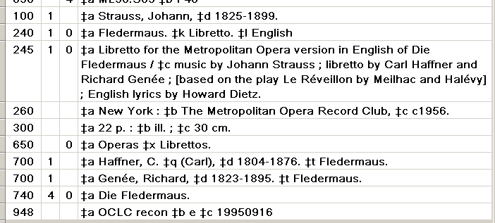

Using the toolkit's 'libretto' button, the operator has modified the record to more closely follow RDA conventions for the access fields:

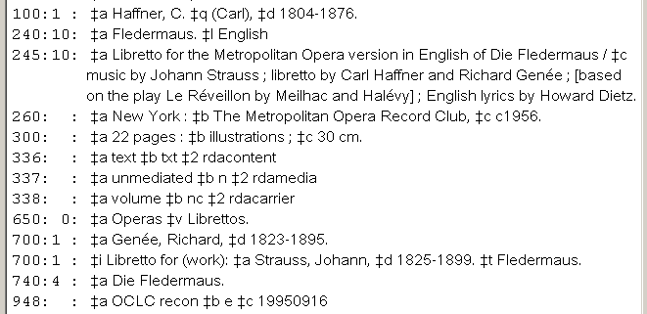

The operator uses the "Save and BAM" button to write the modified record back to Voyager, and to get a BAM report from which to create an authority record for the libretto. The operator highlights the name/title line for the libretto and clicks the "Create authority" button. The toolkit notices that there is a 700 field in the record that is not a name/title field, so the toolkit opens a panel showing the 700 field and presenting the operator with a decision to make.

If any of the names presented is a collaborator on the libretto (as is the case with Genée), the operator highlights the line (or, if there is more than one collaborator, highlights multiple lilnes) and clicks the "Add 4XX" button. If none of the names is a collaborator on the libretto, the operator clicks the "No 4XX" button.

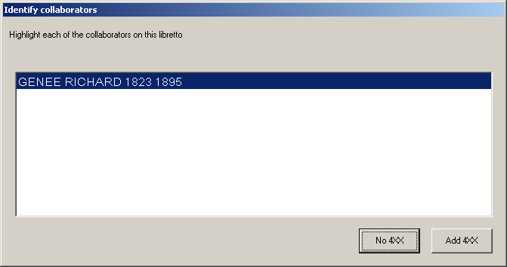

In this case (because the 245 field clearly identifies Genée as a collaborator on the libretto—which can be confirmed by a quick recourse to reference sources if desired) the operator makes sure that the GENEE line is highlighted, and clicks the "Add 4XX" button. The toolkit creates a name/title 400 field for the collaborator, in addition to the standard 400 field for the opera.

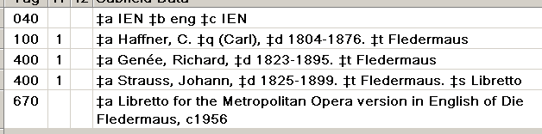

The composer as librettist

Under RDA, the music and the words of a musical work are treated as separate (though related) entities, each of which calls for its own access point. The preceding discussion contains multiple allusions to a complicating factor that can arise with any libretto: the writer of the music may be the same as the author of the text. Additional considerations in the handling of bibliographic records come into play when this condition exists, or appears to exist. The cataloger's toolkit contains a number of features that can help untangle pre-RDA bibliographic records for works for which the composer serves as librettist, but you're going to have to be on your toes to make sure that these records are handled correctly.

The matter of composer as librettist arises most prominently in the case of the operas of Richard Wagner: he wrote the libretti for all of his operas. However, the matter can arise for other opera composers, and for any other kind of musical work with associated text: Jonathan Larson wrote the book, lyrics and music for Tick, tick—boom! and Hector Berlioz wrote the libretto and music for Les Troyens. The toolkit has a hard-coded exception for Richard Wagner (that is, for the one born in 1813), and it contains an option that you can turn on and off for other composers as conditions merit. Because the handling works for which the same person provided both music and text requires extra attention and (except for Wagner) special attention to the toolkit's configuration, you will find it expedient to handle such materials in groups whenever possible. (For example, you will find it expedient to handle everything related to Jonathan Larson's Rent as a discrete group.) Although for purposes of brevity this description will often refer to such works as "operas" and their text as "libretti", it should be understand that the features described here can be used for any work for which the same person provided both music and text.

The toolkit option related to composers as librettists is this check-box:

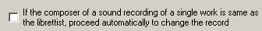

- If this box is checked: When you present the toolkit with a bibliographic record for a sound recording or score containing the same name in the 100 and 700 fields, and if the 700 field has "Libretto" in subfield $s, the toolkit will automatically reconfigure the record following the composer-as-librettist model. This option can safely be selected when you are working on a series of bibliographic records for works (such as Berlioz' Béatrice et Bénédict) for which the same person provided both words and music.
- If this box is not checked (as it should be most of the time): When you present the toolkit with a bibliographic record for a sound recording or score containing a name in the 100 and 700 fields, and the 700 field has "Libretto" in subfield $s, the toolkit will use other clues (such as subfield $4) to identify the librettist; or (if all such attempts fail) wait for you to identify the librettist.

The toolkit assumes that for all sound recordings and scores for works by Richard Wagner (b. 1813) Wagner serves as his own librettist. The value you set for this option has no effect on the toolkit's handling of records for works by Wagner.

The pre-RDA bibliographic record for a separately-published libretto of an opera for which the composer wrote the text can have the same appearance as any other libretto, except that there probably won't be a 700 field for the librettist. (There may of course be 700 fields for editors and/or translators.) Here is a typical example:

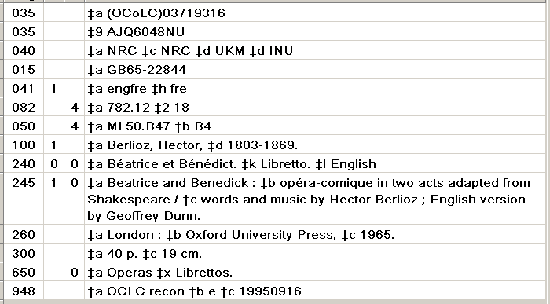

When you display such a record in the cataloging client and click the 'libretto' button, the toolkit won't recognize this as representing any case that it can handle automatically; the toolkit will just show you the record (as enhanced according to your options) and will wait for you to do something:

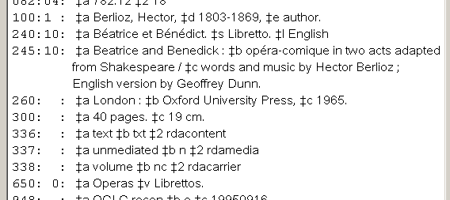

For a work such as this, your proper action is to make sure that the "Musical work" and "Text" lists accurately reflect the kind of material represented by the bibliographic record, and then to click the "Composer is the librettist" button to the right of the record display. The toolkit reformulates the record following the RDA model:

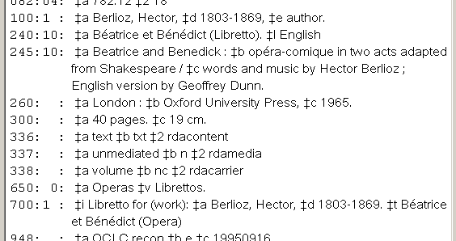

This reformulated record recognizes that the libretto and the opera for which it serves as text are separate (related) entities. Because the basic title of the libretto and the opera are the same, the toolkit has added a qualifier to each, to distinguish them. The texts that the toolkit uses for these two qualifiers are the currently-selected values in the lists of types of musical works and associated texts.

When the composer is also the librettist, the "authority information" frame to the right of the record display shows slightly different information than it does at other times:

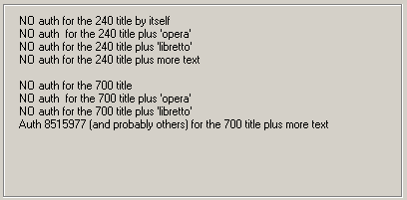

The toolkit has performed several searches (to catch a number of likely permutations), and shows you the results of all of them. In this case, the toolkit is telling you that there is at least one authority record for the basic opera title plus additional text. The toolkit bases this determination on information it finds in a Voyager table. The "more text" referred to may for example be the names of individual selections, as shown in the following illustration:

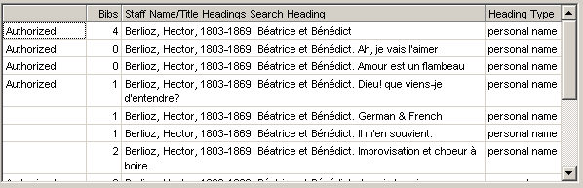

Because access points for this opera under RDA must contain the qualifier "(Opera)" there is often (as here) a lot of cleanup required, both to authority and bibliographic records. The toolkit can help you with the bibliographic records, and the toolkit can create new authority records, but you're going to have to deal with changes to existing authority records on your own.

The "Composer is the librettist" button works in a similar manner when presented with a bibliographic record for a sound recording or score that does not contain an explicit reference to the libretto. In this case, the toolkit adds a qualifier to the uniform title but otherwise leaves the record alone.

For example, when you click the 'libretto' button when the cataloging client displays a record such as the following (there is no 700 field for the text), the toolkit will initially take no action.

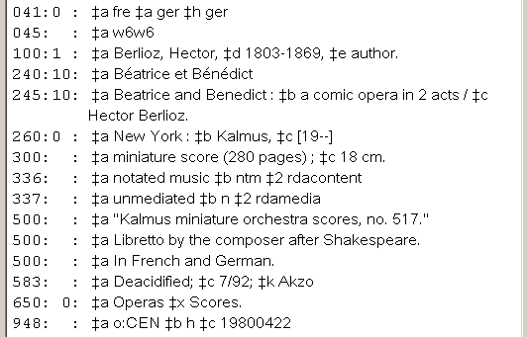

If you click the "Composer is the librettist" button, the toolkit simply adds a qualifier to the 240 field.

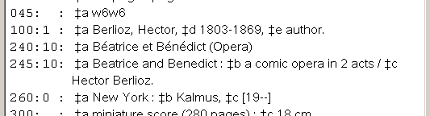

In some cases, the pre-RDA 240 field mashes together information about the musical work and the libretto. For example, the following 240 field tells us both that we have a vocal score, and that the text is present in both German translation and the original French.

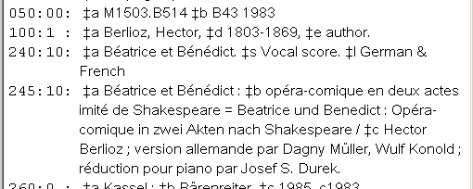

If the 240 field contains subfield $l and if there is not already a 700 field for the libretto, the toolkit will create a 700 field for the libretto, moving subfield $l from the 240 field to the new 700 field. In this case, it remains for the operator to deal with subfield $s in the 240 field, and with subfield $l in the new 700 field.

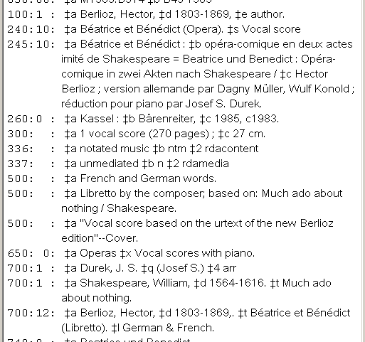

For sound recordings and scores having an existing 700 field for the libretto: if the option telling the toolkit to assume that the composer is librettist is checked, the toolkit will automatically reconfigure, providing separate access points for the music and the words.

Example: If this option is selected, when the toolkit is presented with a bibliographic record containing fields like these:

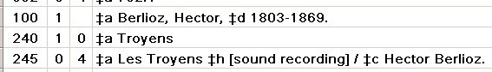

The toolkit will automatically reformulate the record, so that there are separate RDA-like access points for the music and the text:

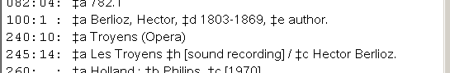

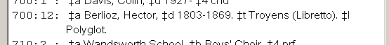

Again, the authority information box shows authority records that match each possible configuration of these access fields, and it is up to you to modify authority records as appropriate.

There is an additional feature added to the toolkit specifically for Wagner's Der Ring des Nibelungen but which can be of use also for Puccini's Il trittico, and other works as appropriate. This feature is based on the fact that the rules for the preferred title of a musical work differ in a fundamental way from the rules for the preferred title of a text. This difference in the selection of title means that additional considerations come into play when dealing with the libretto for a part of a musical work.

To understand the situation, it will be best to work with a specific example. Here is a bibliographic record for the score of Gianni Schicchi, of one of the three operas that comprise Puccini's Il Trittico. Following the rules for musical works, the 240 field in this record shows the full hierarchy: title for the main work followed by title for the part.

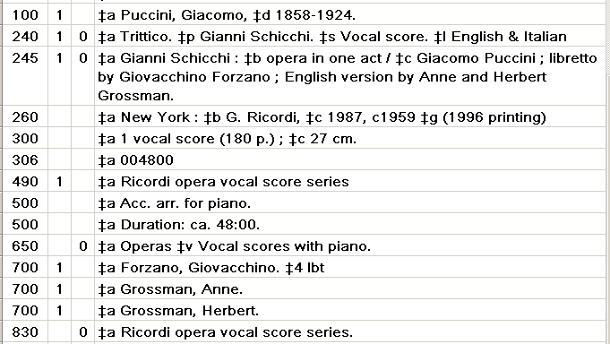

This hierarchy for the title of the musical work needs to be preserved. However, the hierarchy does not apply when we are considering access fields for the libretto. Giovacchino Forzano did not one-third of the libretti for Il trittico, he wrote all of the libretto for Gianni Schicchi. When properly re-configured in RDA fashion, the record should have an appearance something like the following:

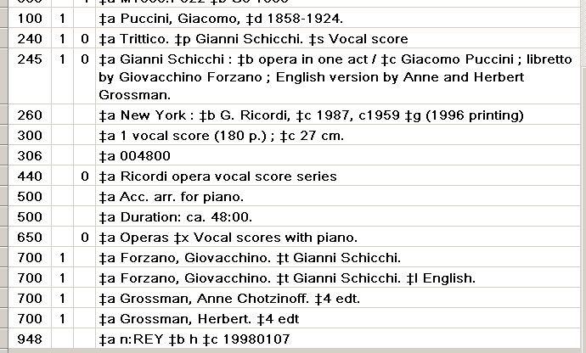
In order to achieve the distinction between the title for the musical work and the title for the libretto, the toolkit's 'libretto' box contains a check-box that is only available when the title of the musical work contains subfield $p:

If this box is checked, when the toolkit constructs the access point for the libretto the title will contain only the title for the individual part (just subfield $p, now in $t), and not the full hierarchy of title for the main work plus the title of the part. If this box is not checked, the toolkit will preserve the full hierarchy in the access point for the libretto. Most of the time, the correct value for this option is 'checked', and you can make sure that it is normally checked by selecting an option listed amongst the options for the libretto button on the toolkit's options panel. This higher-level option sets the default value for the check-box on the libretto tab.

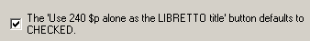
Appendix A: Handling of abbreviations in bibliographic records during BAM

In all cases, the toolkit only examines a bibliographic record for abbreviations if the language of cataloging is English: the bibliographic record must either contain the code "eng" in 040 $b, or it must not contain 040 $b at all.

Unless otherwise noted, the comparisons shown here are case-insensitive. "#" is used in some of the following descriptions to make the presence of a blank space more obvious.

At present, all of the substitutions that the toolkit makes are hard-coded, and are not controlled by information in a configuration file.

245 field

The toolkit only considers portions of the 245 field that are enclosed within brackets. The toolkit makes the following replacements:

- If the text ends "#et#al" or "#et#al." replace the abbreviation with "#and others"
- If the text contains "et#al.", "et.al.", "et#al#.": replace the abbreviation with "and others"
- If the bracketed text is just "et#al" by itself, replace the abbreviation with "and others"

255 field

The toolkit handles each subfield in the 255 field as a separate unit.

Categorical changes:

- Replace "ca.1" with "ca.#1"
- Replace "Scale#l" with "Scale#1" (in the first text, the final character is "el", in the second, the final character is "one")
- Replace "Scale[ca." with "Scale#[ca."

Temporarily remove (but retain for adding back at the end) the terminal punctuation ":", ";", "=" and associated blank spaces. Temporarily remove (but retain for adding back at the end) initial blank spaces.

Handle the remaining subfield text as a series of "words" delimited by spaces. For each word, temporarily remove from each such word (but retain for adding back) the leading punctuation "<", ">", "'", "(", "[", "{", ")", "]", "}", "." , ":" and the trailing punctuation ",", "(", "[", "{", ")", "]", "}", ":", ";", "<", ">", and ")."

If the resulting word contains a full stop, handle it as described in the following table:

Word | Handling
??. | Retain (whatever it means)
conic. | Replace with conic
cm. | Retain as found
determined. | Retain as found
differ. | Retain as found
direction. | Retain as found
given. | Retain as found
indeterminable. | Retain as found
km. | Retain as found
mercator. | Retain as found
meridians. | Retain as found
microfiche. | Retain as found
projection. | Retain as found
scale. | Retain as found
shown. | Retain as found
stereographic. | Retain as found
undetermined. | Retain as found
unknown. | Retain as found
variable. | Retain as found
varies. | Retain as found
vary. | Retain as found
approx. | Replace with "approximately"
ca. | Replace with "approximately"
ed. | Replace with "edition"
lat. | Replace with "latitude"
in. | Retain as found
proj. | Replace with "projection"
proj.. | Replace with "projection"
u.t.m. | Replace with "universal transverse Mercator"

During BAM, the toolkit reports for your consideration any other "word" found in the 255 field that contains a full stop.

260 field, subfield $a

Except as noted, the toolkit only considers portions of 260 $a that are enclosed within brackets. The toolkit makes the following replacements:

- If the entire text of 260 $a is "s.l.#:" (without any brackets at all) the toolkit replaces the subfield with "[Place of publication not identified]#:"
- "s.l.", "n.p.", "s.l#", "s.#l", "n.#p": replace with "Place of publication not identified"
- "s.l]" (with closing bracket but no opening bracket): replace with "Place of publication not identified]"
- "v.p.": replace with "Various places of publication"

260 field, subfield $b

Make the following replacements (the indicated text may either be enclosed within brackets, or may occur at the start of the subfield, without brackets):

- "s.n.", "n.p.": if the next character in the subfield (if any) is not an uppercase letter, replace the text with "Publisher not identified"
- "s.#n.","n.#p.": replace the text with "Publisher not identified"
- "n.p#", "s.n#": replace the text with "Publisher not identified"
- "s.n]": replace the text with "Publisher not identified]"
- "s.n,": replace the text with "Publisher not identified"
- "v.p.": replace the text with "Various publishers"

The toolkit does not attempt to RDA-ize the square brackets in a modified 260 field; the pattern of square bracket usage retains pre-RDA conventions.

Example: The toolkit will convert this 260 field:

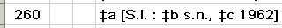

To this:

300 field

The toolkit handles each subfield in the 300 field as a separate unit.

Discard any leading ".", ",", ":" or ";".

Replace each occurrence of the script-l character or the Greek "beta" character with a regular character "el", making sure that each such replacement is followed by a full stop.

Replace "lv." at the beginning of the subfield with "1 v." (in the first text, the initial character is the alphabetic character "el"; in the second, it is the numeral "one").

Consider the following possibilities for the whole subfield:
- "n.#p.", "n.p.", "p.#n.#ch.": replace with "1 volume (unpaged)"
- "var.#paged.": replace with "1 volume (various pagings)."
- "var.#paged.#:" replace with "1 volume (various pagings)#:"
- "bd.": replace with "volumes"
- "2 lea.", "3 lea.", "4 lea.": replace with "2 leaves", "3 leaves" or "4 leaves", respectively

Categorical changes (order is important):
- Replace "1 p. lea." with "1 plain leaf"
- Replace "2 p. lea." with "2 plain leaves"
- Replace "3 p. lea." with "3 plain leaves"
- Replace "4 p. lea." with "4 plain leaves"
- Replace "5 p. lea." with "5 plain leaves"
- Replace "6 p. lea." with "6 plain leaves"
- Replace "#Á." with "#l."
- Replace "1#p.l." and "1#p.#l." with "1 plain leaf"
- Replace "p.#l." with "plain leaves"
- Replace "i.#e.", "i.e.", "#ie.", "i.#e#", "i.e#" with "that is,#"
- Replace "[ie." with "[that is,#"
- Replace "#b&w.", "b.#&#w.", "b.#&w.", "b.&w.", "b&w.", "b&w" with "black and white"
- Replace "h.t.-", "h.-t." with "hors-texte"
- Replace "fac.-sim." with "facsimile"

Insert missing spaces at appropriate points:
- Between any numeral and a following alphabetic character
- Between a closing parenthesis or square bracket and a following alphabetic character
- After any full stop, unless it is followed by a closing parenthesis
- After any semicolon or colon
- Before any opening parenthesis

Remove, but retain for future re-addition, terminal colon, semicolon, equals sign or space.

Divide the subfield text into phrases at each comma. Remove from each phrase (but retain for future re-addition) one trailing or leading space. (Discard any additional leading or trailing spaces.) Divide each phrase into words at each space. Remove from each word (but retain for future re-addition) leading and trailing punctuation, as described for the 255 field.

If the resulting word contains a full stop, handle it as described in the following table:

Word | Handling
abb., cartes., coul., couv., darst., farb., graf., il., ilustr., kolor., kt. | These appear to be abbreviations of non-English words; retain as given.
album., all., analog., annual., arms., atlas., box., boxes., broadsheet., broadside., broadsides., card., cards., case., cartoons., cassette., chart., charts., chiefly., cd-rom., cd-roms., color., columns., container., cover., digital., disc., discs., file., files., filmstrip., filmstrips., folded., folder., folders., foliations., folio., form., format., forms., graph., graphs., group., groups., html., information., inserted., items., jpeg., km., leaf., leaves., looseleaf., loose-leaf., map., maps.,. microfiches., microgroove., monthly., multigraphed., music., of., pages., paginations., paging., pagings., pamphlet., pamphlets., parts., pdf., photographs., pieces., plan., plans., plate., pocket., portfolio., portfolios., postcard., postcards., poster., posters., profiles., reel., reels., reproductions., score., scores., script., semimonthly., sheet., sheets., sketches., slides., some., table., tables., tape., text., unnumbered., unpaged., weekly., wrapper. | Remove the trailing full stop
add., addtl. | Replace with "additional"
adv. | Replace with "advertisement"
ads., advt., advts., advertisms. | Replace with "advertisements"
app., approx. | Replace with "approximately"
autog. | Replace with "autographs"
bibl. | Replace with "bibliography"
bill., cill. | If preceded by a number whose value is 1, replace with "illustration", else replace with "illustrations"
ca. | Replace with "approximately"
cds. | Replace with "cards"
chromolith. | Replace with "chromolithographic"
chron., chronol. | Replace with "chronological"
cm., mm., rpm. | Retain
col., cold., col'd., coll. | Replace with "color"
col)., col.). | Replace with "color)"
cols. | In subfield $a, replace with "columns"; else replace with "colors"
colums. | Replace with "columns"
contin. | Replace with "continuously"
cu. | Replace with "cubic"
diag., diagr., daigr., diagram., diar. | If preceded by a number whose value is greater than 1, replace with "diagrams"; else replace with "diagram"
diagrs., diags., daigrs., dairs., diagrams., diagrams., digrs., diars. | Replace with "diagrams"
ea. | Replace with "each"
engr. | Replace with "engraved"
err., errata. | Replace with "errata"
facsim., facism., fascism., fascim., fascism., fasim., fac-sim., facsm., fascism., facim., fac., facisim., facsi., faxsim., fracsim. | If preceded by a number whose value is greater than 1, replace with "facsimiles"; else replace with "facsimile"
facsims., facs., fasims., fascism., facims., facisms., fascisms. | Replace with "facsimiles"
fasc. | In subfield $a, if preceded by a number whose value is greater than 1, replace with "fascicules" else with "fascicule"; in subfield $b, replace with "facsimile" or "facsimiles" as above.
fig. | Replace with "figure"
figs. | Replace with "figures"
fol., fold., folds., fols., folde., fldg. | Replace with "folded"
fold.; | Replace with "folded;"
fr. | If preceded by a number whose value is 1, replace with "frame", else with "frames"
front., frontis., fron. | Replace with "frontispiece"
fronts., frontp., frons. | Replace with "frontispieces"
ft. | If preceded by a number whose value is 1, replace with "foot", else with "feet"
geneal., geneol, general. | Replace with "genealogical"
geol. | Replace with "geological"
gloss. | Replace with "glossary"
hr. | Retain.
hrs. | Replace with "hr."
ill., illus., ilus., ill.., illi., ills., illus., illustr., iilus., illis., illu. | If preceded by a number whose value is 1, replace with "illustration", else with "illustrations"
illum. | Replace with "illumination"
illustrations., illustrs. | Replace with "illustrations"
in1. | Replace with "in 1"
incl., inc., inclu., inclc. | Replace with "including"
insert. | Replace with "insert"
irreg. | Replace with "irregular"
l. | If preceded by a number whose value is 1, replace with "leaf"; else with "leaves"
micro., microgroove. | Replace with "microgroove"
mimeo. | Replace with "mimeographed"
min. | Retain.
mins. | Replace with "min."
misc. | Replace with "miscellaneous"
mono., monophonic. | Replace with "mono"
mount. | Replace with "mounted"
ms. | Replace with "manuscript"
multigr. | Replace with "multigraphed"
music., mus. | Replace with "music"
no. | If preceded by a number whose value is 1, replace with "number", else with "numbers"
nos. | Replace with "numbers"
num., numb., number. | Replace with "numbered"
obl. | Replace with "oblong"
p. | If preceded by a number whose value is greater than 1, replace with "pages", else with "page"
pag., pgs. | Replace with "pagings"
pam. | If preceded by a number whose value is 1, replace with "pamphlet", else with "pamphlets"
pams. | Replace with "pamphlets"
part., par. | Replace with "partly"
partfold. | Replace with "partly folded"
phot., photo., photogr. | If preceded by a number whose value is greater than 1, replace with "photographs", else with "photograph"
photos., photogs., phots., phtos., photographs. | Replace with "photographs"
pl., plate. | If preceded by a number whose value is 1, replace with "plate", else with "plates"
port., por., portr., portrait. | Replace with "portrait"
portfolio. | Replace with "portfolio"
ports., pots., portrs. | Replace with "portraits"
pp. | Replace with "pages"
prelim. | Replace with "preliminary"
pt. | In subfield $a, if preceded by a number whose value is 1, replace with "part", else with "parts"; in other subfields, replace with "partially"
pts. | Replace with "parts"
quad. | Replace with "quadraphonic"
ref. | Replace with "reference"
script-l. | If preceded by a number whose value is 1, replace with "leaf", else with "leaves"
s. | If this is lowercase "s.": if preceded by a number whose value is 1, replace with "side", else with "sides"; if this is uppercase "S.", treat as unrecognized
sd. | Replace with "sound"
sec. | Retain.
sect. | If preceded by a number whose value is 1, replace with "section", else with "sections"
ser. | Replace with "series"
si., sil. | Replace with "silent"
stats. | Replace with "statistics"
statis. | Replace with "statistical"
stereo., stereophonic., stereos. | Replace with "stereo"
sup., supp., suppl. | Replace with "supplement"
tab., table. | Replace with "table"
tabs., tables., tables. | Replace with "tables"
typog. | Replace with "typographical"
unnumb. | Replace with "unnumbered"
unp. | Replace with "unpaged"
v., vol. | If preceded by a number whose value is 1, replace with "volume", else with "volumes"
var. | Replace with "various"
vols. | Replace with "volumes"

If the fragment ends "p." and is immediately preceded (without a space) by what appears to be a roman numeral, insert a space before the "p." (then handle the "p." as instructed above).

If the word contains a full stop and its handling is not described above, consider it to be unrecognized.

5XX fields

At present, the toolkit only considers abbreviations in the 504 field.

Replace "p." with "pages" if it is preceded by a number whose value is greater than 1, or is followed by a number whose value is greater than 1 or any range of pages (including a range beginning with 1); replace "p." with "page" in other contexts.
Appendix B: Generate 336-338 fields during BAM

If so instructed, the toolkit will add one 336 field, one 337 field, and/or one 338 field to a bibliographic record that does not already contain a field of the same tag.

336 field

The 336 field generated by the toolkit directly reflects the value of position 6 (record type) of the bibliographic record's leader.

Leader/06 value | Handling
a, t | If the record represents a Braille item, use "tactile text"; else use "text"
c, d | If the record represents a Braille item, use "tactile notated music"; else use "notated music"
e, f | If the record represents a Braille item: if the record contains an 007 field beginning "aa", use "cartographic tactile three-dimensional form", else use "cartographic tactile image." If the record does not represent a Braille item: if the record contains an 007 field beginning "aa", use "cartographic three-dimensional form", else use "cartographic image"
g, k | If the record represents a Braille item, use "tactile image". If the record does not represent a Braille item but represents a moving-image item, use "two-dimensional moving image", else use "still image"
i | If the record contains an 006 field with 'm' in byte 00 and 'h' in byte 09, use "sounds", else use "spoken word"
j | Use "performed music"
m | If 008/26 is "b", use "computer program", else use "computer dataset"
o, p | Use "other"
r | If the record represents a Braille item, use "tactile three-dimensional form"; else use "three-dimensional form"
all others | Use "unspecified"

337 field

The toolkit considers the following record elements, in this order, when constructing the 337 field.

245 $h (if present).

245 $h | Use
computer file | computer
electronic resource | computer
filmstrip | projected
microform | microform
microscope slide | microscopic
motion picture | projected
slide | projected
sound recording | audio
transparency | projected
videorecording | projected

Byte 00 in the first 007 field contained in the record (if any).

007/00 | Use
c | computer
g, m | projected
h | microform
k, t | unmediated
s | audio
v | video
z | unspecified

Leader/06.

Leader/06 | Use
a, c, d, e, f, k, r, t | unmediated
g | projected
i, j | audio
m | computer
o, p | unspecified
all others | unspecified

338 field

The toolkit considers the following record elements, in this order, when constructing the 338 field.

245 $h (if present).

245 $h | Use
activity card | card
filmstrip | filmstrip
flash card | card

Bytes 00-01 in the first 007 field contained in the record (if any).

007/00-01 | Use
ca | computer tape cartridge
cb | computer chip cartridge
cc, ce | computer disc cartridge
cd, cj, cm, co | computer disc
cf | computer tape cassette
ch | computer tape reel
ck | computer card
cr | online resource
c+anything else | other computer character
gc | filmstrip cartridge
gd | filmslip
gf, go | filmstrip
gs | slide
gt | overhead transparency
ha | aperture card
hb | microfilm cartridge
hc | microfilm cassette
hd | microfilm reel
he | microfiche
hf | microfiche cassette
hg | microopaque
hh | microfilm slip
hj | microfilm roll
h+anything else | other microform carrier
mc | film cartridge
mf | film cassette
mo | film roll
mr | film reel
m+anything else | other projected carrier
sd | audio disc
se | audio cylinder
sg | audio cartridge
si | sound track reel
sq | audio roll
ss | audio cassette
st | audiotape reel
s+anything else | other audio carrier
vc | video cartridge
vd | videodisc
vf | videocassette
vr | videotape reel
v+anything else | other video carrier

Leader/06.

Leader/06 | Use
r | object

Additional values in 245 $h (if present).

245 $h | Use
microform | other microform carrier
microscope slide | microscope slide
slide | slide
sound recording | other audio carrier
videorecording | other video carrier

If leader/06 is "a" or "t" and the record contains a 300 field with subfield $a:

300 $a contains | Use
p., page, leaves | volume
v., volume | volume
broadside, sheet | sheet

If none of the above leads to a 338 field, the toolkit will not construct a 338 field at all.
Appendix C: Configuration files for romanization and capitalization

A suite of configuration files controls the behavior of the romanization and capitalization tabs of the toolkit's general editing panel.

These configuration files are text files, and take the general form of INI files, though they occasionally vary from the usual INI file format.

These configuration files reside in the same folder as the toolkit's other configuration files.

A configuration file to control other configuration files

The file RomanizationMaster.cfg is a central point that lists the other files of interest. This file got its name when there was only a need to list configuration files for the romanization feature, but it now also lists configuration files for the title-case feature on the capitalization tab.

There are two stanzas in this file. Each stanza lists configuration files of one type. Each file is listed starting with number 1. The two stanzas are:

- Files: This lists the configuration files for the romanization tab
- TitleCaseFiles: This stanza lists the configuration files for the title-case feature on the capitalization tab

Here is a typical example of this file. This file defines twelve romanization configuration files, and two title-case configuration files.

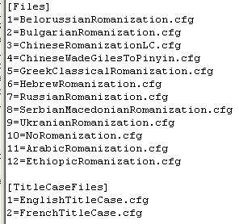

The toolkit expects to find files with the names listed here in the same folder as this the RomanizationMaster.cfg file.

Configuration files for the romanization feature

The contents of these files are contained in a separate document, ConfigurationFilesForRomanization.doc. Although this document is now several years old, it still accurately describes the content of these files.

Configuration files for the title case feature

Each file contains two stanzas. Although this file has the general appearance of an INI file, the toolkit actually reads it serially, from first line to last.

- The "Language" stanza identifies the language covered by the file. The "Name" element is a displayable name for the language; the toolkit uses the "Name" in its drop-down list of choices on the editing panel. The "Code" element is the MARC 3-character code for the language.
- The "TitleCaseWords" stanza lists all of the words that should not be given with an initial uppercase character when the toolkit is applying title-case rules to a string of text.

The next illustration shows the first part of a title-case configuration file for English. This file contains instructions for the information given in the TitleCaseWords stanza.

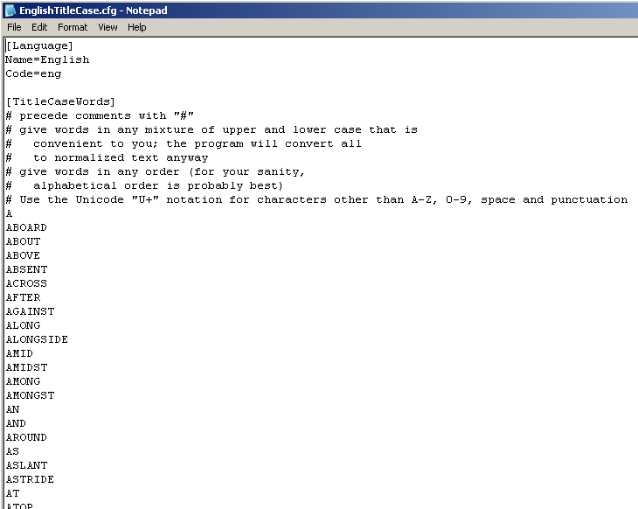
Appendix D: Parsing the 502 field

This appendix describes the method the toolkit uses to parse a 502 field consisting of just subfield $a into a 502 field that contains subfields $b, $c and $d. There are additions to this method that the toolkit applies if the 502 field contains the string "Northwestern University"; these additions are described at the end of this appendix.

Exclusion rules:

- If the 502 field contains subfield $b, $c or $d, if the 502 field begins with any subfield other than $a, or if the 502 field contains any subfields after subfield $a, the toolkit does nothing with the 502 field.
- If the 502 field contains the text "based on" or "originally", the toolkit does nothing with the 502 field.
- The 502 field must contain punctuation that clearly separates the degree and other information from the institution and year. This punctuation may be either a pair of hyphens, or a space-hyphen-space. If the 502 field contains neither of these markers, the toolkit does nothing with the 502 field.

Initial split: degree information, and institution/date

The toolkit splits the 502 field into two work areas: the "left" area (assumed to contain degree information and perhaps other information) and the "right" area (assumed to contain the institution name and a date).

Examination of the degree information

If the left work area does not contain an opening parenthesis and a closing parenthesis, the toolkit does nothing with the 502 field. If the closing parenthesis appears in the left work area to the left of the opening parenthesis, the toolkit does nothing with the 502 field.

The text in the left work area, to the left of the opening parenthesis, must be one of the following "dissertation types" (normalized comparison):
- diss
- dissertation
- doctoral project
- honors thesis
- inaug diss
- inaugural dissertation
- proefschrift
- proefskrift
- senior thesis
- tesis
- the authors thesis
- these
- these complementaire
- these de doctorat detat
- thesis
- thesise

If the text before the opening parenthesis is none of these, the toolkit does nothing with the 502 field.

The toolkit uses the text within parentheses in the left work area as the degree name. If the extracted degree name begins with a numeral, the tookit does nothing with the 502 field.

Examination of the institution/date information

The right work area must contain at least one comma; the toolkit is interested in the rightmost comma. If the right work area does not contain a comma but ends with text enclosed in square brackets, the toolkit acts as if the square brackets were preceded by a comma. The toolkit examines the text to the right of this comma. If the text to the right of the comma is a recognizable date, the toolkit uses the text to the right of the comma as the date in the new 502 field, and the text to the left of the comma as the institution name in the new 502 field. If the text to the right of the comma is not a recognizable date, the toolkit uses date 1 from the 008 field (bytes 07-10) as the date, and uses the entire text of the right work area as the institution name.

Finished 502 field

If the toolkit has been successful in its effort to parse the 502 field into degree name, institution and date, the toolkit replaces the existing 502 field with a new one, containing subfields $b, $c and $d.

Additions and exceptions for 502 fields for Northwestern University dissertations:

- The toolkit recognizes the following additional markers to indicate the dividing point in the note between the degree information and the degree information:
- "),#Northwes" (closing parenthesis, comma, space, "Northwes")
- ")-#" (closing parenthesis, hyphen, space)
Failing this, if the 502 field begins "Thesis (MBA), North", the toolkit acts as if the comma following the closing parenthesis is a double hyphen.
- If the left work area does not contain an opening parenthesis but consists of a recognized degree name (as described above), the toolkit continues with that degree name.
- If the left work area contains an opening parenthesis but not a closing parenthesis, and the right work area contains the text "),#Northwest", the toolkit adds a portion of the right work area to the left work area. This allows the toolkit successfully to parse the large number of 502 fields in this form:
Essay (BA – Economics candidate), Northwestern University, 1911.
- The toolkit recognizes the following additional texts as dissertation types: "project", "res proj", "research project"; the toolkit uses the text within the parentheses as the degree type. If the degree type is "res proj d mus", "res proj d music" or "res proj d" the toolkit uses "D. Mus." as the degree type. Failing this, if the entire left area of the 502 field is a recognized degree type, the toolkit uses that. If the toolkit been able to find a degree type in the left work area for the 502 field, it continues with the examination of the right work area.
- If the left work area contains a comma following the degree name (probably the name of the granting school or department), the toolkit extracts this as "miscellaneous" information, and uses it as subfield $g in the new 502 field.

The toolkit considers the following to be recognized degree names (normalized comparison):
- d mus
- d music
- ed d
- m music
- ph d

If the putative degree name is none of these but if the normalized form of the degree name consists of an odd number of characters, all of the characters must be alphabetic, and (in their normalized form) must be separated by spaces. (This means that the toolkit will recognize "M.A.", "B.F.A." and similar constructions as degree names, without having to list them all.)
Appendix E: Additional configuration for multi-lingual subfield $l

The LanguagesByCodeSubfieldL stanza in the codes.cfg configuration file gives the toolkit additional information about languages whose names may appear in subfield $l in a form different from that given in other parts of the toolkit's configuration. This stanza was designed initially for languages that exist in both modern and earlier forms, but it may be of use in other situations.

[LanguagesByCodeSubfieldL]
#stanza added 20130323, to support work with pre-RDA subfield $l
ang=English (Old English)
dum=Dutch (Middle Dutch)
enm=English (Middle English)
frm=French (Middle French)
fro=French (Old French)
gmh=German (Middle High German)
goh=German (Old High German)
grc=Greek (Classical Greek)
gre=Greek (Modern Greek)
mga=Irish (Middle Irish)
peo=Persian (Old Persian)
sga=Irish (Old Irish)
Appendix F: Additional configuration for classical and modern Greek authors

When working with the '$l' button, the toolkit will occasionally ask if a particular author originally wrote in classical Greek (the alternative being modern Greek), or if a particular work (not associated with an author) was originally written in classical Greek (or modern Greek). The toolkit stores your answers in a configuration file, which you can also modify if you wish.

The configuration file is called ClassicalGreekAuthorsAndWorks.cfg, and contains two stanzas:
- The "Authors" stanza lists authors and their associated language code
- The "Titles" stanza lists titles of works, and their associated language code

The structure of the two stanzas is identical. Each line begins with the identification of an author (all subfields from the author's name) or work (just subfield $a), in normalized form, and with spaces replaced with an underscore. This is followed by an equals sign, and the corresponding language code.

If you incorrectly answer the toolkit's question, so that the toolkit assigns the wrong language code to a person or work, close the toolkit, edit the file to contain the correct code, start the toolkit again and continue with your work.

Here is a sample of lines from a typical file:

[Authors]
ARISTOTLE=grc
ARISTOPHANES=grc
ARATUS_SOLENSIS=grc
PLATO=grc
PINDAR=grc
HERACLITUS_OF_EPHESUS=grc
CLEMENT_I_POPE=grc
THUCYDIDES=grc
HIPPOCRATES=grc
STRABO=grc
CASSIUS_DIO_COCCEIANUS=grc
LONGINUS=grc
THEOGNIS=grc
THEOCRITUS=grc
DIONYSIUS_PERIEGETES=grc
MENANDER_OF_ATHENS=grc
EURIPIDES=grc
SALLUSTIUS=grc
ARRIAN=grc
OPPIAN_OF_APAMEA=grc
HERODIAN=grc
AGATHARCHIDES=grc
LYSIAS=grc
AESCHINES=grc

[Titles]
DE_MELISSO_XENOPHANE_GORGIA=grc
PROBLEMATA_PHYSICA=grc
GREEK_ANTHOLOGY=grc
Appendix G: Changes made to a bibliographic record before the toolkit displays a record

When you start with a bibliographic record and click any button that leads to the fancy editing panel, the toolkit does a number of things to the bibliographic record.

- If the record contains a 243 field, the toolkit re-tags the 243 field as a 240 field. (This is controlled by an option.)
- If 240 $a contains "Selections" or subfield $t of a name/title heading contains "Selections", the toolkit adds "Works" and moves the former subfield to subfield $k.
- If the 240 field contains "Libretto.#" (note the space) with stuff following, insert subfield code $l. If the 240 field contains ".#Libretto" (again, note the space), insert subfield code $k.
- If the 240 field contains subfield $f, delete it.
- If the 240 field contains "Libretto" in subfield $k or $p, re-code it as subfield $s.
- If the 240 field contains subfield $h, remove it; but add it to the 245 field if the 245 field doesn't have subfield $h.
- If at any point the modified 240 field is the same as subfields $a, $n and $p of the 245 field, delete the 240 field.
- If any 7XX field contains "Selections" in subfield $t, re-code that subfield as $k, and precede with "Works" in subfield $t.
- If any 7XX contains "Libretto" in subfield $k, $l or $p, re-code the subfield as $s.
- If any subfield of the 041 field contains more than one code, create separate subfields.
- If any $l subfield contains "#and#" (note the spaces), replace with "&".

After all this, the toolkit sends each bibliographic record through the validation portion of BAM processing. The toolkit may make additional changes, depending on the configuration you have defined for the BAM button.
Appendix H: Configuration files for RDA

The toolkit uses a set of configuration files (originally designed for a separate RDA conversion program) to direct some parts of the manipulation of headings into a more RDA-like form. These files, which are available at the toolkit's download site, are plain text files; most of these can be modified to suit local needs.

Only the RdaSubfieldCConfig.Parels.AllTypes.txt file is used by the toolkit in its handling of bibliographic records. Unless a future version of the toolkit makes RDA-related changes to authority records, the toolkit will not actually draw on the other files described here. However, for the sake of completeness (and probably to make the DLL that handles the RDA conversions happy), you should place all of these files in the toolkit's configuration folder. If a later version of the toolkit offers the option of making similar changes to authority records, these files will suddenly become important.

ConferenceWords.txt

This file lists each term that might be found in subfield $b of a corporate heading (tag group X10, first indicator not "1") that means, or might possibly mean, something conference-y in some fashion. The initial list was generated by finding every distinct subfield $b text in candidate authority records that was followed immediately by conference-specific subfields ($n, $d or $c). The configuration file consists of one line per term; a term may consist of as many words as it needs to contain.

RdaSubfieldCConfig.NoParensForename.txt
RdaSubfieldCConfig.NoParensAllTypes.txt
RdaSubfieldCConfig.ParensAllTypes.txt

These three files define texts used in subfield $c of personal names that have been deemed acceptable for use under RDA. Each file contains subfield $c texts, one per line. The three files define subfield $c texts that are appropriate in various contexts.

- NoParensForename: These subfield $c texts are valid in names that begin with a forename, and are not to be enclosed within parentheses
- NoParensAllTypes: These subfield $c texts are valid in names that begin either with a forename or surname, and are not to be enclosed within parentheses
- ParensAllTypes: These subfield $c texts are valid in names that begin either with a forename or surname, and are to be enclosed within parentheses

RdaConversion.Rda7xxExtendedHeadingConsideration.txt

This file was created during 'phase 1' of the RDA conversion. The contents of this file provide important information during phase 2. This file has a peculiar format; you should not attempt to modify this file.
Appendix I: Generate 368 field during authority creation or BAM

The general scheme

The authority 368 field contains a miscellaneous collection of attributes of persons and corporate bodies; these are best thought of as things that must according to RDA be recorded, but which found no more logical place in the MARC authority format.

$a Type of corporate body
$b Type of jurisdiction
$c Other designation
$d Title of person

The information needed in the 368 field is often present somewhere in the authority 1XX field'; so as is often the case the automatic construction of the 368 field becomes a matter of recognizing the relevant bit of text, perhaps manipulating it, and copying it into the appropriate MARC pigeonhole. Here is an outline of the scheme that the cataloger's toolkit uses for creating the 368 field. The toolkit uses this scheme for new authority records, and for authority records submitted to the BAM button:

- If the authority record contains a 100 field, the last subfield in the 100 field must be $a, $b, $c, $d or $q; otherwise, the toolkit does not attempt to build a 368 field. Further, the 100 field must contain subfield $c; otherwise, the toolkit won't attempt to create a 368 field. This is a "personal" heading.
- If the authority record contains a 110 field: If the last subfield is $n, $d or $c, the field must also contain subfield $b; a 110 field with $n, $d and/or $c but not $b is of no interest. (If the last subfield is $n, $d or $c, the toolkit considers this a "conference" heading even though the tag is 110.) If the last subfield in the 110 field is anything other than $a, $b, $n, $d or $c the toolkit does not attempt to create a 368 field. The toolkit is interested in the last subfield $b if present, otherwise (if $b is not present) the toolkit is interested in subfield $a. If the 110 does not represent a conference heading (because $n, $d or $c is present), it is a "corporate" heading.
- If the authority record contains a 111 field: If the last subfield is $n, $d or $c, the field must also contain subfield $e, otherwise a 111 field with $n, $d and/or $c is of no interest. If the last subfield in the 111 field is anything other than $a, $e, $n, $d or $c, the toolkit does not attempt to create a 368 field. The toolkit is interested in the last subfield $e if present, otherwise (if $e is not present) in subfield $a. All 111 fields represent "conference" headings.
- If the authority record contains a 151 field, the 151 field must contain no subfields other than $a. The toolkit is interested only in the 151 subfield $a. The toolkit considers this a "geographic" heading.
- If the authority 1XX field has any other tag, the toolkit does not attempt to generate a 368 field.

If the authority record represents a personal name, the toolkit examines the subfield $c text for "spirit" and "saint", and also examines the subfield $c text for a recognizable title. If 100 $c contains "spirit" the toolkit creates a 368 field "$c Spirits $2 lcsh". If the 100 $c contains "saint" the toolkit creates a 368 field "$c Saints $2 lcsh". If the 100 $c contains a recognizable title and if the option to create 368 $d is turned on, the toolkit creates a 368 field with the personal title in subfield $d.

If the authority 1XX field represents a corporate body, conference or geographic name, the subfield of interest must contain a parenthetical qualifier; if the subfield does not contain a parenthetical qualifier, the toolkit does not attempt a 368 field. The toolkit compares the normalized form of each colon-delimited segment in the qualifier against a list of type-of-jurisdiction terms, and a list of type-of-corporate body terms. (More on this list in a moment.) If the toolkit finds a term from the qualifier in one of these lists, the toolkit creates a 368 field with subfield $a (type of jurisdiction) or subfield $b (type of corporate body). Depending on the manner in which the toolkit is working, the 368 field may also contain subfield $2. If the toolkit does not create a 368 field based on the qualifier, and if the heading is a geographic name, the toolkit may be able to recognize a type-of-jurisdiction term in the portion of the heading to the left of the parenthetical qualifier. Finally, if the toolkit is not able to create a 368 field for a conference name based on the qualifier, the toolkit creates a 368 field "$a Congresses and conventions $2 lcsh".

Made-up examples (assuming the proper configuration is available):
151 ## $a Smithville (Ill. : Stadtkreis)
368 ## $b Stadtkreis

151 ## $a Smith (Ill. : Parish)
368 ## $b Parishes $2 lcsh

110 2# $a Smiths (Cricket team)
368 ## $a Cricket team

111 2# $a Smiths On Parade (Beauty pageant)
368 ## $a Beauty contests $2 lcsh

100 1# $a Smith, Knucklehead, $c Earl of Smithville
368 ## $d Earl of Smithville

How does the toolkit identify terms for type of jurisdiction and type of corporate body?

The original attempt at the creation of the 368 field involved a list of suitable terms that was hard-coded into the toolkit program itself. This worked well enough, but it made it difficult for others to adjust the terms to suit their needs. The original scheme was quickly supplemented by a second scheme, which involves a new configuration file: if the configuration file is present, the toolkit uses information in the configuration file to identify suitable bits of text in the parenthetical qualifier; if the configuration file is not present, the toolkit uses its original hard-coded scheme instead.

The configuration file for type of jurisdiction and type of corporate body terms is called RdaOtherAttributes.cfg, and resides in the same folder as all of the other toolkit configuration files. A sample version of this file is available in the Configuration folder at the toolkit's download site. The file contains two stanzas: TypeOfJurisdiction and TypeOfCorporateBody. Each stanza contains lines composed of 1, 2 or 3 segments, each separated from its neighbors by a slash. (You don't need slashes to delimit segments to the right that are not present.) The three segments are:

- The normalized form of a term as it would be found in a parenthetical qualifier
- If the term as found in the qualifier is not suitable for use in the 368 field, an equivalent for that term (perhaps drawn from a standard vocabulary, perhaps not)
- The subfield $2 code for the vocabulary from which the replacement term was drawn, if appropriate

Here are some sample lines from these stanzas, with an explanation

AMTSBEZIRK
If the toolkit finds "Amtsbezirk" in a parenthetical qualifier, the toolkit will use that term in subfield $b of a 368 field.

ARCHERY CLUB
If the toolkit finds "Archery club" in a parenthetical qualifier, the toolkit will use that term in subfield $a of a 368 field.

ANCIENT KINGDOM/Kingdoms
If the toolkit finds "Ancient kingdom" in a parenthetical qualifier, the toolkit will create a 368 field with the term "Kingdoms" in subfield $b.

CHIEFDOM/Chiefdoms/lcsh
If the toolkit finds "Chiefdom" in a parenthetical qualifier, the toolkit will create a 368 field with the term "Chiefdoms" in subfield $b, and "lcsh" in subfield $2.

ART DEALER/Art dealers/lcsh
If the toolkit finds "Art dealer" in a parenthetical qualifier, the toolkit will create a 368 field with the term "Art dealers" in subfield $a, and "lcsh" in subfield $2.

There is one other thing you can accomplish with the configuration file, that isn't part of the toolkit's build-in configuration. In some geographic names, the term for the type of jurisdiction is build into the name itself, and not in the qualifier. (Examples: Greene County (Ala.); Washington Township (Macomb County, Mich.).) If you prefix such terms in the configuration file with an asterisk, the toolkit will also look for them just to the left of the opening parenthesis.

*COUNTY/Counties/lcsh
If the toolkit finds "County" in a parenthetical qualifier, or if the toolkit finds that the text just before the parenthesis ends "County", the toolkit will create a 368 field with the term "Counties" in subfield $a and "lcsh" in subfield $2.

For a description of these changes, see an appendix.
For a description of the changes that the toolkit might make to the record before it displays it to you, see an appendix.
The toolkit treats '#and#' (with '#' representing a blank space) in subfield $l same as it treats an ampersand.
The changes that the toolkit might make are described in an appendix.
An appendix describes yet other changes that the toolkit can automatically make to bibliographic records examined with the '$l' button.
The libretto button also works for libretti of anonymous operas, having an entry for the opera in a 130 field and "Libretto" in subfield $s of the 130 field. But, as always, the author of the text must be known. The toolkit attempts to allow for older bibliographic records that have ". Libretto" in subfield $a following the name of the opera.
For a description of the changes that might be made when you click the libretto button, see the appendix.
This example was created before the toolkit learned that forenames of librettists are often given in 500 fields as initials rather than in full. More recent versions of the toolkit should be able automatically to identify the librettist for this opera, assuming that "libretto by" is defined as text that precedes the name of the librettist.
After this example was constructed, the toolkit also learned to compare the "final" 240 field to the 245 field. If this example had been constructed from the current version of the toolkit, the toolkit would have removed the 240 field because it is redundant with the 245 field. As is always the case, "Libretto" in the 700 field is the currently-selected item in the list of text types.
Assuming that you can identify the librettist! Many libretti are written by a single person, but some are written by several people working together (or one after the other), and the order of names may vary from one source to another.
The toolkit collects the names to present from the BAM report; because the BAM report does not include information about subfield $4, the toolkit is not able to eliminate 700 fields that are obviously irrelevant, such as 700s for performers.
In this example, the operator has selected "Opera" and "Libretto".
The occasional use of the character "beta" in the 300 field may be the result of a chain of bad conversions from one character set to another, or it may simply be an error of long standing. Whatever may be its origin, in all cases eamined it appears that the script-l character was intended.
As is the case with the "beta" character, the appearance of uppercase A with an acute accent in a 300 field appears in all cases to be intended for the script-l.
The initial character in both cases appears to be a ghost of a subfield code.
No doubt additional variants await discovery.
Moving image: 007/00 contains code "m" or "v".
Under current policy, NACO participants are not to supply 368 subfield $d. The creation of 368 $d is controlled by an option whose default value is "do not create 368 $d."
As usual, there is an exception: if the 1XX does not contain a parenthetical qualifier but if the 1XX field represents a conference, the toolkit adds a 368 field "$a Congresses and conventions $2 lcsh".
In the future, this configuration file may contain additional stanzas for the handling of additional RDA attributes.

