CTKV:
The cataloger’s toolkit for Vger

by

Gary L. Strawn
Authorities Librarian, etc.
Northwestern University Library

Northwestern University
Evanston, Illinois
2002

The following trademarks, tradenames, registered trademarks, and/or service marks are used in this publication: Microsoft Windows™—Microsoft Corporation; NOTIS™—Ameritech Library Systems; OCLC and Passport—OCLC Online Computer Library Center, Inc.; Eudora™ and Eudora Pro™—Qualcomm, Inc.

The expression Vger is used in this document to represent the name of a well-known client-server integrated library system.

No copyright or trademark protection is claimed on the name CTKV or the expression cataloger’s toolkit.

This documentation, and the executable modules it describes, are made available at no cost by Northwestern University to all interested parties. These modules may be incorporated into other programs developed by other parties, and freely redistributed with such other programs. The documentation may likewise be freely reproduced and redistributed. The following restrictions are placed on this free redistribution:

- There must be no charge of any kind assessed for programs that incorporate these modules. There must be no charge assessed for copies of the documentation.
- The documentation will be distributed as is, without changes of any kind, and especially without removal of marks identifying it as having been produced by Northwestern University.
- No attempt will be made to remove any identifying marks that may be contained within the modules themselves.

Those wishing to incorporate these modules into programs distributed under other conditions should contact the following organization for the terms under which this distribution may be allowed:

Technology Transfer Program
Northwestern University
1801 Maple Avenue
Evanston, IL 60208
847/491-3005

Copyright © 1999-2002 Northwestern University.
All rights reserved.

Table of contents

Welcome 6

Introduction 1
Background 1
What the toolkit is 2
How the toolkit looks and behaves 3
General points to keep in mind 5
Suggestions for improvements 5
About this manual 5
Typographical conventions 6
A note on the illustrations 6
How to find out more 6
Installation 6

Checking headings and MARC content designation 1
Basic concepts 1
Inspecting the record 2
Extracting headings 2
Searching headings 2
The bibliographic verification report 4
General description 4
Searching a heading 8
Finding out what a report line means 9
Displaying an authority record 9
Creating a new authority record 10
Creating an authority record for a series-like phrase 10
Printing the report 11
Transferring a record from a reference file 11
Inspecting MARC coding problems 11
The authority verification report 13
General description 13
Searching a heading 14
Finding out what a report line means 16
Displaying an authority record 16
Creating a new authority record 16
Printing the report 16
Inspecting MARC coding problems 16

Working with call numbers 18
Generate a list of classification numbers used with a subject heading 18
Generate a list of subject headings used with a classification number 22
Move a call number from bibliographic record to holdings 25
Assigning sequential numbers 26
Shelflisting classification numbers 27

Miscellaneous buttons
Options: Changing the way the toolkit works 18
About tab 29
Authority tab 29
BAM tabs 30
Call number tabs 33
Connections tab 34
E-mail tab 38
File locations tab 38
Fixed field editor tab 39
General tab 39
Merge names and Merge subjects tabs 40
NUC codes tab 41
Printer tab 42
Screen colors tab 42
Sequential #s tab 42
E-mailing Vger records 43
Printing processing slips 44
Requesting batch corrections 46
Copying a record to the clipboard 70
Creating 501 fields (‘with’ notes) 71
Editing the fixed fields 72
Reviewing and printing item records 75
Searching Vger 77
Exiting the program 77

Appendix A: What gets verified, and how 78
Appendix B: Inspection of headings 79
Appendix C: Handling of diacritics, etc. 80

Welcome!

This manual tells you how to use a program called the cataloger’s toolkit to perform many time-consuming, repetitive, and error-prone cataloging activities. The toolkit has special strengths in the verification and validation of bibliographic and authority records, and the creation and manipulation of authority records, but helps you perform many other operations that allow you to work with your Vger system in a more efficient manner.

Using the cataloger’s toolkit, you should be able to produce records of high quality, in less time and with less effort than before. The toolkit can be an important part of a movement to continue the creation of high-quality authority and bibliographic records in the face of reductions in staff and higher productivity standards. I’m glad you are able to use the cataloger’s toolkit, and I wish you much success in your work.

Gary L. Strawn

Introduction

Background

For years, catalogers have been looking forward to a time when the full benefits of automation would be available to them. To be sure, large libraries now have online systems, and catalogers don’t type headings onto cards any more; yet much of the early promise of automation for enhancing productivity and quality has yet to be realized. The mainframe library system was good at manipulating vast amounts of data, but is not so good at the elaborate routines, sometimes involving substantial interaction with an operator, which are required to build an authority record.

The client/server model offers much promise for altering the library computing environment. The tasks at which a large, central computer excels—storing a vast amount of data, and the swift execution of complicated keyword searches, for example—are left to the central computer (the server), while other tasks—such as the formulation of index and record displays from data passed along by the server—are handed off to programs running on smaller computers perched on individual library workers’ desktops (the clients). Unfortunately, the full promise of the client/server model has yet to be realized: clients are often more elaborate than helpful; productivity and quality can suffer. For the next several years, until client/server library systems allow library staff to work with speed, efficiency and accuracy, there will be a need for satellite programs to help maintain levels of productivity and quality enjoyed under mainframe library systems. The cataloger’s toolkit for Vger (CTKV) is the first such program to be developed at Northwestern University Library and made available to the general Vger community.

What the toolkit is

CTKV is a program that runs in the Microsoft Windows™ operating environment. It does its work in some cases by asking Windows certain questions, and using information gained from Windows to query your Vger database; in other cases, the toolkit simply manipulates some information. The toolkit may present information for your disposition, send a modified record back to Vger automatically, or write a record to a file for your later use. Here are some examples:

- If you ask the toolkit to check the headings in a bibliographic record, the toolkit asks Windows a set of questions that allows the toolkit to determine the number of the Vger record currently being displayed. The toolkit then retrieves a fresh copy of the record from Vger, extracts headings from it, and directly searches the Vger indexes to find out how well the headings in the record match information in authority and other bibliographic records in your database.
- If you ask the toolkit to create an authority record for a heading that doesn’t already have one, the toolkit formulates a new authority record and either writes it to a file or sends it directly to Vger. If the toolkit writes the record to a file, you then use the Vger cataloging client to add the record to your Vger database.

Your Vger system is not aware that CTKV exists; you do not need to make any kind of modification to your Vger system in order to use the toolkit. CTKV does not allow you to do things on your Vger system that your Vger system does not allow, or that you haven’t been granted permission to do; it simply helps you to use your Vger system in a more efficient manner.

The toolkit assists in some of the repetitive parts of cataloging, and frees you to concentrate on the aspects of your job for which your training and experience are of vastly greater value. The toolkit does not relieve you of responsibility for the content of your records. Instead, the toolkit helps you gather the information you need to make decisions, and then carries out your informed instructions faithfully, quickly and accurately.

How the toolkit looks and behaves

The cataloger’s toolkit is a collection of buttons with little pictures, letters, or combinations of pictures and letters on them, arrayed together on a floating toolbar. The different background colors used on the buttons identify the different functional groups into which they fall. (Buttons with bright blue backgrounds deal in some way with call numbers, for example.) The picture on the button is intended to help you remember what a button does. (The connection between picture and function is not always clear-cut. Suggestions for changes to the icons on the buttons are always welcome.)

In the following illustration, the toolkit is the pad of buttons in the lower left-hand corner of the screen, with the title ‘Cataloger’s toolkit’; Vger is the large window in the upper right-hand corner.

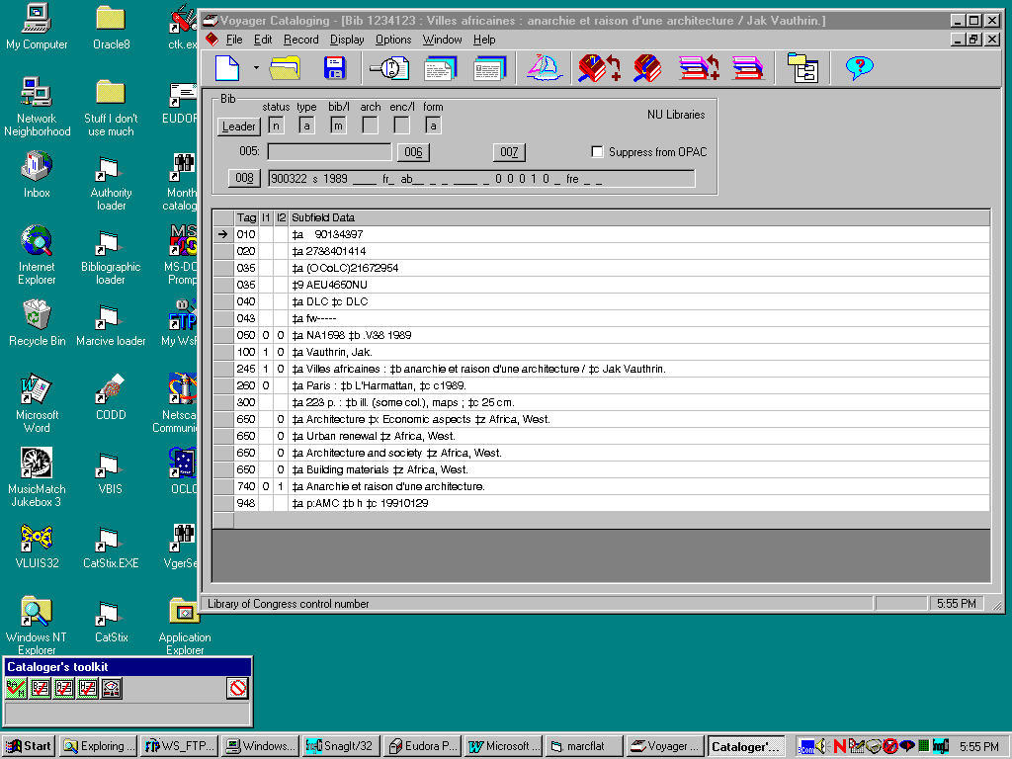

Naturally, the appearance of the toolkit will change as buttons are added, redesigned and removed. The above picture shows the toolkit as it appeared in mid-November 1999. Here’s a bigger picture of the toolkit, showing a later version (it has changed some more, since):

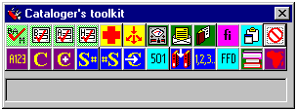

There are spaces for 24 buttons on the toolkit’s pad. However, the toolkit has more than 24 functions available. You can use the Buttons tab on the toolkit’s Options panel to decide which buttons should appear when you’re using the toolkit.

The gray area under the bottom row of buttons is the ‘status window.’ CTKV puts messages in this window from time to time. For example:
- When the toolkit is checking the headings in a bibliographic record, CTKV shows in the status window the heading it’s currently working on.
- When the toolkit is collecting information related to a call number, it displays progress information in the status window.
- When the toolkit is assigning a call number, it shows the steps it takes in this window.

When the toolkit doesn’t have anything particular to report, the status window is empty.

By default, the toolkit is set to be always ‘on top’ of every other program you have running. This is because it’s very easy to loose the toolbar on a cluttered screen. (You can change the toolkit so that it is not always ‘on top,’ if you wish. If you loose the toolkit, you should be able to find it in the system tray, to the right of the ‘Start’ button.)

General points to keep in mind

You may for one reason or another have multiple copies of the Vger cataloging client open in your Windows desktop. The cataloger’s toolkit will only ‘see’ the one that’s currently ‘on top’ of the other ones.

You may have more than one record (bibliographic, holdings, ect.) open in the Vger cataloging client at a time. The cataloger’s toolkit will only ‘see’ the one that’s currently ‘on top’ of the other ones.

The cataloger’s toolkit does not maintain any kind of permanent connection to the Vger cataloging client; it makes no assumptions about the ‘state’ of the cataloging client. If for some reason you are forced to close the Vger cataloging client, you do not need to do anything special to the cataloger’s toolkit; it should be able to find the Vger cataloging client after you start that program up again.

Suggestions for improvements

From time to time, you may find yourself saying ‘Why can’t the toolkit do ...?’, or ‘Wouldn’t it be nice if the toolkit did ...?’ Do not suppress these ideas for enhancements, but let them be known! Many of the buttons in the toolkit are the result of suggestions made by real live catalogers at institutions other than Northwestern University Library, prompted by the needs of the work before them; certainly, the wealth of detail offered by the toolkit is the result of countless suggestions for improvements over many years. (For example, the validation/verification routine is a descendant of one first written in 1994.) The program exists to make your life easier and better; take the responsibility upon yourself to pass suggestions along.

When you think you have an idea for an enhancement to the toolkit , talk it over with your local toolkit expert—the person responsible for maintaining the current version of the program. In some cases, this person may show you a way to realize your suggestion by using existing features. In other cases, this person should recognize that you have an efficiency- or quality-enhancing idea, and will (with your help) write up your idea into a suggestion, and forward the suggestion to Northwestern University Library.

The idea you have may seem to be of interest only to workers at your institution. Do not let this deter you from making a suggestion. If your idea will promote efficiency or improve quality at your institution, pass your suggestion along.

About this manual

This manual should tell you everything you need to know to use the toolkit effectively. It is divided into several large sections, each dealing with a different set of tasks performed by the toolkit. In each section, there is a brief general description of the kinds of things the buttons do, followed by a detailed description of the work done by each button.

In this manual, the word screen means the video monitor attached to your personal computer.

References to the left and right mouse buttons assume the native disposition of buttons under Windows. If you have reversed the left and right mouse buttons, you should mentally reverse the instructions in this manual as well.

It is assumed throughout this manual that you know how to perform common Windows operations, such as clicking buttons and selecting text.

Typographical conventions

Keys on the keyboard are named with the first letter in upper-case: Clear, Enter.

Names of buttons on the toolkit’s button pad are given in upper-case italic letters: BAM button; BIG RED CROSS button.

Names of buttons on other CTKV forms are given in mixed-case letters within quotation marks: ‘Create authority’; ‘OK.’

If you print out this manual in black and white, some of the features of the toolkit which rely on color or shades of gray will only be approximated.

Exceptions and other unexpected but especially important things to remember are marked with a ‘pointing finger’ symbol in the left margin.

A note on the illustrations

The illustrations in this document may fairly be assumed to show the most recent version of the item under immediate discussion. Some illustrations will reflect earlier versions of items not under immediate consideration. For example, an illustration of the verification report should show the current version of that report; but the toolkit’s toolbar visible in the same illustration may not show all buttons currently available.

How to find out more

When you have questions about using CTKV, you should always look in this manual first. You should be able to find answers to most of your questions somewhere in these pages.

Each institution should have a ‘toolkit guru,’ a person responsible for installing and maintaining the program. If you are unable to find an answer to your question in the manual or online, discuss the situation with your local toolkit expert. In most cases this person may be able to find an answer for you.

In some cases, you may wish to post a description of your problem, or a question, to an appropriate online discussion group.

If your friendly local toolkit expert and the body of toolkit users available via an online discussion list are unable to answer your question, your local toolkit expert may decide to contact the appropriate person at Northwestern University Library. (You should never attempt to contact Northwestern directly, but always work through your local toolkit expert.)

To summarize: When confronted with a question, always try to find the answer yourself. If this doesn’t work, contact your local toolkit expert, or other toolkit users. Individual users should never contact Northwestern University with questions about the toolkit. You should not rest until you believe your problem has received a proper airing.

Installation

Before you install the toolkit, you should install the ODBC drivers for Oracle, and define an ODBC data source for your Vger installation. This document does not describe the installation of ODBC drivers, or their configuration.

To install the toolkit, retrieve the following files from the ‘\VoyagerNNNN\CatalogersToolkit’ appropriate folder at Northwestern University Library’s FTP site (the same site from which you obtained this document). (The name of the superior folder includes the Voyager version number—for example, \Voyager2001\CatalogersToolkit.) The following files comprise the installation sequence for the toolkit; copy them into any folder that seems convenient.

setup.exe
setup.lst
CTK.CAB

When you have downloaded these three files, start the program setup.exe. This will move modules into the proper places, and create entries for them in the Windows Registry.

The installation program creates an entry for the toolkit in the Windows ‘Start’ menu. The default location is:

Start
Programs
Northwestern University Library
Cataloger’s toolkit

You can of course create a shortcut on the desktop for the toolkit if you wish. The program’s main module is ‘ctk.exe’; this is located by default in this hierarchy of folders:

Program Files
ctk

Some of the tools of which the toolkit is composed depend on a large number of configuration files. The first time you install the toolkit, you should also download the file ‘ctksupport.zip’, which you’ll find in the folder at Northwestern University Library’s FTP site that contains the other installation files. Unzip this file into the folder that contains the toolkit itself (probably the c:\Program Files\ctk folder). After unzipping the file, move (not copy) all of the ‘ini’ files to the standard folder for initialization files. (The folder varies, depending on the operating system; in Windows 2000, it’s the \winnt folder.) Once you’ve downloaded these files, you probably don’t need to download them again—they don’t change from one version of the toolkit to the next.

Immediately after installing the program and obtaining the configuration files (and creating a shortcut, if you wish), start up the program, go to the ‘Options’ dialog (see the description in another part of this document) and do the following:

- On the ‘Connection’ tab, create a connection to your Vger installation (via the ODBC definition you have already established); do this before you do anything else. See the instructions elsewhere in this document for important instructions about the information on this tab.
- On the ‘File locations’ tab, fill in the ‘Path to Vger tag table files’ box with the location of your Vger tag tables; best to use the Browse button. Fill in the ‘Files of validation rules’ box with the location of the configuration files (authobs.cfg and so on) you downloaded from Northwestern’s FTP site.
- On the ‘NUC codes’ tab, identify your bibliographic and authority NUC codes
- On the ‘BAM’ tab, check all of the ‘Follow national’ boxes that apply; check the ‘Ignore first personal indicator’ box; select subject headings of interest
- Click the ‘OK’ button

You may wish to make changes to other parts of the Options dialog, but this much should allow you to get started. Cancel the toolkit (click the red-circle-with-a-line-through-it button) and then start up the toolkit again. The toolkit is now ready for use.

By default, the toolkit stores its configuration in a file called ‘CTKV.INI’ stored in the default Windows location for configuration files. (The default folder for configuration files varies from one version of Windows to another.) If you want the toolkit to use a configuration file in some other location, you can include the full name of the file following the label ‘-i’ in the instruction you use to start the toolkit. For example, to tell the toolkit to use the configuration file ‘garysconfig.cfg’ in the ‘d:\configs\’ folder, start up the toolkit with this instruction (the name of the executable file will vary, of course):

“C:\Program Files\ctk\ctk.exe” -i d:\configs\garysconfig.cfg

If you wish, you can define a number of shortcuts to point the toolkit to several different configurations.

Checking headings and MARC content designation

Basic concepts

These four buttons allow you to verify the headings in a bibliographic or authority record and check the MARC content designation (tags, indicators, and subfield codes) in a bibliographic, authority or holdings record. These buttons are the BAM button, the Bibliographic report button, the Authority report button and the Holdings report button.

To do its work, the toolkit inspects the record for proper MARC content designation; for bibliographic and authority records, it extracts search keys from appropriate fields, and searches each heading. This process, complicated though it is, normally takes about a second. The online report that the toolkit prepares contains additional buttons to help you with whatever next step may be appropriate in each case: correcting MARC coding, creating authority records, and so on.

To validate the MARC content designation in a record and verify its headings, click the BAM button. (BAM stands for bibliographic and authority verification, and MARC validation.) What the toolkit does next depends on the topmost record in the Vger window.

If the topmost record is a bibliographic record or authority record, the toolkit retrieves a fresh copy of the record from Vger, checks the MARC coding in the record, extracts headings from the record, and checks each of those headings against bibliographic and authority records in your Vger database.

If the topmost record is a holdings record, the toolkit retrieves a fresh copy of the record from Vger and checks the MARC coding in it.

As part of its work, the toolkit may make changes to the record, save it back to Vger, and re-open the modified record in the cataloging client. If you have asked Vger (through a set of configuration options) to save records modified during BAM to Vger, once you click the BAM button you should leave the Vger cataloging client alone until you see the toolkit’s BAM report. If you have asked that Vger not modify records during BAM, you can resume your work with Vger immediately after you click the BAM button; none of the work you do will interfere in any way with the work the toolkit is doing. In any case, the toolkit’s status window shows the heading with which it is working. As soon as the toolkit has finished work on a record, it presents you with its report.

The very first time you use the BAM button, there will be a significant pause (on the order of a minute or more), as the toolkit has to read your Vger tag tables and build a compressed version of them. After this first time, the toolkit uses the compressed version of the Vger tag tables; work with the BAM button will happen much more quickly. (If you install the configuration files on each workstation, as opposed to installing them on a networked drive, you can copy this compressed tag table from one machine to the next, to avoid repeating this delay. The file is VITagTableC.txt, and it’s in the folder identified on the ‘File locations’ tab of the Options panel in the ‘Files of validation rules’ box.)

Inspecting the record

The toolkit performs a large number of tests on the MARC content designation (tags, indicators, subfields, fixed-field codes, and values in coded subfields) of each record it inspects; these validation tests are of two basic kinds.

- The toolkit checks each piece of MARC content designation to determine whether or not it is valid
- The toolkit checks relationships between pieces of data in different parts of the record

The amount of MARC validation the toolkit performs is entirely under your control. The toolkit comes with a set of default configuration files that perform hundreds of different tests. You may choose to remove some of these tests, and/or to define other tests.

The rules the toolkit uses to inspect records may instruct it to make certain changes to records. If this is the case, and if you have asked the toolkit to save modified records back to Vger, the toolkit will write the modified record to Vger and re-open it in the cataloging client. If the toolkit finds any problems in the record it can’t resolve, it prepares a list of them, which you can review later.

The toolkit draws directly on the same tag tables your Vger cataloging client reads, but it uses them in a predigested form that is easier for the program to read than the raw Vger tag tables. Whenever you change your local tag table, the person in charge of the toolkit can take the appropriate step that will migrate those changes automatically into the form that the toolkit uses.

Extracting headings

The toolkit extracts each heading from the bibliographic or authority record. The toolkit breaks each heading into its components, and verifies each piece of each heading separately. Appendix B lists the fields and subfields tested, and describes the manner in which they are handled.

Searching headings

The toolkit searches each of the headings extracted from a bibliographic or holdings record against your local authority and bibliographic records.

In most cases, the toolkit is only looking for exact matches; it does not attempt to find ‘fuzzy’ matches for a heading. A heading either matches, or it doesn’t.

For bibliographic records:

- Τhe toolkit first searches for an authority record that matches the heading. If it finds a matching authority record or a reference, the toolkit stops work in this heading, and moves to the next heading.
- If the toolkit doesn’t find an authority record or reference that matches the heading, it does a second search. The toolkit looks for any bibliographic records—other than the one from which this process began—that contain the same heading; it stops when it finds the first such bibliographic record.
- If the toolkit doesn’t find an authority record or a reference that matches the heading in your main Vger database, and if your installation maintains one or more ‘resource’ files of authority records, the toolkit searches the resource file(s) for a match. If it finds a match, it will extract the authority record; if you wish, you can move the authority record into your local authority file.
- If the toolkit can’t find an authority record for any 6XX bibliographic field that contains subfield $v, $x, $y or $z, it removes the last subfield and searches your database for a separate authority record for that subdivision.
- The toolkit can be configured to search databases beyond your local database, if it doesn’t find any authority-related information in the local database; each of these databases may likewise contain one or more resource files. (See the description of the ‘Connections’ tab on the Options panel.)

For authority records:

- When verifying the established heading (1XX field), the toolkit checks to see if there is a duplicate authority record for the heading. The toolkit expects, but does not require, that each ‘piece’ of the 1XX field (except the whole heading) will match a 1XX field in another authority record, and that no part of the 1XX field will match a see reference.
- For each 4XX field or piece thereof: If the tested heading fragment is not the complete 4XX field, the toolkit expects but does not require that the heading will match a 1XX field in another authority record, and that the heading will not completely match a 4XX field in any authority record. If the tested heading is the complete 4XX field, the toolkit expects that the heading will not match a 1XX or 5XX field in another authority record, and that the heading will also not match a heading in any bibliographic record.
- For each 5XX field or piece thereof, the toolkit expects but does not require that the heading will match a 1XX field in another authority record, and expects that the heading will not completely match a 4XX field in any authority record.

At the end of all of this work:

- If the toolkit found anything worth reporting, the toolkit shows you the verification report, described just below (since holdings records don’t have a verification report, the toolkit shows you the MARC validation report instead)
- If there is noting noteworthy to report, the toolkit simply tells you that everything is OK. If you want, you can use the Bibliographic report, Authority report or Holdings report button to view the report.

You should use the information in the verification report to guide your further work with the record. The verification and validation reports, and the kinds of things you might want to do next, are described on the following pages.

The bibliographic verification report

General description

The bibliographic verification report shows the results of the inspection of the headings in a bibliographic record. Associated with this is a second report, showing any problems detected in the record’s MARC content designation.

The toolkit shows this report as soon as it has completed the verification. You can use the Bibliographic report button to recall this report whenever you like—the toolkit keeps the bibliographic verification record on file until you verify the next bibliographic record, or you cancel the program. (To remove the report from the screen temporarily, click its ‘Close’ button.)

Here is a typical bibliographic verification report:

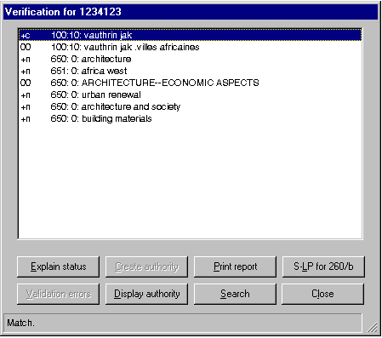

The body of this report is a list of the terms the toolkit searched, with the tags and indicators from the original variable fields. At the bottom of the report is a set of buttons to automate several tasks related in some way to this list, or to the original bibliographic record.

At the very left of the line for each reported heading is a group of codes that together describe the results of the verification. Although you will quickly come to recognize the most common verification codes, you’re not going to be able to remember all of them. The status box at the bottom of this form gives you a terse explanation of the codes for the currently-highlighted heading. You can get a fuller explanation of the codes in a line in the verification report by clicking on a heading, and then clicking the ‘Explain status’ button at the bottom of the report form. When you do this, the toolkit pops open a window which expands the verification codes into real words. (See ‘Finding out what a report line means,’ p. 9.)

The first code in any of the heading lines shows the result of the comparison of the heading to headings in authority records. Here are some common examples:

+ The heading matches a 1XX field in an authority record
% The heading matches a 1XX field in an authority record, but there is a problem with the heading use codes
$ The heading matches a 1XX field, with slight differences
H The subdivision ‘History’ appears to be applied incorrectly
S Heading matches, except for differences in the coding of subfield $v/$x
? The heading matches the text of a 1XX field in an authority record, but the tags don’t correspond
( Because of some ambiguity in LCSH, CTKV is not able to determine whether geographic subdivision has been applied correctly.
0 The heading doesn’t match anything in any authority record. (Note that this code is a ‘zero,’ not the letter ‘oh’)
! The heading matches a see reference or something else suspicious
' The heading matches the text of a 4XX field, but the tags don’t correspond
* The heading matches a 4XX field; but this match is acceptable
5 The heading only matches a 5XX field
o The heading is a geographic heading which contains ‘Metropolitan Area,’ ‘Region,’ or similar extending phrase. There is no authority record for the heading as given. However, there is an authority record for the heading without ‘Metropolitan Area,’ etc. (Note that this code is the lower-case letter ‘oh,’ not a ‘zero.’)

If there is an authority record for the heading (for example, the first code in the report line is ‘+’ or ‘*’), the second character in the line is the ‘RULES’ code from the authority record’s fixed fields. If the authority record was created locally, the rules code is shown as an upper-case letter. For example:

+c The heading matches a 1XX field in an AACR2 authority record
+n The heading matches a 1XX field in a topical subject authority record
+C The heading matches a 1XX field in a locally-created AACR2 authority record

If there is an authority record for the heading, the rules code may be followed by one or more of the following codes:

# There is an inconsistency between the numbering of a series in a bibliographic record and the numbering information in the authority record. (This can stem from a large number of causes, such as the following: the authority record may indicate that the series is not numbered, or there may not be a numbering example, or the numbering example does not correspond with the numbering in the bibliographic record.)
@ Geographic subdivision appears to have been applied incorrectly
- One or more series treatment fields in the authority record lacks the local NUC code in subfield $5
4 One or more series treatment fields in the authority record lacked the local NUC code in subfield $5; following instructions contained on the Options panel, the toolkit has added subfield $5 to the authority record
A There is a problem with the series analysis practice
C The authority record indicates that members of the series should be classed together.
I The first indicator in a personal name in the bibliographic record doesn’t match the first indicator in the authority record
M The authority record indicates that members of the series should be classed with the main series
N The authority record represents a ‘non-unique’ personal name
P The authority record is a provisional, preliminary or memorandum record
T There is a problem with the series tracing practice

If there is no authority record for the heading and if the bibliographic heading doesn’t conflict with anything, the first code is ‘0’ and the second and third columns show how the heading compares against bibliographic records in your file. (The bibliographic record from which verification started doesn’t count here.) Here are some typical codes used in the second column:

0 The heading is used in no other bibliographic records
+ The heading is used in at least one other bibliographic record
* The heading is used in at least one other bibliographic record; a geographic subdivision has been removed from the heading (see Appendix B)
? The heading matches text in a bibliographic record, but the tags don’t correspond

If there is no authority record in the local file for a heading:

- If there is at least one matching bibliographic record (the first two columns contain ‘0+’), and if the heading is not a topical subject and if at least one of the bibliographic records is an AACR2 record, then the third column contains an ‘a’ (this is the code from the DCF fixed field element in the bibliographic record).

- If the heading contains general, form/genre or chronological subdivisions and if there are no bibliographic conflicts (the first two columns contain ‘0+’ or ‘00’), CTKV searches the last subdivision in the heading against subdivision records in the local authority file. If the toolkit finds an authority record for the subdivision, CTKV gives the letter ‘f’ (for ‘free-floating’) with the verification report. If the subfields appear to be out of order, the toolkit gives the letter ‘v’; if there is some other problem with the last subdivision, CTKV gives the letter ‘e’.

The toolkit applies similar logic to uniform title headings that end in a date (subfield $f). If there is no authority record for the heading through the date, the toolkit assumes that the heading (or heading portion) ending with the date is acceptable; but other portions of the heading (such are described on separate report lines) may or may not be acceptable.

CTKV does not attempt to determine whether a subdivision is suitable for use under a heading; it only determines whether or not the subdivision is recognized by the subject heading system.

Here are some typical bibliographic verification report lines, with an explanation of each:

+n 650/1: 0: science
The heading Science is authorized by an LCSH authority record.

0+f 650/3: 0: natural history--study and teaching elementary
There is no authority record for the LCSH string Natural history |x Study and teaching (Elementary). The string occurs in at least one bibliographic record other than the one being verified; the subdivision |x Study and teaching (Elementary) is an authorized LCSH subdivision.

+c 710/7:20: aims education foundation
There is an AACR2 authority record for the heading AIMS Education Foundation.

! 650/4: 0: CHILD STUDY
There is some disagreement between the LCSH heading Child study and information in LCSH authority records. (Specifically, there are 450 fields in two different LCSH authority records which contain the heading Child study.)

Once CTKV has collected the available information about a heading, it is able to guess whether or not it is likely that you need to pay further attention to the heading. For example, if a heading matches an authority record, the odds are that you probably don’t need to worry about the heading. (Of course, there is always the possibility that the matching authority record is actually for a different entity.) At the other extreme, if the heading matches a see reference, you need to do further investigation. CTKV shows you the headings which seem to be OK by giving the search terms in lower-case letters; those which seem to need further work are in upper-case letters. This visual clue allows you to concentrate on the headings most likely to require your attention.

+n 650/1: 0: science--study and teaching elementary
The heading is probably OK, because it matches an authority record.
00 700/6:10: DAHL BRENDA
The heading is probably OK (you’ll have to check Vger yourself to be sure), but may require an authority record.

At the bottom of the bibliographic verification report are several buttons. Use these buttons to do further work with the headings listed in the report. These buttons are described in the following paragraphs.

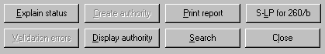

Searching a heading

Use the ‘Search’ button to re-search a heading, and see what the index looks like. This button is of special use when CTKV reports some kind of conflict—you can jump immediately to the problem. To search a heading, click on the heading in the list, then click this button. CTKV inserts the heading (normalized for use as a Vger search term) into the same search dialog you get when you click the FIND button; after you adjust the search as appropriate, CTKV does the search for you and displays the results. (See the description of the FIND button.)

Finding out what a report line means

To see an explanation of the results of the verification of the heading, click on a heading in the list to highlight it, then click the ‘Explain status’ button. CTKV expands the codes into words, and tells you other things about the heading.

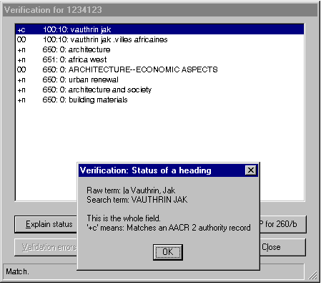

Displaying an authority record

If the heading matches an authority record, you can view the record either by double-clicking on the heading in the list, or clicking once on the heading and then clicking the ‘Display authority’ button. CTKV opens up a separate window and shows you a formatted version of the authority record.

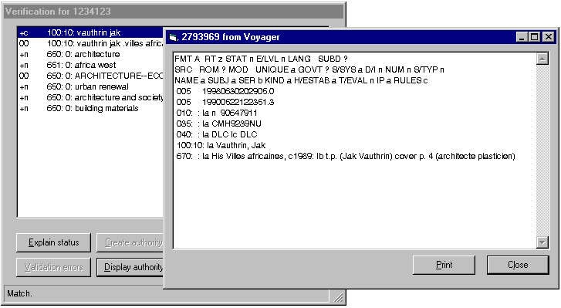

Creating a new authority record

To create a new authority record, click on a heading in the bibliographic verification report for which there is not yet an authority record (i.e., a line whose the first code is not a plus sign), and click the ‘Create authority’ button. (If the highlighted heading already has an authority record, this button is not active.) CTKV formulates a proposed new authority record. What happens next depends on the choice you’ve made on the Options panel.
- If you’ve asked Vger to send new authority records to Vger, it writes the new authority record directly into your Vger database and opens it in the cataloging client for you. You should inspect the record carefully before moving to the next task. The record is already in your Vger database. If the record needs to be modified, fix it now; if it needs to be deleted, get rid of it now.
- If you’ve asked Vger to send new authority records to a file, it writes the record into a disk file (the file defined on the ‘Authority’ tab of the Options panel). If you asked the toolkit to send new authority records to a file, you must import it in the same manner you would import an authority record exported from OCLC. It is your responsibility to make sure that everything in the record is correct, and that the record is complete. The record will not be added to your local authority file until you import it, and add it to Vger by ‘clicking the boat.’

In either case, you can immediately view the authority record from the verification report by clicking the ‘Display authority’ button.

Creating an authority record for a series-like phrase

The schemes followed by both Vger and CTKV for the validation of headings do not provide a simple means for creating authority records for series-like phrases. If you wish to create an authority record for a series-like phrase, you can click the ‘S-LP for 260/b’ button; this button causes CTKV to create an authority record for a ‘series-like phrase’ that consists of the text from subfield $b of the 260 field. After CTKV has created the record you can modify it to suit the exact needs of the situation. In most cases, you’ll need to change the heading, and the wording of the 667 field. The following illustration shows a typical authority record for a series-like phrase as created by the toolkit, before it has been modified. Obviously, some work is yet needed on this record.

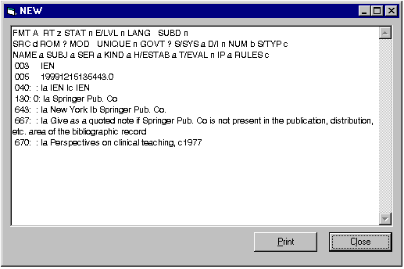

Printing the report

Use the ‘Print report’ button to print a copy of the bibliographic verification report. CTKV includes your initials and date at the top of the first page of the print.

Transferring a record from a resource file

If CTKV found an authority record for a heading in one of the resource files or secondary connections you’ve defined, one of the buttons (the one that often says ‘Create authority’) will say ‘Export authority.’ What happens when you click this button depends on the choice you have selected on the Options panel for authority records created by the toolkit.
- If you have asked the toolkit to send new authority records directly to your Vger system, the toolkit will add the authority record to your system, and open it in the cataloging client’s window
- If you have asked the toolkit to send new authority records to a file, the toolkit will append the imported record to the file named on the Options panel; you can import it with the Vger cataloging client’s Record|Import menu selection.

Inspecting MARC coding problems

Use the ‘Validation errors’ button to review the list of MARC content designation problems CTKV discovered during its examination of your bibliographic record. If CTKV didn’t find any errors in MARC content designation in the record, this button is not available.

Here is a typical report of bibliographic validation problems, superimposed on the related bibliographic record:

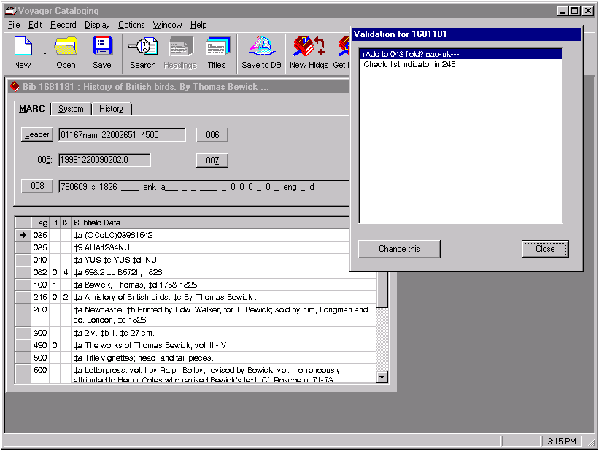

Most of this report consists of terse descriptions of each problem. As a general rule, you should correct each of the problems before starting work on another record. (The Vger cataloging client will not allow you to save a record that contains any MARC coding errors, but the toolkit cannot force you to fix the problems it reports.)

Some of the lines in the validation report may begin with a ‘plus’ sign (+); if there are any plus signs, the ‘Change this’ button on the validation report form will be enabled. If you highlight one (or more) of the lines with a ‘plus’ sign and then click the ‘Change this’ button, CTKV will make the indicated change to the record.

The authority verification report

General description

The authority verification report shows the results of the inspection of the headings in an authority record. Associated with this is a second report, showing problems in the MARC content designation.

If CTKV finds anything in the authority record it doesn’t like, it shows you this report as soon as it completes the verification. If you verify an authority record and everything seems OK, CTKV simply gives you a message to this effect. You can use the Authority verification report button to call up this report whenever you like—CTKV keeps the authority verification report on hand until you verify the next authority record, or you cancel the program. (To remove the report from the screen temporarily, click the ‘Close’ button.)

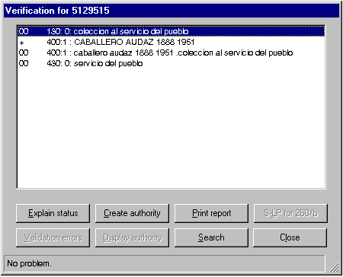

The body of this report is a list of the terms CTKV searched, with the tags and indicators from the original variable fields. At the bottom of the report is a set of buttons to automate several tasks related to this list.

At the very left of the line for each reported heading, is a group of codes that together describe the results of the verification. Although you will quickly come to recognize the most common verification codes, you’re not going to be able to remember all of them. The status window at the bottom of the verification report gives a brief description of each set of codes. You can get a fuller explanation of the codes by clicking on a heading, and then clicking the ‘Explain status’ button at the bottom of the report form. CTKV pops open a window which expands the verification codes into real words.

The first code in any heading line shows the result of the comparison of the heading to headings in other authority records. Here are some common examples:

- + The heading matches a 1XX field in another authority record. (For 1XX fields, this is bad: duplicate authority record? For other fields, this is OK.)
- ? The heading matches the text of a 1XX field in an authority record, but the tags don’t correspond
- 0 The heading doesn’t match anything in any authority record that it shouldn’t
- ! The heading matches a see reference or is otherwise suspicious
- 5 The heading only matches a 5XX field

If there appears to be no conflict between the heading being tested and authority-related information (the first column contains ‘0’), the second and third columns show how the heading compares against headings in bibliographic records in your file. Here are some typical codes for the second column:

- 0 The heading is used in no bibliographic records
- + The heading is used in at least one bibliographic record
- ? The heading matches text in a bibliographic record, but the tags don’t correspond

Once CTKV has collected the available information about a heading, it is able to guess whether or not it is likely that you need to pay further attention to the heading. For example, if a 1XX heading in an authority record doesn’t match any other authority 1XX or 4XX headings, you probably don’t need to worry about that heading. (Of course, there is always the possibility that there is a ‘duplicate’ authority record with a different heading.) At the other extreme, if the heading matches a see reference, you definitely do need to do something. CTKV shows you the headings which seem to be OK by giving the OK headings in lower-case letters; it gives the headings which seem to need further work in upper-case letters. This visual clue allows you to concentrate on the headings most likely to require your attention.

At the bottom of the authority verification report are several buttons. Use these buttons to do further work on the headings listed in the report. These buttons are described in the following paragraphs.

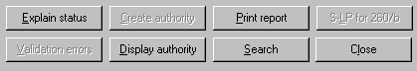

Searching a heading

Use the ‘Search’ button to search a heading, and see what the resulting index looks like. This button is of special use when CTKV reports some kind of conflict—you can jump immediately to the problem. To search a heading, click on the heading in the list, then click this button. CTKV inserts the heading (normalized for use as a Vger search term) into the same search dialog you get when you click the FIND button; after you adjust the search as appropriate, CTKV performs the search and displays the results. (See the description of the FIND button.)

Finding out what a report line means

To see an explanation of the results of the verification of the heading, click on a heading in the list to highlight it, then click the ‘Explain status’ button. CTKV expands the codes into words, and tells you other things about the heading.

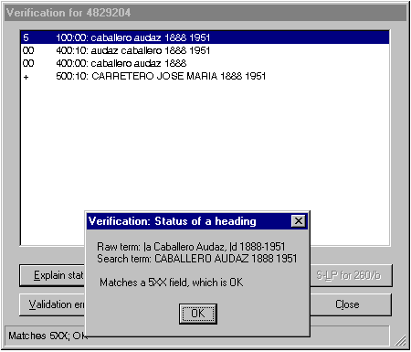

Displaying an authority record

If the heading matches an authority record, you can view the record either by double-clicking on the heading in the list, or clicking once on the heading and then clicking the ‘Display authority’ button. CTKV opens up a separate window and shows you a formatted version of the authority record.

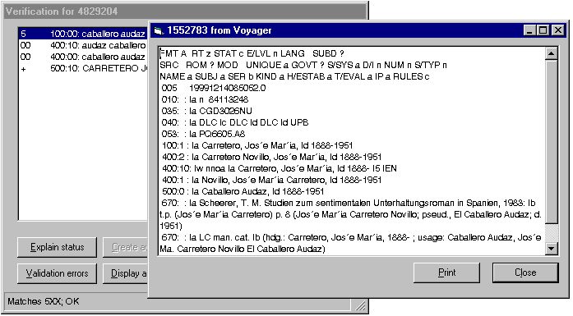

Creating a new authority record

To create a new authority record, click on a heading in the authority verification report for which there is not yet an authority record, and then click the ‘Create authority’ button. (If the highlighted heading already has an authority record, this button is temporarily deactivated.) CTKV formulates a proposed new authority record. What happens next depends on the option you’ve selected.
- If you’ve asked Vger to send new authority records to Vger, it writes the new authority record directly into your Vger database and then opens it in the cataloging client for you. You should inspect the record carefully before moving to the next task. The record is already in your Vger database. If the record needs to be modified, fix it now; if it needs to be deleted, get rid of it now.
- If you’ve asked Vger to send new authority records to a file, it writes the record into a disk file (the file defined on the ‘Authority’ tab of the Control panel to receive new authority records). If you asked the toolkit to send new authority records to a file, you must import it in the same manner you would import an authority record exported from OCLC. It is your responsibility to make sure that everything in the record is correct, and that the record is complete. The record will not be added to your local authority file until you import it, and add it to Vger by ‘clicking the boat.’

In either case, you can immediately view the authority record from the verification report by clicking the ‘Display authority’ button.

Printing the report

Use the ‘Print report’ button to print a copy of the authority verification report. CTKV includes your initials and date at the top of the first page of the print.

Inspecting MARC coding problems

Use the ‘Validation errors’ button to review the list of MARC content designation errors CTKV discovered during its examination of your authority record. If CTKV didn’t find any errors in MARC content designation in the record, this button is temporarily deactivated.

Here is a typical list of authority validation problems:

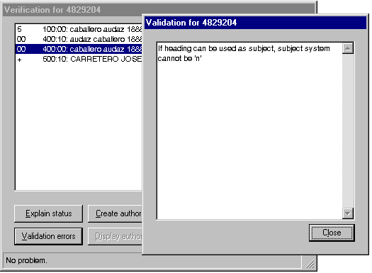

Most of this report consists of terse descriptions of each ‘error’ that CTKV discovered. As a general rule, you should correct each of the problems before starting work on the next record.

Some of the lines in the validation report may begin with a ‘plus’ sign (+); if there are any plus signs, the ‘Change this’ button on the validation report form will be enabled. If you highlight one (or more) of the lines with a ‘plus’ sign and then click the ‘Change this’ button, CTKV will make the indicated change to the record.

Working with call numbers

This group of buttons allows you to do various things related to call numbers: to build complete call numbers, to find associations between call numbers and subject headings, to shelflist classification numbers, and to move a call number from a bibliographic to a holdings record.

Some of these buttons only work with Dewey classification numbers, and follow closely the policies of Northwestern University Library. Others of these buttons are more general: they work with Library of Congress, National Library of Medicine and Dewey numbers, and follow a more general set of policies. To help separate the two groups (Northwestern-only, and general), they have two different background colors: Buttons only used within Northwestern University Library have a deep purple background; buttons for general use have a bright blue background. The Northwestern-only buttons aren’t described in any detail in the following pages.

From left to right in the above illustration, the buttons with the blue background:
- Construct a list of classification numbers appearing most commonly with a subject heading (requires setup on the Vger server)
- Construct a list of subject headings appearing most commonly with a classification number (requires setup on the Vger server)
- Generate a complete unique call number, shelflisted to fit into the local collection
- Transfer a call number from the bibliographic to the holdings record (without checking for duplication)
- Assign a sequential number in lieu of a call number (all users)

Generate a list of classification numbers used with a subject heading

The S# button gives you a way to find the classification numbers that appear in your database most frequently with a given subject heading—when that subject heading is the first subject heading of its type in a bibliographic record. The image on the button means ‘go from subject to class number.’

For efficiency’s sake, this button calls on a library of routines that resides on your Vger server. Before you can use this button, you must install this library of routines (written in the PL/SQL language, the native Oracle programming language), and configure the toolkit to use it. The library resides in two text files (one header file and one body file) available from Northwestern University Library. (The library calls on the services of a set of utility routines, also available from Northwestern.) A person with sufficient authorization on your Vger server must use a separate program to install the header and body files on the server, and to grant permission for all users to access these routines. This person will do this work under an Oracle signon, to which Oracle assigns ongoing responsibility for the routines. This Oracle signon is the text you put into the ‘Oracle schema’ box for the primary Vger connection on the ‘Connections’ tab of the Options panel. Only after the routines have been installed on the server, and you have configured the toolkit correctly, can you use this button.

Configuration points to keep in mind

This button depends on the following information on the Options panel:

- The owning library on the ‘General’ tab
- The first connection on the ‘Connections’ tab, including the ‘Oracle schema’ box (see description below)

This button also depends on the installation of routines on the server.

What happens

When you click this button, CTKV presents you with an inquiry form that looks something like this:

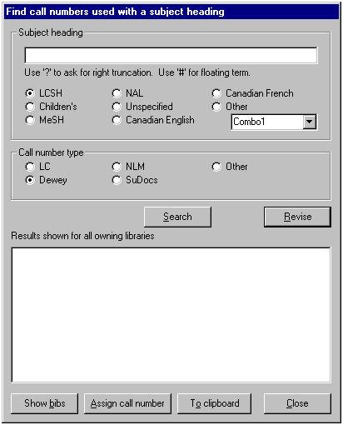

Type the heading in which you’re interested into the box in the upper frame. If the heading consists of a main heading with subject subdivisions and if you’d like to see a list of call numbers not only for the whole heading but also for shorter parts of the heading, give two hyphens between each segment. If you’d like to see a list of call numbers associated with any heading that begins with your text, follow your heading with a percent sign, a pound sign or a question mark. If you’d like to see call numbers for a main heading plus a subdivision, skipping over any intervening subdivisions, place a pound sign (‘#’) between the main heading and the subdivision.

If you type:
caribbean area--politics and government--1945
the toolkit will search for call numbers used with the following headings:
caribbean area--politics and government 1945
caribbean area--politics and government
caribbean area

If you type:
caribbean area politics and government?
the toolkit will search for call numbers used with headings that begin ‘caribbean area politics and government’:

If you type:
caribbean area # bibliography
the toolkit will search for call numbers used with any heading that begins ‘caribbean area’ and also contains ‘bibliography’

In the upper frame, also click the radio button that identifies the subject heading system to which the heading belongs. In the next frame, click a radio button that identifies the kind of call numbers you’re interested in. When everything appears OK, click the ‘Search’ button in the middle. Depending on the nature of your request, you will see results immediately, or after a delay of variable length. The following illustration shows a typical example.

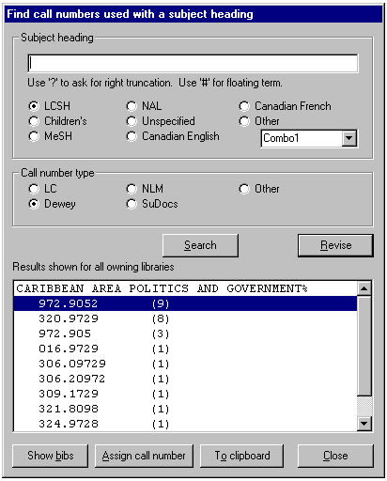

To generate this summary, the server routine asks Vger for a list of the bibliographic records owned by your owning library that contain a given subject heading and have a call number of the proper type. The routine examines each bibliographic record, and considers only those that contain your subject heading as the first subject heading. (To determine this, the server routine has to retrieve each record that contains the heading, normalize the first subject heading, and compare it to your subject heading.) The routine generates a summary of the classification numbers assigned to records that contain the subject as the first heading.

When you see this report, you can do the following:
- Click the ‘Revise’ button to move the original search term back into the topmost box. You can modify the heading as needed, and click the ‘Search’ button again.
- Supply another subject heading and generate a summary of classification numbers associated with it.
- Assign the classification number to the item you’re cataloging. If you click the ‘Assign call number with this’ button, the toolkit hands the number over to the routine that handles the SHELFLISTING button, which pretends that the number comes from a call number field of your bibliographic record. (Northwestern University Library users only: the toolkit pretends that you’ve just clicked the ‘C’ button, which behaves as if the number you select came from the 082 field of your bibliographic record.
- Copy the classification number to the Windows clipboard. You can then paste it (with Control-V) into a holdings record.
- Click the ‘Show bibs’ button to request a list of bibliographic records that contain the given subject heading as the first subject heading, and the highlighted call number as the first part of the call number in the holdings record. Using this list (shown on the left in the following illustration), you can view the related bibliographic records. (CTKV adds the 852 fields from each of the bibliographic record’s holdings records.)

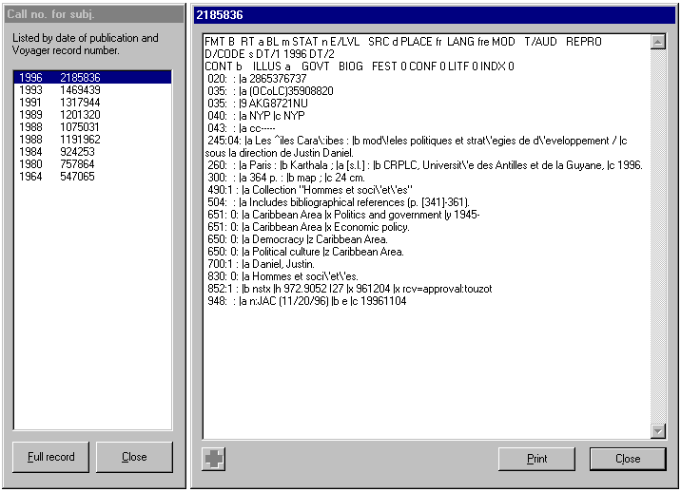

Generate a list of subject headings used with a classification number

The #S button gives you a way to find the subject headings that appear in your database most frequently with a given classification number. The image on the button means ‘go from class number to subject.’

For efficiency’s sake, this button calls on a library of routines that resides on your Vger server. Before you can use this button, you must install this library of routines (written in the PL/SQL language, the native Oracle programming language), and configure the toolkit to use it. The library resides in two text files (one header file and one body file) available from Northwestern University Library. (There’s also a separate file of utility routines—the same one used by the S# button—that must also be installed.) A person with sufficient authorization on your Vger server must use a separate program to install the header and body files on the server, and to grant permission for all users to access these routines. This person will do this work under an Oracle signon, to which Oracle assigns ongoing responsibility for the routines. This Oracle signon is the text you put into the ‘Oracle schema’ box for the primary Vger connection on the ‘Connections’ tab of the Options panel. Only after the routines have been installed on the server, and you have configured the toolkit correctly, can you use this button.

Configuration points to keep in mind

This button depends on the following information on the Options panel:

- The owning library on the ‘General’ tab
- The first connection on the ‘Connections’ tab, including the ‘Oracle schema’ box (see description below)

This button also depends on the installation of routines on the server.

What happens

When you click this button, CTKV presents you with an inquiry form that looks something like this:

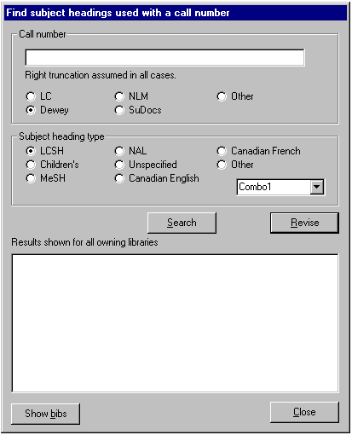

Type the classification number in which you’re interested into the box in the upper frame. The toolkit assumes right truncation in all cases.

If you type:
759.5
and identify this as a Dewey number, the toolkit will consider all call numbers that begin ‘759.5’: 759.5, 759.51, 759.52, etc.

If you type:
B132
and identify this as an LC number, the toolkit will consider all call numbers that begin ‘B132’: B132.D5, B132.V3N38 1977, etc.
Because of the way Vger normalizes Library of Congress numbers, you cannot use a truncated number to search for a range of numbers; searching for ‘B13’ will retrieve only numbers that begin ‘B13’, and not anything in the range B130-B139.

In the upper frame, also click the radio button that identifies the classification system to which the classification number belongs. In the next frame, click a radio button that identifies the subject system of the headings you’re interested in. When everything appears OK, click the ‘Search’ button in the middle. Depending on the nature of your request, you will see results immediately, or after a delay of variable length. The following illustration shows a typical example.

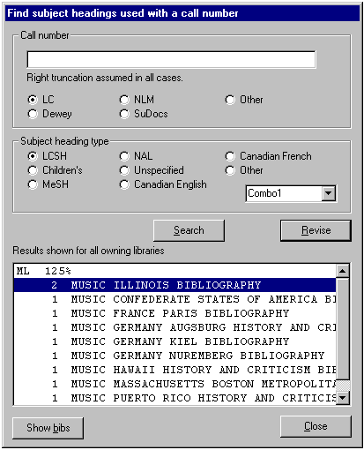

To generate this summary, the server routine asks Vger for a list of the bibliographic records owned by your owning library whose holdings records contain a given call number of the proper type, and begin with the number you supply. The routine extracts from each bibliographic record the first subject heading of the proper type. It generates a summary of the subject headings it finds. This summary does not identify the actual classification numbers assigned to each bibliographic record; you can only be certain that each classification number begins with the information you supply.

When you see this report, you can do the following:
- Supply another classification number and generate a summary of subject headings associated with it.
- Click the ‘Show bibs’ button to request a list of bibliographic records whose holdings record contain the given call number and whose first subject heading matches the highlighted heading. Using this list (shown on the left in the following illustration), you can view the related bibliographic records. (CTKV adds the 852 fields from each of the bibliographic record’s holdings records.)

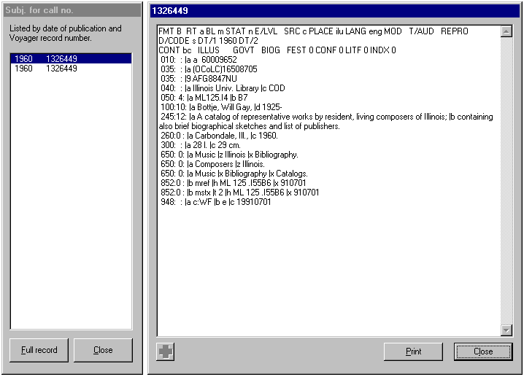

Move a call number from bibliographic record to holdings

This button allows you to move a call number from a bibliographic record into the holdings record without having to copy it to the Windows clipboard. You define on the Options panel the kind of call number you want to move, and then use this button to move the call number. You can click this button when either a bibliographic or a holdings record is the active record in the Vger cataloging client’s window.

Configuration points to keep in mind

This button depends on the following information on the Options panel:

- The ‘Work with bibliographic call number’ and ‘Handling of completed call numbers’ frames on the ‘Call numbers’ tab
- The first connection defined on the ‘Connections’ tab, including the ‘Write UID’ and ‘Write PWD’
- The ‘Path to Voyager.INI’ box on the ‘File locations’ tab
- The owning library on the ‘General’ tab

What happens

When you click this button, the toolkit obtains from the Vger cataloging client the number of the active record, and retrieves from Vger a fresh copy of that record. The toolkit scans the record for the kind of call number you defined on the Options panel. If it finds the appropriate kind of call number, the toolkit inserts it into the first holdings record attached to your bibliographic record that appears not already to have a call number. The toolkit saves this modified holdings record to your Vger database, and then displays it in the Vger cataloging client’s window. When you see the record in the cataloging client’s window, it has already been saved to your Vger database. If you don’t like the number for some reason, you must modify the holdings record and save the record again.

The toolkit does not perform any kind of search before transferring the call number from the bibliographic to the holdings record; most specifically, it does not check the number for duplication. This is simply an automated copy-and-past operation. You can also use the SHELFLISTING button to copy a call number from the bibliographic to the holdings record; this button provides a check for duplication and other features.

Assigning sequential numbers

Use this button to find the next number in a sequence and use that number as all or part of the call number in a Vger holdings record.

Configuration points to keep in mind

This button depends on the following information on the Options panel:

- The sequential number configuration on the ‘Sequential #’ tab
- The owning library on the ‘General’ tab
- The ‘Write UID’ and ‘Write PWD’ for the first connection on the ‘Connections’ tab

What happens

The program retrieves the active record from the Voyager cataloging client. If this is a bibliographic record, the program also retrieves the first holdings record attached to the record that doesn’t already have a call number; if this is a holdings record, the program also retrieves the bibliographic record. The program extracts various pieces of information from these two records (the location from the holdings record, the leader, 006, 007 and 008 fields from the bibliographic record). The toolkit then attempts to match all this information to the definitions for sequential numbers. If the program finds exactly one match, it assigns the next number in the series. If the program finds more than one match, the toolkit asks you which pattern is the one it should use. After it has assigned the next number, the program puts the finished call number into the holdings record, saves it to the Vger database, and calls up the record in the Vger cataloging client. Finally, the toolkit updates its configuration (so it knows the number it has assigned most recently).

Shelflisting classification numbers

This button is not yet operational.

Miscellaneous buttons

Options: Changing the way the toolkit works

CTKV has a collection of miscellaneous pieces of information that it uses to direct its behavior. Some of this information pertains to your Vger installation, some of it pertains to CTKV itself, and some pertains to you, the individual CTKV user.

To inspect these pieces of information, or to make changes to them, click the Control panel button. CTKV shows you its options screen. There are too many options to fit on one panel, so the options are arranged on a series of tabs, rather like cards in a file. To see a set of options, click the tab heading. When you’re done with all of the variables in the options panel, click the ‘OK’ button to preserve your changes, or click the ‘Cancel’ button to tell CTKV to ignore them.

The following view of the toolkit’s options screen is included here for the purposes of illustration only. The options panels are subject to constant adjustment, and this illustration will not be updated every time a tab is added or changed. The following descriptions of elements on the tabs are supposed to be complete and current.

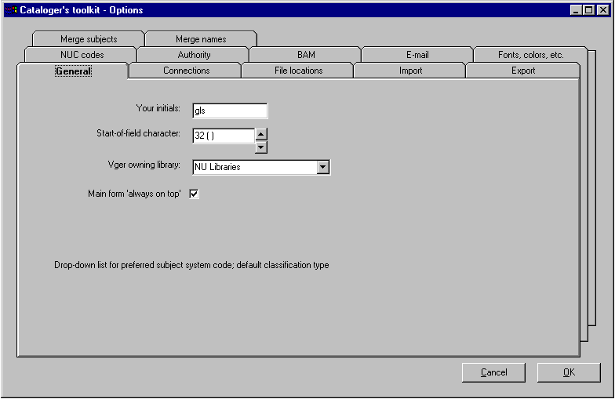

About tab: information about the toolkit

This tab contains, for your information only, some details about the toolkit. (There are no options on this tab for you to change.) The most important things here are the version numbers of the toolkit and its various components. These version numbers will allow someone to know if you have the most recent version, or are working with an earlier version. If you have some difficulty with the toolkit, you may need to include one or more of these numbers in your message to the appropriate party, as an aid in determining the source of the problem. The panel also includes information about the copyright of the toolkit.

Authority tab: information for CTKV to use when proposing new authority records

In the new 670 field: Three checkboxes control the formulation of the 670 field in authority records. If Include 1XX is checked, any main entry in the bibliographic record will appear in the 670. If Include 240 is checked, any 240 field will appear in the 670. If Include GMD is checked, CTKV will include a designation such as ‘VR’ or ‘CF’ for materials other than printed materials. In most cases, participants in cooperative programs such as PCC should leave all of these boxes unchecked.

Default subject heading system for names: Identify here the code CTKV should use as the subject system code (008/11) in authority records for names (i.e., when the field in the bibliographic record is not a subject heading). For LCSH or MeSH, simply select the appropriate radio button. For other subject heading systems, click the ‘Other’ radio button and select the abbreviation for the subject heading system from the list. (The list contains the codes used in subfield $f of the authority 040 field and subfield $2 of bibliographic 6XX fields.)

Handling of new records: The toolkit can send its newly-created authority records directly to Voyager, or can save them to a file. The radio buttons in this frame allow you to tell the toolkit what it should do with new authority records.

To ask the toolkit to send new authority records to a file, click the ‘Save records to file for later import’ radio button. You must also give in the accompanying File for exported records box the name of the file. (CTKV will append new records to the end of this file; it will not overwrite records.) After creating a record, you can use the Vger cataloging client’s Record|Import from file dialog to open this file and bring the record into Vger.

To ask the toolkit to save new authority records directly to Voyager database, click the ‘Write records directly to Voyager’ button. In addition:
- On the Connections tab, include a ‘Write UID’ and ‘Write PWD’ in the definition of the first Vger connection. This ID and password must be defined (in the Vger SysAdmin client) to allow the creation of authority records.
- On the General tab , select a Vger ‘happening’ cataloging location
- On the File Locations tab, Give the path to the appropriate copy of Voyager.INI.
(These three items are required whenever you wish the toolkit to add mor modify Vger records directly.)

BAM tabs: these options affect certain aspects of the verification routine. Because there are so many options controlling the BAM operation (with the possibility of more to come), there are two tabs containing BAM options, labeled BAM, part 1 and BAM, part 2.

BAM, part 1

Follow national … Individual libraries may choose to mark series treatment practice in a downloaded copy of an authority record from the shared authority file by adding subfield $5 with the local institution’s code to series treatment fields. Other institutions may choose not to mark local practice explicitly, and to work on the assumption that unless local practice is marked, the practice indicated in the authority record should be followed. The four Follow national… buttons indicate whether or not, in the absence of an explicit indication of local practice, CTKV should assume that the practice shown in the authority record is to be followed. If these boxes are not checked and if an authority record does not contain an indication of local practice, CTKV will not be able to determine local series treatment.

Subfield $5 and authority records: If the toolkit finds an authority record that matches a heading in a bibliographic record, and if local series treatment is not indicated in that authority record by subfield $5 with your institution’s NUC code, CTKV can add your institution’s NUC code to the series treatment field(s). You control in this area the series treatment fields to which the toolkit should add subfield $5. If you check any of these boxes, the toolkit will add subfield $5 to the record if wanting and then save the record back to Voyager. If you check the If the toolkit adds $5 ... box, the toolkit will call up the modified record for you in the Vger cataloging client.

Subject systems of interest: A list of the subject heading systems (identified by both brief name and value used in the second indicator of bibliographic 6XX fields) that participate in verification. (In most cases, these should be the systems for which you have authority records in your authority file.) CTKV will not bother itself to verify subject headings whose systems are not listed here. (For example, if you don’t list second indicator ‘6’ here, CTKV won’t check French-language subject headings.)

BAM, part 2

Ignore first personal indicator 1/2 discrepancies: If this box is checked, the toolkit will ignore a difference between the first indicator in a bibliographic record and in the corresponding authority record if one record uses a ‘2’ for the first indicator and another uses a ‘1’ for the first indicator.

Copy record to Clipboard: If this box is checked, the toolkit will write a copy of each record verified to the Windows Clipboard, for use by macros or other programs. The record written to the clipboard is not the raw MARC record, but is instead converted into plain text.

Ignore MeSH geographic authority records: If this box is checked, the toolkit will ignore any MeSH authority records for geographic headings that may be present in an authority file.

Report suppressed bibliographic records: If this box is checked, CTKV will add a line to the validation report during inspection of a bibliographic record if the record is marked for suppression from the public catalog.

Report if all holdings records are suppressed: If this box is checked, the toolkit will add a line to the validation report during the inspection of a bibliographic record if all of the holdings records attached to a bibliographic record are marked for suppression from the public catalog.

Force undefined fixed field codes to blank: If this box is checked, CTKV will modify the 008 fields in records it checks, setting all undefined positions to blank if they contain any non-blank values.

Make no change to records during BAM: If this box is checked, the toolkit will not make any changes to records when you click the BAM button. Normally, you want to leave this box un-checked, and allow the toolkit to modify records. This only affects changes the program makes during the BAM process itself—primarily based on rules in configuration files. Other changes that may follow the BAM operation—such as the addition of 043 codes or the change of indicators for nonfiling characters changed from the validation report—are not affected by this option.

Test order of variable fields: If this box is checked, the toolkit will inspect the order of variable fields in a record, and rearrange the fields according to instructions defined at your institution. Normally, you want to leave this box checked.

Test order of subfields: If this box is checked, the toolkit will inspect the order of subfields within each variable field in a record, and rearrange the subfields according to instructions defined at your institution. Normally, you want to leave this box checked.

Minimum severity levels: The toolkit uses a set of definitions (chiefly in configuration files) to tell it how to go about checking records. Associated with each error to be checked for is a pair of error codes; these are intended to show the severity of each error. Your error-detection rules may designed so that errors that may safely be ignored by catalogers performing certain tasks (for example, errors that can be ignored by copy catalogers) are assigned lower severity levels than errors to which attention must be paid. If this is the case, you can indicate here the minimum levels of severity you’re interested in by clicking the up and down buttons. The toolkit will ignore errors whose severity levels are both below the corresponding values on this page; to see all errors, set both of these to zero.

If record modified during BAM: The component that performs MARC validation can make certain low-level changes to records. (These are defined in the configuration files for the validation tool.) If you click the ‘Save record’ radio button in this box, the toolkit will allow the validation tool to make these changes, and will send the modified record back to your Voyager database. If you click the ‘Do not save record’ radio button, the toolkit will report as errors those changes it would otherwise have made.

Buttons tab: Use this tab to arrange the buttons on the toolkit, and to hide certain buttons from view.

Some staff will not need all of the toolkit’s buttons, and may in fact find that the extra buttons get in their way. In other cases, certain staff may be using the toolkit only in limited ways, and you don’t want them to have access to certain toolkit functions. Use this tab whenever you want to control the availability and/or arrangement of toolkit buttons.

The important part of this tab contains two working areas. When you option the Options panel, the Visible buttons area shows the buttons that are currently visible on your toolkit, with the exception that any areas that are blank on your toolkit are represented here by buttons with gray faces. The Hidden buttons area shows buttons that are available to toolkit users, but are not part of the toolkit’s current display. In the following example, nineteen of the toolkit’s buttons are available for display; the remaining six buttons are hidden from view.

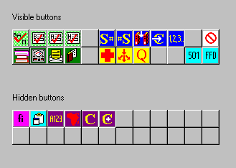

You’ll notice that the number of available buttons in the two work areas is greater than the number of spaces in the Visible buttons area. There are more toolkit functions than can be accommodated without making the pad of buttons so big as to be obtrusive. It’s not likely that any one operator will need all of the functions.

Use “drag and drop” to move a button from one area to another. “Pick up” a button by clicking and holding down the right mouse button while the pointer is over the button and, while continuing to hold down the right mouse button, move the mouse until the pointer lies over the button’s new location. When you finally release the mouse button, the button you start with will switch places with the button at the new location. You can use this technique not only to move buttons from the visible to the hidden work areas, but also to arrange buttons in the visible area. (You can rearrange buttons in the hidden area if you want, but there wouldn’t be much point.)

If at any time you have 12 or fewer buttons in the ‘visible buttons’ area, you will see a checkbox labeled “Limit toolkit to a single row.” If you move all of the toolkit buttons in the ‘visible buttons’ area to the top row and check this box, your toolkit will have only one row of buttons. The next illustration shows a toolkit whose display contains only 10 buttons, arranged in a single row. As also shown in this illustration, the buttons need not be contiguous: you can use gaps to arrange buttons into groups, if you wish.

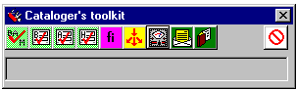

It is possible to hide any of the toolkit’s buttons you wish to conceal. You can see in the following illustration that the person setting up the configuration has hidden the Options panel’s own button. This means that the person using this installation of the toolkit will not be able to change the configuration—this might be an appropriate course of action to take for operators who are to be restricted to a few tasks.

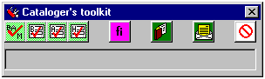

Call numbers tabs: two tabs that control the behavior of the toolkit’s buttons related in some way to call numbers. Because there are so many options, they are spread onto two tabs.

Call #s (General) tab:

Choices on this tab control buttons available to all toolkit users. Where there is overlap in functionality, choices on this tab also control buttons available only to NUL users.

Choices in the Work with bibliographic call number frame control the behavior of the ‘shelflisting’ and ‘move a call number’ buttons.

Type of call number to work with: Select the type of call number you’re interested in shelflisting, or moving from a bibliographic to a holdings record. If your institution uses NLM classification for materials related to medicine and the LC classification for other materials, select ‘National Library of Medicine’ in this drop-down box, and also check the ‘NLM and LC’ box; otherwise, leave this box unchecked.

Field priority for selection: Define in the appropriate box or boxes the ‘call number profile’ the toolkit will use to select call numbers from the bibliographic record. You only need to fill in boxes for the types of call numbers you’re interested in. List in each box the bibliographic tags the toolkit should look for in the bibliographic record; list the tags in the order the toolkit should search for them. If the toolkit should search the record from top to bottom, use just the tag; if the toolkit should search the record from bottom to top for the tag, follow the tag with an asterisk. Follow each tag (and asterisk, if present) with a slash and the subfields from which the toolkit should draw the call number.

Examples:

LC: 050/ab 090*/ab
Use the first 050 in the record; else use the last 090 in the record. From the selected field, use subfield $a for the classification number, and subfield $b for the book number.

Dewey: 092/ab
Use the first 092 field in the record. From the selected field, use subfield $a for the classification number, and subfield $b for the book number.

Superintend of Documents: 086*/a
Use the last 086 field in the record. Use subfield $a for the complete call number.

Always prepare class list for first subject heading: This applies only to the ‘shelflisting’ button. When you click the ‘shelflisting’ button the program makes a list of all of the subject headings in a bibliographic record. You can select any of these, and ask for a list of the classification numbers that appear most often with it. If you check this box, the toolkit will automatically produce this list for the first subject heading when you click the ‘shelflistint’ button.

If your primary classification is NLM, and if you wish to restrict the second cutter in call numbers to a single digit (unless additional digits are necessary), check the ‘NLM 2nd Cutter begins with 1 digit only’ box. If your primary classification is not NLM, or if you are an NLM user but wish to the second cutter to be assigned to its full extent, leave this box unchecked.

Choices in the Handling of completed call numbers frame control the manner in which the toolkit handles finished numbers. These choices apply not only to the ‘move call number’ and ‘shelflisting’ buttons available to all, but also to the two call number buttons available only to NUL users.

Coding of completed number frame: If you want the toolkit to put the classification portion of the number (the first subfield in the string of subfields for this tag) into subfield $h and the other portion of the number (taken from subfields other than the first one listed) into subfield $i, click the Use both 852 $h and 852 $i radio button; if you want the toolkit to put the entire call number—classification number, Cutter number, date, the whole thing—into subfield $h, click the Put whole number into 852 $h radio button.

Handling of completed number frame: If you want the toolkit to add the finished call number to holdings records, click the Save in holdings records(c) and put into clipboard radio button. If you want the toolkit only to copy the finished call number into the clipboard, click the Put into clipboard only radio button.

Choices in the Searches for class number and subject headings frame apply to the S# and #S button.

If you do not check the Report results for all owning libraries … box, the toolkit will limit its search for class numbers or subject headings to the single owning library identified on the General tab. If you check this box, the toolkit will search all owning libraries for call numbers and subject headings.

Call #s (NUL) tab: This tab configures two buttons available only to NUL users. This tab is not described in this document.

Connections tab: this tab lists the databases CTKV should inspect when it is verifying records, and searching for authority-related information.

The list on the left side of the panel shows each of your defined connections: there must be at least one connection defined here in order for the toolkit to work properly. The first time you start up the toolkit, you’ll get one or more cryptic error messages that mean you haven’t set up any proper connections yet. You must establish a connection before you can use the toolkit.

The first connection in this list must be the one that identifies your local Vger production database; the others—if any—will be additional databases in which you are permitted to search for information, and from which you are permitted to extract information. If there is more than one connection in the list, you can change relative positions of connections—and hence the order in which the toolkit searches them—by highlighting a connection name and using the ‘v’ and ‘^’ buttons to move it down or up in the list.

To add a new connection, click the ‘Add’ button; to delete a connection, highlight it and click the ‘Delete’ button; to change the definition of a connection, highlight it and click the ‘Change’ button. The display on the Connections tab changes when you click the ‘Add’ or ‘Change’ button—you will see a bunch of boxes that contain the full definition of the connection. (See the following illustration.) After creating a new definition or changing a definition to your satisfaction, click the ‘OK’ button within the ‘Ad/change a connection’ frame. Items in this list whose names begin with an asterisk (*) are optional—at least, in the sense that they are not required. You will not be able to use all of the toolkit’s functions if you do not supply information in these boxes; and for some operators, this will be what you want.

You should normally close the toolkit and start it up again after you have changed information about the first connection listed. In fact, in most cases the toolkit will recognize that you have made a significant change to the connection information, and will close itself when you save your changes; but you should do this yourself even if it doesn’t happen automatically. When the toolkit closes itself, you should re-open the toolkit and examine other parts of the configuration that depend on the connection information (owning library, cataloging ‘happening’ location, etc.)

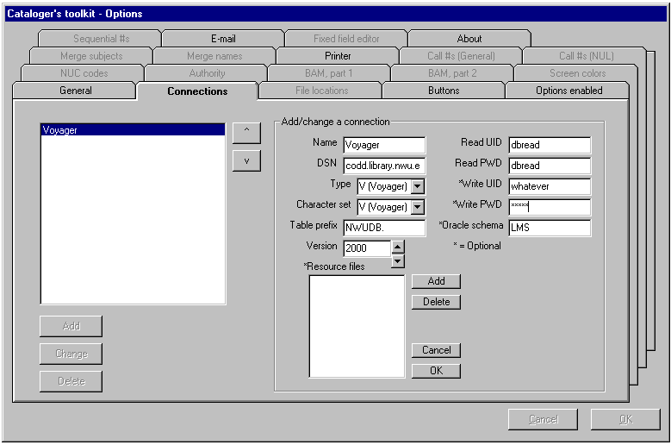

- Name: the name of the connection—this can be anything you choose.
- DSN: the ODBC data set name you’ve already defined for this connection
- Type: the kind of connection being defined. At present, CTKV can only talk to Vger resources.
- Character set: the character set used at the installation. All Vger installations use the Vger character set.
- Table prefix: if the connection is a Vger installation, this is the table name prefix for the ‘main’ database. The table prefix typically consists of one or more letters—perhaps representing your institution—plus the letters ‘DB’ and a full stop (examples: BIGDB., CORNELLDB.). This can be in any mixture of upper- and lower-case letters.
- Version: the Vger major version number, expressed as a four-digit year (use the up and down buttons to change the version number).
- Resource files: see immediately below
- Read UID: the user ID that CTKV should use to log on to the resource; this logon should give CTKV read-only access. This signon is normally assigned by the Oracle administrator; typically, it’s the default value of ‘dbread’.
- Read PWD: the password associated with the read UID. Typically, this is also ‘dbread’.
- *Write UID: a Voyager user ID that grants permission to add and modify bibliographic, authority and holdings records. In other words, a Voyager cataloging signon. If you don’t supply the Write UID and Write PWD, the toolkit won’t be able to write records it creates and modifies back to your Vger database.
- *Write PWD: the Voyager password associated with the write UID
- *Oracle schema: the name of the Oracle schema (Oracle user ID) under which PL/SQL files of routines are loaded. See the discussion of the S# button. If you do not supply this information, the S# and #S buttons (which, respectively, search for classification numbers used frequently with a subject heading, and subject headings used frequently with a classification number) won’t work.

Any connection may contain one or more resource files, which are separate databases at the same connection as the main database defined here. (The declaration of resource files for a connection is optional; most connections will not have resource files.) For example, an institution using Vger may choose to maintain a complete copy of the Library of Congress name or LCSH subject authority records in a separate database, and to move records from that file into the production authority file as they are needed; this separate file of authority records is a resource file. An installation may contain any number of such resource files. The DSN, read UID and read PWD for the resource files must be the same as for the main database. (If for some local reason the resource file must have some other signon, you can define the resource file as a separate connection.)

To add a resource file to the definition of a database, click the ‘Add’ button next to the list of resource files. To delete a resource file definition, highlight the resource file name in the list and click the ‘Delete’ button.

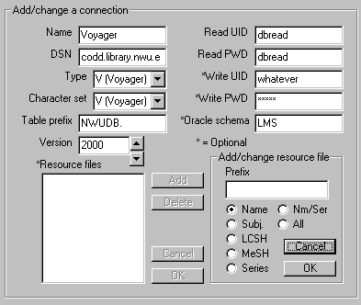

When you click the ‘Add’ button, the panel changes to show fields related to the resource file definition. After completing the definition of a resource file, click the ‘OK’ button within the ‘Add/change resource file’ frame.

- Prefix: this is the table name prefix for the resource file (this typically consists of one or more arbitrary characters, plus the letters ‘DB’ and a full stop)
- The seven radio buttons allow you to indicate the kind of authority records available in the resource file: name records, subject records of all types, LCSH records, MeSH records, series authority records, both name and series records, and all kinds of authority records.

Notes about the ‘DSN’ on this tab: You use two different programs to establish an ODBC connection to a Vger database. After installing the ODBC drivers themselves, you use the program n8sw.exe (supplied by Oracle, located in the \bin folder of the Oracle installation on the workstation) to create a database service. (The definition of this service includes the IP address, port number, and the Oracle service name ‘LIBR’.) You can give this service any name that the program will accept. (By a convention which may perhaps lead to some confusion, this service is often named ‘LIBR’.)

The second stage involves the definition of the data source name; you use the Microsoft ODBC applet for this. The definition of the data source name consists of four elements: the source’s name itself (which can be anything you choose that the program will accept), a description of the source (another piece of free text), the read-only signon for the source, and the database service name you defined with n8sw.exe.

It is the data source name you create in the Microsoft ODBC applet that you supply in the DSN box on the toolkit’s Connections tab. It is likely that this will be something other than ‘LIBR’. Do not use the service name you define within n8s2.exe; the toolkit won’t know what to make of it.

E-mail tab: Information used when you use the toolkit to e-mail a Vger record to someone.

Default subject line: The subject line that you expect to be appropriate for most of the e-mail messages you send via CTKV.

Only one addressee per message: If this box is checked, CTKV will only allow you to select one recipient for an e-mail message; if this box is not checked, you can select as many recipients as you want. (If this box is checked, you cannot accidentally send a message to the wrong recipient. Unless you’re really good at paying attention all the time, it’s best to send e-mail messages via the toolkit to one recipient at a time.)

Default values for messages: Default values for most of the options available when you’re sending records via e-mail:
- Should the toolkit include the raw MARC record as an attachment? (useful if you’re sending the record to someone whose system can import MARC records)
- Should the toolkit change source code ‘d’ to ‘c’ (preferred for records sent to the Library of Congress)?
- Should the toolkit add the designation ‘[Proposed]’ to topical subject headings (preferred for records sent to the Library of Congress)?
- Should the toolkit remove the Voyager record number and any institution code (001 and 003 fields, respectively) from the record (preferred for records sent to the Library of Congress)?

Your complete e-mail address: Your full e-mail address (for example, ‘mrsmith@northwestern.edu’, not ‘mrsmith’). The toolkit uses this information in certain limited circumstances. For example, when the toolkit packages up a correction request, it includes your e-mail address as part of the request; this makes it possible for someone else reviewing correction requests to e-mail you any questions that might arise.

File locations tab: these tell the toolkit where to find some of the things it needs to do its work

Path to Vger tag table files: This is the full path (but not including any particular file name) in which you store your Vger system tag tables. (This directory may be on your own computer, or it may be on a network file server.) This name should end with a reverse slash.

The Cutter/GAC table (MARC32.MDB): The location (including file name) of the file ‘marc32.mdb’ (if available at your institution). This table is connected to the ‘A123’ button (available only to NUL users) and makes available the 3-figure Cutter/Sanborn table, and a table of geographic area codes. (The Cutter table is only available to licensees.)

Files of validation rules: The full path (but not including any particular file name) that contains the validation rules files originally downloaded from Northwestern University’s FTP server. (Two of the many files are authobs.cfg and bibsup.cfg.) Without the correct path in this box, you will not be able to use the BAM button.

Supplementary files: The validation tool that CTKV uses to check records can pull validation rules not only from a primary set of files, but also from a secondary set (one file for each type of record). This allows an institution to have a set of rules that applies across the organization, and for selected users to enforce additional rules tailored to their work. Place the name of any file of supplementary validation rules in the appropriate box.

Path for writing correction requests: If an operator is allowed to request batch heading changes (i.e., is allowed to request corrections that will be performed by Northwestern University Library’s Correction Receiver program), place in this box the name of the folder selected for communication between the toolkit and the correction program. For more information, see the documentation for the Correction Receiver program.

Path to Voyager.INI: If you wish to use those features of the toolkit that send information into your Vger database, this box must contain the folder which holds the copy of Voyager.INI that points to your Vger installation. (This should in most circumstances be the folder that contains your production version of the Vger cataloging client, catalog.exe.) For example, if you wish the toolkit to send newly-created authority records directly into Vger, you must put the Voyager.INI folder name here.

Fixed field editor tab: configuration of the toolkit’s ‘fixed field editor’ panel.

The toolkit’s fixed field editor displays fixed fields in labeled format. Alternate fixed fields have different background colors, to make it easier for you to tell one field from another. The text in each field can be shown in different colors, depending on whether a code is valid, invalid or obsolete; or whether you have deleted the entire field. You can set the background colors and the colors of each kind of text, in the Field 1 colors and Field 2 colors frames on this tab.

Pressing ‘enter’ same as selecting ‘OK’: When you’re done editing a record’s fixed fields, you can use the mouse (or alt-O) to click the editing panel’s ‘OK’ menu item. If you check this box, you can also press the Enter key to get the same result.

Pressing ‘escape’ same as selecting ‘Cancel’: If you decide to abandon the editing of a record’s fixed fields, you can use the mouse (or alt-C) to click the editing panel’s ‘Cancel’ menu item. If you check this box, you can also press the Escape key to get the same result.

General tab: information that didn’t seem to fit anywhere else

Your initials: The initials or other identifying marks by which you are identified at your institution. CTKV includes this information in reports it prints for you.

Start-of-field character: The character CTKV should use at the start of each variable field in its own full-record displays (such as displays of authority records from a bibliographic verification report). Including some character at the start of each field makes individual fields easier to find; in most cases, you’ll find that the space (character 32) works best.

Vger owning library: The Vger owning library for which you are cataloging; you can only select one. (CTKV primarily uses this during preview of downloaded records, to determine whether any matching records in the database should be counted as duplicates.) If you haven’t yet defined any connections on the ‘Connections’ tab, there won’t yet be anything in this box from which to choose.

Vger cataloging ‘happening’ location: The Vger location defined as a ‘happening’ location for cataloging which you wish to use as your location of record when using the toolkit to add or modify Vger records. For example, Vger uses this location code when it adds new authority records. The list of codes in this box is tailored to the operator identified in the first connection on the Connections tab.

Main form ‘always on top’: The toolkit is a small form, and can easily get lost on a cluttered screen. If this box is checked, the toolkit will always appear to be floating above all other forms on the screen; if this box is not checked, other windows can overlay the toolkit. (If you change the state of this checkbox, your change will take effect the next time you start the toolkit.)

Use underscore separator in fixed fields: If this box is checked, the ‘fixed field’ values of authority and bibliographic records are linked to the preceding label by an underscore. This makes the values and the labels keep together if the record window is restricted in width. (Narrowing the record display causes lines to wrap; labels and codes may be separated. If screen width is not an issue, you’ll find that the record is easier to read if this box is not checked.)

Retrieve records natively: There are occasional problems with the way ODBC retrieves records from Vger. (Recall that the toolkit uses a standard method called ODBC to communicate with your Vger server.) A distinguishing symptom of this problem is that the toolkit reports headings containing diacritics as matching a heading in an authority record except for cosmetic differences, even though you cannot on inspection find any such differences. These problems may or may not be cleared up by a change to the Windows Registry, described on the Endeavor Web site. This problem can also be cleared up in most cases by the proper setting here. If in your BAM reports repeatedly complain about cosmetic differences in headings containing diacritical marks, this box should not be checked. If you’re not having this problem, you should probably leave this box alone, regardless of its value.

When this box is not checked, the toolkit uses an extremely ‘safe’ method to retrieve records from Vger. This safe method is guaranteed to transfer all diacritics and special characters correctly; this safe method involves the translation of the record into a different form for transfer to the PC, and the re-translation back into the MARC character set. When this box is not checked, the toolkit does not make this extra effort, and pulls record directly from Voyager without the intermediate translation steps.

The extra translation steps the toolkit takes when this box is not checked do take a bit of time, although on most PC available today you won’t notice the difference. There is no real harm done if this box is not checked, even if you’re not having the problem described in this section.

Merge names and Merge subjects tabs: these choices control the way CTKV processes fields in the existing version of an authority record when it is merging two authority records. (This merging takes place during the review of downloaded authority records with the ‘preview download records’ button.) A ‘subject’ authority record is one whose descriptive cataloging rules code (008/10) is ‘n’ or the fill character (which implies that the heading may only be used as a subject); a ‘name’ authority record is an authority record with any other descriptive cataloging rules code.

For the purposes of merging authority records, CTKV recognizes nine categories of fields:

Call numbers: fields with tags in the 050-099 range
Other 0XX fields: fields with tags in the 010-049 range
260/360 fields
4XX fields
5XX fields
Series fields: 642, 644, 645 and 646 fields (CTKV copies local NUC codes from the lower-quality record to any corresponding field in the higher-quality record)
690 fields
Other 6XX fields
7XX fields

There are three radio buttons for each group of fields:
- If you choose the ‘Reject’ button, CTKV does not copy any fields in that tag group from the existing record into the incoming record
- If you choose the ‘Keep’ button, CTKV copies all fields in that tag group from the existing record into the incoming record if those fields are different from fields in the incoming record.
- If you choose the ‘with $5’ button, CTKV copies all fields from the existing record in that tag group that are identified via a local NUC code in subfield $5 as containing local information into the incoming record if those fields are different from fields in the incoming record.

Note that this list does not include the 1XX field. You cannot ‘overlay’ the existing 1XX field into the incoming record.

NUC codes tab: these tell CTKV which NUC codes to use in new records, and which codes apply to institutions sharing your Vger installation

NUC code for authority records: Your local NUC code for use in authority records. CTKV uses this in the 040 field of new authority records, and in subfield |5 of series treatment fields (642, 644-646) in series authority records.

NUC code for bibliographic records: Your local NUC code for use in bibliographic records.

NUC code roots: The basic NUC codes of all of the institutions which participate in your Vger installation. An NUC code root is the part of an NUC code to the left of any hyphen.

If institutions with the following NUC codes participate in your Vger installation:
IEN IEN-M IEN-Tr IEN-Mu IEN-L IEG
this field should contain:
IEN IEG

When you use the ‘Merge’ button to combine two authority records, CTKV consults the NUC codes in this field to determine which information in series treatment fields belongs to local institutions.

Options enabled tab:

Use this tab to control the tabs on the Options panel that are available to operators. The box at the left lists all of the tabs on the Options panel (except the ‘About’ tab). If the tab’s name is highlighted, it will be available to the operator; if the tab’s name is not highlighted, it will not be available to the operator.

To select all of the names (thereby making all tabs available) click the ‘Select all’ button. To clear all selections (thereby making only the ‘About’ tab available) click the ‘Clear all’ button.

If you wish to disable all of the options tabs, you can also ‘hide’ the Options button altogether by moving it to the ‘hidden’ area on the Buttons tab.

Printer tab:

Will print on this printer: The printer to which CTKV will direct all of its output. Click the ‘Change’ button to select a different printer. (CTKV can only show printers you’ve already defined to Windows.)

Printer font: The font CTKV will use when it’s printing reports. You can select any available font, but you should normally use a font that contains definitions of the complete Vger character set.

Screen colors tab: These fields control some of the mechanical aspects of CTKV’s behavior.

Displays: The four rows of boxes and buttons allow you to set the foreground and background colors for bibliographic, authority, holdings and other displays. The ‘Default’ button changes the setting to the default—black text on a white background.

Screen font for lists, etc. The font CTKV will use when it’s displaying information in lists and tables. You can select any available font, but you should normally use a font that contains definitions of the complete Vger character set.

Sequential #s tab: Information on this tab controls the assignment of sequential numbers with the 1,2,3 button.

You can define any number of different models for assigning sequential numbers. Normally, you’ll define a separate model for each different kind of sequential number you assign. For example, if you assign one sequence of numbers to microfilms, another sequence of numbers to microfiche, and a third sequence of numbers to music CDs, you’ll have three definitions listed in the box on this tab.

Each definition can contain an almost bewildering set of different elements. (You can see the possibilities if you click the Add button next to the list of models.) Some of these elements allow the toolkit to identify the records that belong to the category; others allow the toolkit to construct the sequential number.
- Location: the locations(s) that holdings records must bear to be considered for this category
- Prefix: A constant piece of text the toolkit will use before the sequential number.
- Suffix: A constant piece of text the toolkit will use after the sequential number.
- Next #: The next sequential number to be assigned. (The toolkit automatically increments this number.)
- 852 Ind 1: the value the toolkit should use for the first indicator in the 852 field
- Code requirements: characteristics that bibliographic records must bear in order to be considered for this category

Each code requirement consists of a code for one or more formats (books, computer files, mixed materials, maps, sound recordings, scores, serials, visual materials) and, optionally, one or more codes from Leader, 007 and/or 008 fields. In order for a record to be considered part of the group, it must (in its record leader) contain codes that match one of the listed formats, and it must contain fields that bear the indicated Leader, 007 and/or 008 field codes.

You can make any definition temporarily inactive by making sure the ‘Active’ box is checked when you see the definition of one model. When the toolkit is trying to match the characteristics of a bibliographic and holdings record against your models, it ignores those not marked ‘Active.’

E-mailing Vger records

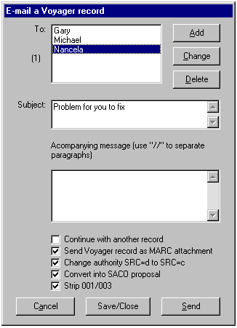

Printing processing slips

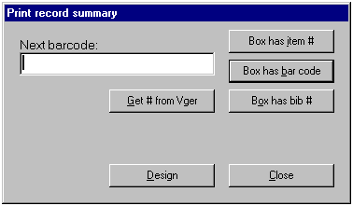

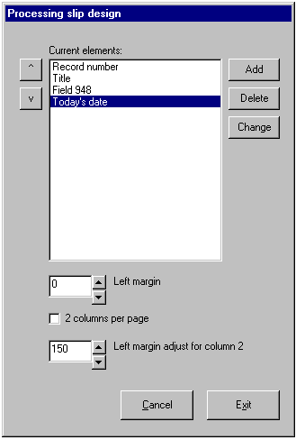

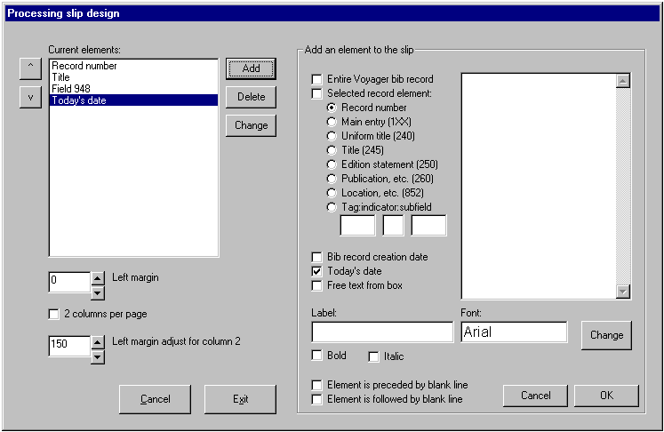

Requesting batch corrections

Introduction

Libraries often need to make the same change to a number of records. If a name or topical heading changes from one form to another (from ‘Ray, Satyajit, $d 1922-’ to ‘Ray, Satyajit, $d 1921-1992’, or from the MeSH heading ‘Hemodialysis’ to ‘Renal Dialysis’, for example), libraries need to find and change each instance of the former heading in their records. Libraries have two principal courses of action open to them: they can ask an operator to call up each affected record and make a suitable change to each; or they can use a program to change records for them. The latter course, because it is quicker and less prone to error, should be the preferred one—provided the batch correction program is sufficiently capable, elaborate and robust.

Northwestern University Library distributes a suite of ‘batch correction’ programs for the Vger system. Working together, these programs allow you to make changes to a number of records with a single request. These programs can make a substantial difference—a positive difference—in the quality of headings in your database. Endeavor Information Systems, Inc. also distributes a set of programs as part of its Vger system that makes changes to groups of records. The Vger and Northwestern batch correction programs differ in significant ways, both in the manner in which you make correction requests, and the manner in which programs carry out your requests.

Depending on how your institution wishes to change records, the Northwestern University Library suite of batch correction programs consists of either two or three separate programs; this means that the work of performing corrections is a multi-step task. You will use different programs to request corrections to your records, and to perform the corrections. If you wish to review corrections before they are performed, you will use yet another program some time after you make the initial request but before the request is actually performed.

This section of this document tells you how to do the first step: how to use buttons on the cataloger’s toolkit to request a change to a heading in a set of records; this document also outlines the remainder of the correction process. Another document (Making changes to headings, available from NUL’s FTP site) tells you in detail how the other programs in the batch correction suite use the requests you make with the toolkit to change your records. The description of the correction process is divided into two parts in this manner because the majority of those engaged in this work will only perform the first step (generate the request), while only a very few people at a given institution (perhaps only one person) will be responsible for the remainder of the process (approving and performing corrections). Naturally, at some institutions, one person may be in charge of all of the steps.

You will use each of the correction request buttons in different situations.
- Some corrections consist of a single change to a single field (such as the replacement of one form of a personal name with another; the replacement of one topical heading to another), and are to be applied to all records in a database. You request such corrections—which will constitute the great majority of your correction work—with the BIG RED CROSS button. (It may help to remember what this button does if you think of it as the ‘first aid for headings’ button.)
- In other situations, you will want to do something more elaborate: change one heading into several, or change headings in some records to one heading but change the same heading in other records to a different heading; or apply a change to a subset of records that contain a heading. When your needs are more elaborate than can be encompassed within the ‘big red cross’ button, you will use the SPLIT HEADINGS button to make the request.
- You can use the BIG RED Q button to review headings in the Vger changed headings queue, and request corrections based on the authority record that lies behind the changed headings queue entry.

Here are some examples of the kind of changes the program can make with the BIG RED CROSS button:

Based on these fields (and other information) from a name authority record:
100 1 $a Kimball, Dexter S. $q (Dexter Simpson), $d 1865-1952
400 1 $w nna $a Kimball, Dexter Simpson, $d 1865-1952
These programs can change this bibliographic field:
700 1 $a Kimball, Dexter Simpson, $d 1865-1952. $t Selections. $f 1997.
to this:
700 1 $a Kimball, Dexter S. $q (Dexter Simpson), $d 1865-1952. $t Selections. $f 1997.

Based on these fields (and other information) from an LCSH authority record:
150 $a Iban (Bornean people)
450 $w nne $a Ibans (Bornean people)
These programs can change this bibliographic field:
650 0 $a Ibans (Bornean people) $z United States $x Bibliography.
to this:
650 0 $a Iban (Bornean people) $z United States $x Bibliography.

Based on these fields (and other information) from an LCSH authority record for a subject subdivision:
180 $x African American authors
180 $w nne $x Afro-American authors
These programs can change this bibliographic field:
650 0 $a American literature $x Afro-American authors $x Bibliography.
to this:
650 0 $a American literature $x African American authors $x Bibliography.

Here is an example of one kind of change the program can make with the SPLIT HEADINGS button:

Based on these fields (and other information) from two different subject records:
- $a Afghanistan $x Politics and government $y 1973-1989
451 $w nnoa $a Afghanistan $x Politics and government $y 1973-
151 $a Afghanistan $x Politics and government $y 1989-2001
These programs can when requested to do so change this bibliographic field:
651 0 $a Afghanistan $x Politics and government $y 1973- $v Bibliography.
to this pair of fields:
651 0 $a Afghanistan $x Politics and government $y 1973-1989 $v Bibliography.
651 0 $a Afghanistan $x Politics and government $y 1989-2001 $v Bibliography.
And, with this button, this correction can be applied to selected records.

The Vger system maintains a heading change queue, with an entry for each heading that has changed. You can use the toolkit’s QUEUE button to review entries in the Vger changed heading queue, and convert them into change requests to be processed by other parts of Northwestern’s suite of heading change programs. Each entry that you choose to process with these programs becomes either a simple request handled with the BIG RED CROSS button or the SPLIT HEADINGS button. It will make the most sense to describe these other two buttons first, and then show how the QUEUE button relates to them.

Outline of the correction process

Northwestern University Library’s batch correction programs use a system of queues to contain messages about corrections to be performed. Queues are in reality nothing more than dedicated folders on some disk drive somewhere. The messages in these queues are actually text files (which you can inspect with the Windows Notepad or similar program), each of which describes one change to be made. The correction programs do their work by creating messages, moving them from one queue to another, and using them to direct changes to records.

Each library has a great deal of flexibility in the implementation of queues; the person at your institution who oversees the performance of correction requests will design a workflow for batch corrections that suits the needs of your institution. (The design of queues and the shuttling of messages between them is described in some detail in Making changes to headings.) The most important thing for you to know right now is that when you use the toolkit to formulate a request for a change to headings, you are in fact creating a small file that gets written to a folder somewhere; and this file at some later time is used to tell some other program to find and modify a group of records.

There are two basic models for setting up queues of correction messages.
- In the simpler model, the correction requests you create with the toolkit are handed directly to the program that performs corrections, without any review of any sort: you request the correction, and it gets performed. This model will work best for smaller institutions, or institutions in which only a very small number of people are allowed to make requests for corrections.
- In the more elaborate model, the correction requests you create with the toolkit are sent to a holding queue. Requests in this queue are reviewed by someone else. If this person approves a request, it gets moved into a different queue, where it is picked up by the program that performs corrections. In this model, corrections you request are only performed if they pass a second-stage review.

In either case, an institution may choose to have corrections performed as requests are submitted (or approved, depending on the model followed at your institution), or an institution may choose to perform corrections in batches, when Vger is not too busy. All this means that, depending on choices made at your institution, the changes you request may or may not be reflected immediately in your database.

Toolkit configuration

Several pieces of configuration (available on the toolkit’s Options panel) are related to the request for a batch correction:
- The ‘Path for writing correction requests’ box on the ‘File location’ tab tells the toolkit the name of the folder into which it will write correction requests. (This is the only piece of configuration information mentioned here that is, strictly speaking, required.)
- The ‘Your initials’ box on the ‘General’ tab identifies you. The toolkit uses your initials as part of the name it uses for correction requests you initiate; it also includes your initials within the correction definition. This allows the person (if any) making the final review of correction requests to return questions to you as necessary.
- The ‘Your e-mail address’ box on the ‘E-mail’ tab contains your full e-mail address, which the toolkit also includes in the correction request. This allows the person making the final review of correction requests to send a question about the correction to you as an e-mail message.

Making the simple correction request: basing a correction request on an authority record

Use the BIG RED CROSS button on the toolkit to initiate a request for a general batch correction. More specifically, use this button when you want to change every occurrence of a particular heading or subdivision to one other thing.

When you click this button, the toolkit looks at the Vger cataloging client. If the active record in the cataloging client’s window is an authority record, the toolkit assumes you’re interested in making a correction based on that authority record. The toolkit searches each 4XX field in the record against your Vger headings index, in an attempt to find reference tracings that might indicate the need for corrections. (The toolkit doesn’t limit itself to reference tracings marked ‘old heading’—it checks them all.) If the toolkit finds a 4XX field in the authority record that matches one or more entries in your Vger headings index, it adds it to a list of potentially-interesting headings. The toolkit also picks up other pieces of information from the authority record. (You won’t necessarily be able to see or modify these other pieces of information.)

When the toolkit has examined each of the 4XX fields in an authority record, it displays its findings in a small dialog box. The following illustration shows a sample of the dialog box the toolkit generates, based on the authority record shown in the Vger cataloging client’s window. (At the time this picture was taken, this institution’s database contained bibliographic records with subject headings beginning ‘Poor $x Housing’.) Don’t worry if you can’t quite read the dialog box text—see the enlargement on the next page.

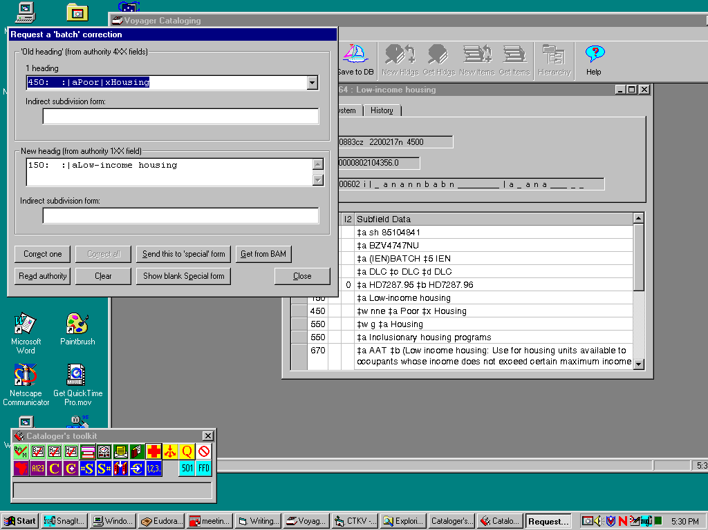

Here’s an enlargement of the correction request form shown just above:

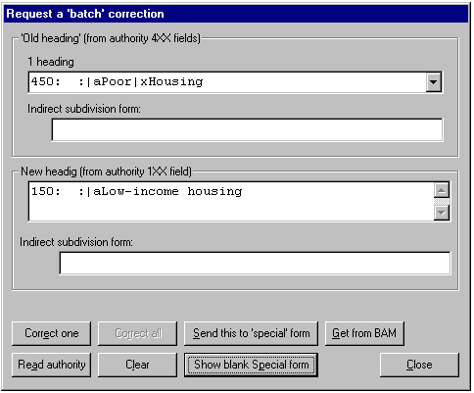

The ‘old heading’ frame contains information about 4XX fields that might be needed for batch corrections. The principal business in this frame is a drop-down list showing each 4XX field that matches headings in your database. (The counter just above this drop-down box shows how many headings are in this drop-down list—not how many bibliographic records would be affected by the correction.) If the ‘old’ heading is a 451 field (geographic heading) that contains only subfield $a, the toolkit attempts to manipulate the old heading into the proper form to use in indirect subdivision, and shows this to you in the ‘Old indirect subdivision form’ box.

The ‘new heading’ frame contains the 1XX field from the authority record. If this is a 151 field that contains only subfield $a, the toolkit attempts to manipulate it into the proper form to use in indirect subdivision, and shows you this form in the ‘New indirect subdivision from’ box.

When you see this form, you can do the following things:
- For geographic headings, you can adjust the headings in the ‘old indirect subdivision’ and ‘new indirect subdivision’ boxes as appropriate. You can delete this information altogether, if you don’t want the program to modify the indirect subdivision form for a geographic name.
- If there is more than one heading in the drop-down list of ‘old’ headings, you can select the heading of interest by clicking on its ‘down’ arrow. If the selected heading is a simple geographic heading, the contents of the ‘Indirect subdivision form’ box may change as you select different ‘old’ headings.
- If the selected heading in the ‘Old heading’ box (including any geographic subdivision form) represents something you wish to have a program find and change into the heading in the ‘New heading’ box, click the ‘Correct one’ button. The toolkit packages information about the heading change into a message, and sends that message to the appropriate correction queue. The toolkit also removes the heading from the list in the ‘Old heading’ frame. If there are no other headings in the list in the ‘Old heading’ frame, you won’t be able to generate any more correction requests related to this authority record.
- If you want to generate correction requests for all of the headings listed in the ‘Old heading’ frame, click the ‘Correct all’ button. (This button won’t be available unless there are multiple headings in this list.) The toolkit creates a correction request for each heading in the list, sends each request to the appropriate queue and clears the list.
- If you want to erase all information from the form, click the ‘Clear’ button.
- If you are done working with one heading and want the program to pick up information from some other authority record, call up the new authority record in the Vger cataloging client and click the ‘Read authority’ button. The toolkit looks at the Vger cataloging client to find the active record, searches each 4XX field it finds there, and fills in the batch correction form with information from this authority record. (You can get the same effect by clicking the toolkit’s BIG RED CROSS button again.)
- If you want to see the complete definition of a correction, and perhaps modify it, click the ‘Send this to special form’ button. The toolkit transfers the correction definition from this simple request form to a more elaborate form (described below), and removes the definition from this form.
- If you want the program to fill out this form based on the currently-highlighted report line in the most recent bibliographic BAM report, click the ‘Get from BAM’ line. The program looks at the bibliographic BAM report; if the currently-highlighted line in this report indicates that an authority record is available for a heading, the program retrieves that authority record, searches all of its 4XX fields, and presents the results in the correction request panel.
- If you want to define some other correction (most likely, one that isn’t based on information in any authority record), click the ‘Show blank Special form’ button. The toolkit shows you its special correction definition form, which allows you to create a complete correction request from scratch.

Making the simple correction request: defining your own correction

Under certain circumstances, you won’t be able to use the toolkit’s simple correction request form (described just above) to initiate a one-for-one correction. In many of these cases, there will not be an authority record for the heading you want to change; in some cases there will be an authority record for the ‘new’ heading, but the heading you want to change will not be represented by a 4XX field in it. In still other cases, you will want to base a correction request on information in an authority record, but you will want to adjust the information in ways that are not allowed by the simple correction request form. In these and similar circumstances, you need to use the more elaborate correction request form the toolkit makes available. You can ask to see this elaborate correction request form either by clicking the ‘Show blank Special form’ or ‘Send this to special form’ button on the toolkit’s simple correction request form.

The following illustration shows how the form looks when you click the ‘Show blank’ button. When you click the ‘Send this to special form’ button, the form contains information (old heading, new heading, etc.) lifted from an authority record.

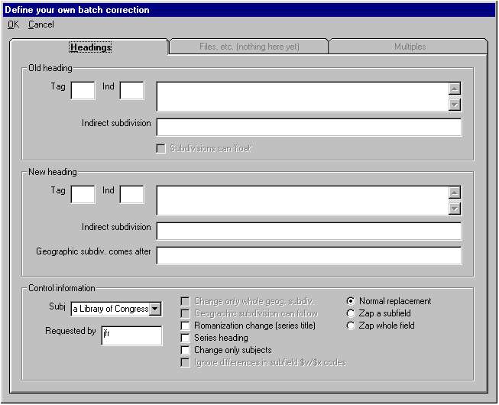

The main part of this form contains information distributed on three tabs. All of the information you’ll use in run-of-the-mill batch corrections is on the ‘Headings’ tab. In rare circumstances, you’ll need information on the ‘Files, etc.’ tab or the “Multiples” tab. However, the cataloger’s toolkit does not provide access to these tabs; you must use a separate program to gain access to them. If you think a batch correction you’re about to define might require special handling, confer with the person at your institution in charge of batch corrections before submitting your correction request.

The ‘Old heading’ frame

This frame defines the heading that will be changed. The correction program uses this information to search Vger indexes to find candidate records.

Give the tag and indicators as they are (or would be) found in a 4XX field in an authority record: the tag must always begin with ‘4’, and the indicators must be those appropriate for use in authority records. (The program will translate blank indicators into ‘#’ symbols so they’re easier for you to see, but it will later translate those symbols back into spaces.) The text of the field must contain all appropriate subfield codes, but it does not otherwise have to be properly capitalized, and diacritical marks that normalize to ‘nothing’ in Vger can be omitted. (If you’re pulling this information directly from an authority record, it’s simplest just to leave the field as you find it. The correction program knows how to handle diacritics, punctuation and so on.)

In the box for the old heading, use the vertical bar to represent the subfield delimiter. Do not use spaces around subfield codes. If you include diacritics and special characters, use the equivalents described in Appendix C. The text should begin with a subfield code: most of the time, this is going to be subfield $a.

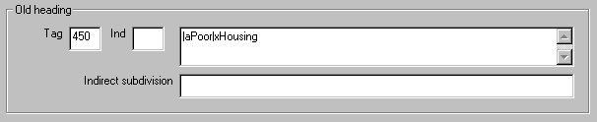

If the old heading is a simple geographic heading—a 451 field with only subfield $a—the ‘Indirect subdivision’ box contains the indirect subdivision form of the old heading. This text must begin with subfield $z. If the old heading is anything other than a simple geographic heading, or if you do not wish the correction program to change the indirect subdivision form for a simple geographic heading, leave the ‘Indirect subdivision’ box blank.

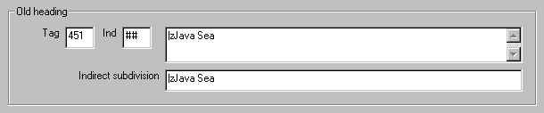

To change a subject subdivision (one appearing in subfield $v or $x of a subject heading) regardless of the main headings after which it appears, give a tag in the 48X group; the heading text should begin with the appropriate subfield code.

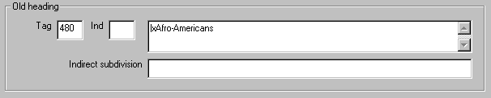

The ‘New heading’ frame

This frame contains information pertaining to the heading that will replace the heading named in the ‘Old heading’ frame. When the correction program finds the ‘old’ heading in a record, it will replace it with the heading defined in this frame.

Give the tag and indicators as they are (or would be) found in a 1XX field in an authority record: the tag must always begin with ‘1’, and the indicators must be those appropriate for use in authority records. (The program will translate blank indicators into ‘#’ symbols so they’re easier for you to see, but it will later translate those symbols back into spaces.) The text of the field must contain all appropriate subfield codes, must be properly capitalized, and must contain all diacritical marks and special characters. (Use the equivalents for diacritics and special characters listed in Appendix C.) The text in this box should not end with a full stop or other punctuation unless that punctuation is an integral (i.e., inseparable) part of the heading.

In the box for the new heading, use the vertical bar to represent the subfield delimiter. Do not use spaces around subfield codes.

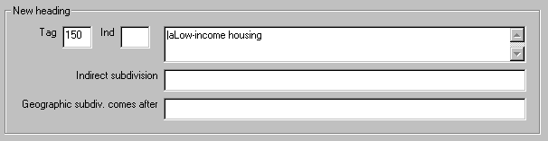

If the old heading is a simple geographic heading—a 151 field with only subfield $a—the ‘Indirect subdivision’ box contains the indirect subdivision form of the new heading. If the new heading is anything other than a simple geographic heading, or if you do not wish the correction program to change the indirect subdivision form for a simple geographic heading, leave the ‘Indirect subdivision’ box blank.

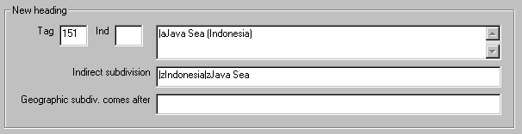

To change a subject subdivision, give a tag in the 18X group; the heading should begin with the appropriate subfield code.

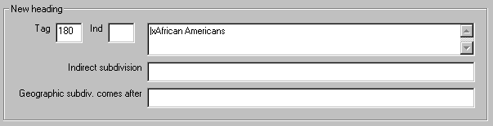

In rare instances (even rarer now than in the past), when you are changing a main heading/subdivision combination, you will wish the program to retain a geographic subdivision present within the existing heading at some point within the modified heading, instead of moving it to the end of the new part of the heading. In this rare instance, give in the ‘Geographic subdiv. comes after’ box’ the portion of the new heading (with subfield codes, special characters, etc.) that precedes the geographic subdivision.

The ‘Control information’ frame

This frame contains information—mostly parallel to information found in an authority record’s 008 field—that controls the performance of the correction. (The program fills the drop-down box on the left side from your Vger configuration file authfix.cfg.)

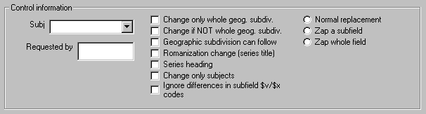

- The ‘Subj.’ box identifies the subject heading system used to formulate the heading. (Although the illustration above does not show it, this box normally contains a list of recognized subject heading systems.) The program uses the subject system code to derive the appropriate second indicator value for bibliographic 6XX fields, so that it only corrects those headings that belong to the proper subject heading system. This code is similar to the code used in byte 11 of the authority 008 field.
- The ‘Requested by’ box contains your initials (pulled from the toolkit’s Options panel). The toolkit uses your initials as part of the names of the files that contain your correction requests.
- The ‘Change only whole geog. subdiv.’ line is important only when the heading being changed is a simple geographic heading, and when the indirect subdivision form for the ‘old’ geographic heading employs a single instance of subfield $z. (In other words, the value in this line is only material when you are changing a heading that can be used as a first-order geographic subdivision.) If this line is checked (and if you supply the indirect subdivision form in the appropriate boxes), the correction program will change the indirect subdivision form only when it appears by itself, and will not change it if the indirect subdivision form is preceded or followed by another subfield $z. If this line is not checked, the program will change the indirect subdivision form without regard to the following subfields. There is no equivalent for this information in the authority record.
- The ‘Change if NOT whole geog subdiv.’ line is important only when the heading being changed involves a single-subfield geographic subdivision. (In other words, if the indirect form of a geographic name contains more than one subfield $z, this line is irrelevant.) If this line is checked, the program will change the geographic subdivision only when it is followed by another geographic subfield $z, and will not change it if the indirect subdivision in a heading contains only a single subfield $z. If this line is not checked, the program will change the indirect subdivision form without regard to the following subfield. There is no equivalent for this information in the authority record.
- The ‘Geographic subdivision can follow’ line is only important when you’re changing a topical subdivision (i.e., when the ‘new’ tag is 180). If geographic subdivision can immediately follow this subdivision, check this box; if geographic subdivision may not immediately follow this subdivision, do not check this box. If you check this box, the correction program will move any geographic subdivision in a heading that appears to the left of the changed subdivision, so that it follows the subdivision; if you do not check this box, the program will not alter the placement of geographic subdivisions in changed headings.
- The ‘Romanization change (series title)’ line identifies headings that have changed simply because of a change in romanization practice, without any other substantive change to the heading. This line is only relevant for series title headings. If this line is checked and the program finds a bibliographic 440 field matching the old heading (and if certain other conditions are met), the program substitutes the new heading for the old heading in the 440 field. If this line is not checked and the program finds a 440 field matching the old heading, the program converts the 440 field to a 490 field and adds a new 8XX field. This code can be compared to byte 07 of the authority 008 field.
- The ‘Change only subjects’ line limits the application of a correction. If this line is checked, the correction program will only apply the definition to bibliographic 6XX fields; if this line is not checked, the correction program will apply the definition to all bibliographic fields.
- The ‘Series heading’ line tells the program whether the authority record represents a series heading, or some other kind of heading. If the ‘type of series code’ (008/12) in the authority record contains ‘n’ or the fill character the box should be not checked—meaning the established heading is not a series; if the type of series code contains anything else, the box should be checked—meaning the established heading is a series.
- The ‘Normal replacement’, ‘Zap a subfield’ and ‘Zap whole field’ lines define the handling of the correction. Most change requests involve the hunt for a given piece of text in a record and the replacement of that text with another piece of text; these are ‘normal’ replacements, and constitute the bulk of the work performed by the correction program. In some cases, you will wish the program to search for a subject subfield and remove the subfield; this is a ‘zap a subfield’ correction. (Consider the former LCSH subdivision ‘Addresses, essays, lectures’—it was removed without replacement.) In some (even rarer) cases, you will wish the program to search for a field that begins with a given piece of text and to remove the entire field; this is a ‘zap whole field’ correction.

Summary of ‘simple’ corrections

To summarize the batch correction process:
- You use the BIG RED CROSS button on the toolkit to formulate a request for a correction. The toolkit packages your request into a file and writes it to a particular folder (a queue). If your institution does not implement a queue for the review of requests, your requests are available immediately for performance by the correction program.
- If your institution implements a queue for the review of requests, an authorized person reviews the requests you (and others) make, and sends approved requests to another queue.
- At some convenient time, an authorized person starts up the correction program. This program retrieves each request from the queue of approved requests and carries out the instructions it finds there. Only after this program has done its work will you see the change you requested reflected in your records.

In this manner, you can use the cataloger’s toolkit and associated programs to change your records in a safe and efficient manner, with a degree of control tailored to your institution’s needs.

Making the elaborate correction request

In certain circumstances, the capabilities of the BIG RED CROSS button will not meet the need for a correction. The SPLIT HEADINGS button allows you to define corrections with additional characteristics. Use this button when:
- A single heading has ‘split’ into two or more headings, and you wish to assign the heading to be received by each bibliographic record
- A single heading has ‘split’ into two or more headings, and you wish both to change the existing heading and at the same time create a new heading
- You wish to limit the performance of a batch correction to a subset of the records that match the characteristics of the ‘old’ heading

At present the SPLIT HEADINGS button only works for ‘standard’ corrections, those that involve the replacement of the leftmost subfields in a heading with new text. (The majority of corrections fall into this category.) There is no doubt that, in the future, the concept will be expanded to other kinds of corrections (for example, the replacement of one topical or form subdivision with another).

The SPLIT HEADINGS button offers you much more flexibility than the BIG RED CROSS button does; but this means that you must do more work to formulate your correction request. You must identify the heading to be changed, the heading(s) to which that heading should be changed, and the records that should be changed.

When you click the SPLIT HEADINGS button, the toolkit shows you a special form:

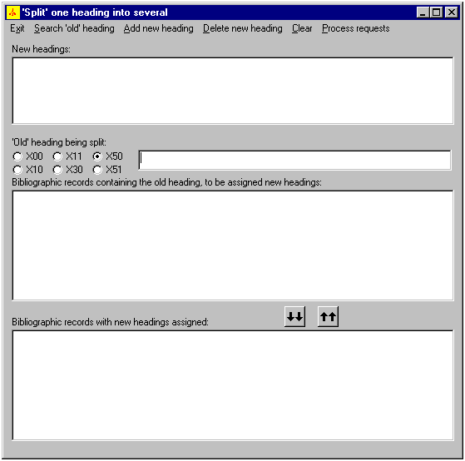

The general manner of proceeding is to fill in the form from top to bottom. When you’re all done, you’ll ask that the corrections you’ve defined be performed.

First, you need to build a list of the new headings that will replace the old heading. To do this, select the menu’s ‘Add new heading’ choice. The toolkit presents you with a second form.

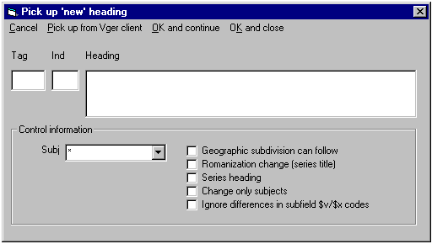

You can identify each new heading in one of two ways:
- Type the heading’s tag, indicators and full text into the appropriate boxes, select the subject heading system (if the heading can only be used as a topical heading) and check such boxes as may be appropriate. (You can also copy the heading text from a Vger record and paste it into the box with Ctrl-V, as long as the pasted text contains at least one subfield marker.) The tag and indicators should be as they are or would be given for an authority 1XX field. The field text must be exactly the heading you wish to use to replace the ‘old’ heading—it must contain all subfield codes, have proper capitalization and punctuation, etc. Do not, however, include terminal punctuation in this heading unless the punctuation is an integral part of the heading.
- Use the Vger cataloging client to find an authority record that bears the desired heading as its 1XX field, then select ‘Pick up from Vger client’ from the menu. The program reads the Vger authority record, and fills in the form. (This only works if the authority record is the active record in the Vger cataloging client—the one at the top of any stack of records.)

When the definition of one ‘new’ heading meets your approval, do one of these:
- If you want to identify additional ‘new’ headings, select ‘OK and continue’ from the menu. The program moves the heading from this panel to the central space on the main split headings panel (the space captioned ‘New headings’, and wipes out the data in this ‘Pick up a new heading’ panel. You can now use the ‘Pick up a new heading’ panel to define another ‘new’ heading.
- If this is the last ‘new’ heading you wish to define, select ‘OK and close’ from the menu. The program adds this heading to its list of new headings on the main ‘split headings’ panel, then hides this panel.
- Select ‘Cancel’ to hide this dialog panel.

Here’s the top part of the split-heading panel, with three new headings listed:

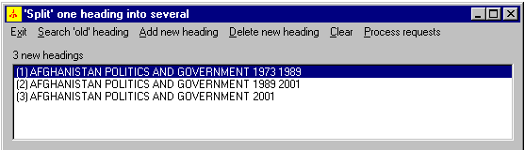

Next, you need to identify the ‘old’ heading—the heading to be changed. You can either:
- Type the heading into the ‘old heading’ box. Use the vertical bar to represent the delimiter character, and use the ‘backslash’ conventions for diacritics and special characters. Be sure to include the initial subfield |a marker.
- Copy the heading from a Vger record and paste it (with Ctrl-V) into the ‘old heading’ box. If you do this, remember to copy the initial subfield |a marker. When you copy text from Vger, the toolkit will know to translate special characters into their ‘backslash’ equivalents as long as the text contains at least one delimiter.

Make sure that you select the type of heading from the group of radio buttons to the left of the old heading box. If the wrong radio button is checked, the correction program won’t be able to find headings in the records it inspects.

After you’ve supplied the ‘old’ heading, select ‘Search old heading’ from the window’s menu. The toolkit searches Vger for bibliographic records that contain the heading, and lists them in the ‘bibliographic records’ window. Each line contains the date of publication (from the record’s 008 field), the title (or the first part of the title) and the Vger record number (at the end, in brackets). If at any time you wish to see the full display of one of these bibliographic records, just double-click on the title.

The following illustration shows the top part of the split-heading form. Threre are 3 possible new headings, and 9 bibliographic records that contain the old heading. They’re listed in ascending order by date and title.

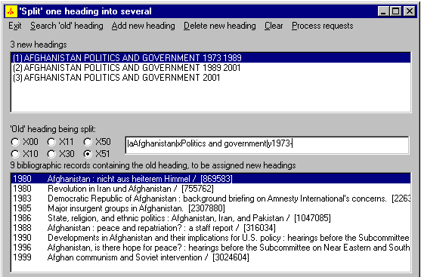

Now it’s really time to get to work. You need to define which heading or headings should end up in each bibliographic record.

- To change the heading in one or more bibliographic records to one and only one of the headings, highlight the line(s) for the bibliographic record(s) and the line for the one heading (making sure no other heading lines are also highlighted), and click the double ‘down’ arrows. The toolkit will add the heading’s number to the highlighted bibliographic lines and move them from the middle box to the bottom box.
- To change the heading in one or more bibliographic records to several of the new headings (creating new bibliographic headings in the process), highlight as many of the lines in the top box as are appropriate, highlight the line(s) for the bibliographic record(s) in the middle box, and click the double ‘down’ arrows. The toolkit will append the numbers for all of the headings to the bibliographic lines, and move them from the middle box to the bottom box.

As is the case with bibliographic records listed in the top box, you can double-click a line in the bottom box if you want to see the full bibliographic record for any reason.

The following illustration shows the same form again. Note these changes:
- Four records have been assigned to the first heading
- One record has been assigned to the first two headings
- One record has been assigned to all three headings
- Two records have been assigned to the second heading alone
- No records have been assigned to the third heading alone

Two lines in the top box and one line in the middle box are shown highlighted in this illustration; a click of the double ‘down’ arrow button would assign the bibliographic record to the second and third headings, and move the line for this bibliographic record from the middle box to the bottom box. This would become the only item in the bottom box assigned the second and third headings. (Note that this illustration has been constructed to display the capabilities of the correction request form; the actual corrections shown are almost certainly not the ones that would actually be made.)

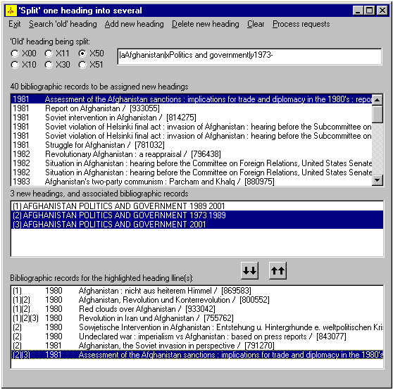

If you want to see the bibliographic record for any title listed in either the middle or the bottom box, double-click on its line. (Seeing the whole record may help you decide how to handle it.)

Continue in this manner until you have assigned as many of the bibliographic records to single headings or combinations as you wish. You may be left with some bibliographic lines in the middle box to which you have not assigned any headings. The correction process will not touch these unassigned bibliographic records in any way; if they contain the ‘old’ heading before the correction, they will continue to contain the old heading after it.

If you make a mistake, you can undo it.
- To remove a bibliographic line from the bottom box, highlight the line and click the double ‘up’ arrows; the line will reappear in the middle box. (You can then assign it to a different heading or heading combination, if you want.)
- To remove a new heading from the top box, highlight the heading and select ‘Delete new heading’ from the menu. The program removes the heading from the list, and sends back to the middle box any lines in the bottom box that were assigned to it.

At the end of all of this work, you should have in the bottom box one or more bibliographic lines, each assigned to one or more headings. In the middle box you may have one or more bibliographic lines to which you have not assigned any headings.

When everything in this form is as you wish it to be, select ‘Process requests’ from the program’s menu. This next step may take a few seconds, so please be patient. The program scans the bottom list for each set of bibliographic records assigned to the same heading or group of headings; the toolkit prepares a correction request for each separate group. This correction request is accompanied by a corresponding list of bibliographic record numbers. The program then removes the bibliographic lines from the bottom box.

The middle box now contains any unassigned bibliographic records, the top box still contains the same heading lines, and the bottom box is empty. You can assign additional bibliographic records to the headings in the manner described above and create additional correction requests, or you can select ‘Exit’ from the menu to discontinue work on this one problem. (Don’t worry if you find on further review that additional bibliographic records need to be assigned to a heading or group of headings for which you have already created a request; just create another request. The program that performs the work won’t be bothered in the least.)

As is the case with corrections requested with the BIG RED CROSS button, corrections initiated with the SPLIT HEADINGS button may be subject to approval at your institution, and may not be performed immediately after you request them.

You can also use the ‘split heading’ form even when there is only one new heading, if you wish to correct only some of the records that contain a given old heading. In this case, there will be only one ‘new’ heading in the middle box, and you will move to the bottom box only those records to be changed. You don’t have to have more than one heading in the middle box before you can use this form.

Reviewing the Vger changed heading queue

Whenever a modified authority record is written to the database (either as a result of an operator saving a record, or as the result of a batch load of records), if the 1XX field of the previous version is not the same as the 1XX field in the new version, Vger writes a notification of the ‘changed heading’ to one of its database tables. Later, you can use information in this table, together with three batch jobs run on the server, to identify changed headings that appear to call for changes to bibliographic records and—to the extent possible with the Vger heading change program—change those bibliographic records.

The BIG RED Q button allows you to view entries in the Vger heading change queue. This button allows you to see the headings that are in the queue, to find out which records have reference tracings that appear to match headings in bibliographic records, and to initiate batch corrections when appropriate, using features already available via the toolkit’s BIG RED CROSS button.

It is very important to note that the BIG RED Q button allows you to inspect entries in the Vger changed heading queue and to change related bibliographic records, but this button does not and can not change the Vger changed heading queue itself. After you use this button to clean up your records, the Vger queue is exactly the same as it was before, even though your bibliographic records may be markedly different.

There may be many thousands of entries in the Vger heading change queue. When you click the BIG RED Q button, the toolkit shows you a little panel that allows you to define the subset of the queue entries you’re interested in reviewing. The following illustration shows a typical example of this little panel.

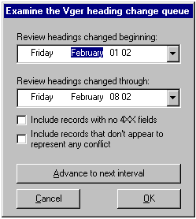

The most important part of this work is setting the date range in which you’re interested. Each entry in the Vger heading change queue indicates the date on which the heading was changed; you’ll use this information to look at only part of the queue at a time.

To change the beginning and ending dates, you can either click on the element you want to change (beginning month, ending year, etc.) and use the up and down arrow keys to select a different value; or you can click the ‘down arrow’ button next to the date, which gives you access to a calendar from which you can pick a date, as shown in the following illustration.

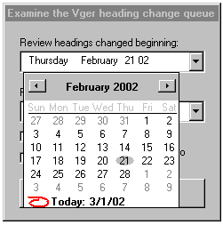

By selecting dates in this manner, you control the size of the report—and also the amount of time the toolkit takes to prepare the report. The toolkit remembers the dates you’ve inspected most recently, and shows them to you the next time you click the BIG RED Q button. When you subsequently click this button and then click the ‘Advance to next interval’ button, the toolkit will adjust the dates to show the next review period. For example, if the dates are set to the 8-day period Feb. 1 to Feb. 8 when you click the ‘Advance to next interval’ button, the toolkit will reset the dates to Feb. 9 and Feb. 16, the next 8-day interval.

When you click the ‘OK’ button this form, the toolkit finds each entry in the heading change queue in the range you specify, and calls up the corresponding authority record. The toolkit first does a crude search for each of the 4XX fields in each record. If an authority record appears to have any 4XX fields of interest, the toolkit does a more detailed inspection of bibliographic records in your database.

As it does its work the toolkit sorts entries in the queue into three categories:
- Authority records that contain 4XX fields that appear to match headings in bibliographic records. This category actually has two parts: one part contains cases of simple conflicts; the other part contains cases in which there is not only a conflict, but the text in the 4XX field is also the 1XX field in a different authority record.
- Authority records that contain 4XX fields, but none matches headings in bibliographic records
- Authority records with no 4XX fields

In its report on the headings queue, the toolkit always includes authority records in the first category. You can control the appearance in the report of records from the other two groups by checking (or not checking) the two boxes on the little panel that begins the queue review. (Most of the time, you won’t want to see these records, and you’ll leave the boxes unchecked.)

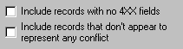

When you’ve got the definition of the heading change review set to your liking, click the panel’s ‘OK’ button. The toolkit first does a search of the queue to find out how many authority records are listed there. The toolkit shows you the total, and asks if you want to continue. If you approve the extent of the work, the toolkit immediately starts retrieving and inspecting authority records.

While the toolkit is retrieving and inspecting records, it shows you its progress in the title bar of the little panel you used to set the beginning and ending dates. The inspection may take quite a while, depending of course on how many entries are in the part of the queue you want to inspect. If at any time you want to interrupt the toolkit’s work, click the ‘Cancel’ button; the toolkit will show you the entries it has inspected so far.

When the toolkit is done inspecting records in the queue (or when you click the ‘Cancel’ button) the toolkit shows you a list of the headings. Each heading is preceded with a label that shows the category into which the authority record appears to fall (4XX matches bibliographic heading, no 4XX in record, etc.).

The following illustration shows a typical example of the first part of a report on the Vger changed headings queue. The first group of entries shows authority records that contain references matching bibliographic headings, followed by authority records that contain references matching bibliographic headings and also represented by 1XX fields in other authority records. (The text following the label “Conflict?” near the bottom of the display shows the heading that appears to be the problem.) The remainder of the entries shown here represent authority records that contain 4XX fields that don’t represent a conflict. A final group (not shown here) would list authority records with no 4XX fields at all. (As described above, the operator could have chosen to omit the ‘no conflict’ and ‘no 4XX fields’ groups from this report.)

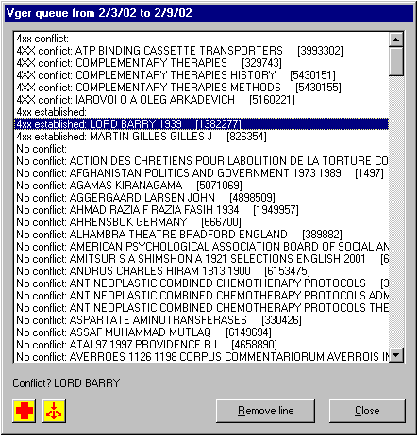

If the toolkit found a 4XX field in the authority record that appears to match something, it shows you that heading immediately under the list of authority records; as you highlight different headings, this text changes correspondingly. (The authority record may contain multiple 4XX fields that match bibliographic headings. For the purposes of this report, it is sufficient that the toolkit stop when it finds the first one.)

To view the authority record, simply double-click on a heading’s line. To close the heading report, click the ‘Close’ button.

After appropriate review (which may involve inspection of the authority record and one or more searches in Vger) you may decide that a batch correction is called for. If this is the case, click the BIG RED CROSS button. The toolkit passes the authority record number and some other information to the same routine that handles the BIG RED CROSS button on the toolkit’s main panel; you’ll get the same effect if you call up the authority record in Vger yourself and then click the other BIG RED CROSS button. (When you move a heading to the correction request from, the toolkit removes the line from the queue review list.) Here’s a typical example of a potential heading change request, initiated via the BIG RED Q button.

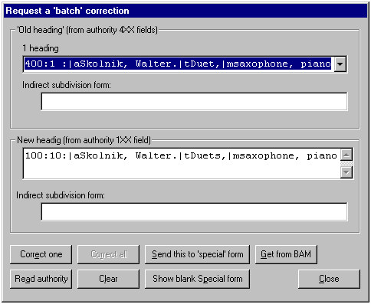

You can now use this correction request form exactly as you would for other requests. For example, if you click the ‘Correct on’ button, the toolkit will generate a heading change request that will be handled by a separate program. This request is identical in form with other heading change requests.

To treat a conflict as a ‘split heading,’ highlight the heading of interest in the list and click the SPLIT HEADING button. The toolkit passes the authority record number and some other information to the same routine that handles the SPLIT HEADING button on the toolkit’s main panel; you’ll get nearly the same effect if you call up the authority record in Vger yourself and then click the other SPLIT HEADING button. (When you move a heading to the ‘split heading’ from, the toolkit removes the line from the queue review list.) The toolkit supplies what it thinks of as the ‘old heading’ in the appropriate box on the split heading panel. Inspect this heading and add subfield codes as necessary before you select ‘Search old heading’ from the split heading panel’s menu.

Copying a record to the clipboard

This button allows you to put a version of the current Vger record into the Windows clipboard.

When you click this button, the toolkit retrieves from the Vger cataloging client the number and type of the current record, retrieves this record from Vger, formats the record in its standard manner, and copies this formatted record to the Windows clipboard. You can use the ‘Edit|Paste’ function of some applications (or Control-V) to use this formatted record in some manner.

The toolkit prefixes each element in the Leader and 008 field with an appropriate label; it presents each remaining variable field on a separate line. The program makes substitutions for diacritics and special characters (Appendix C).

Creating 501 fields (‘with’ notes)

This button allows you to build 501 fields (‘with’ notes) in bibliographic records. To use this button, you call up each bibliographic record to be linked with ‘with’ notes, and tell the toolkit to add information about this record to a list. When the list contains all of the items to be linked, you ask the toolkit to build the finished notes.

Normally, you’ll start with the first item in the series. Call up the bibliographic record for this item in the Vger cataloging client, and then click the 501 button. The toolkit digests information from this record and puts it into a small window.

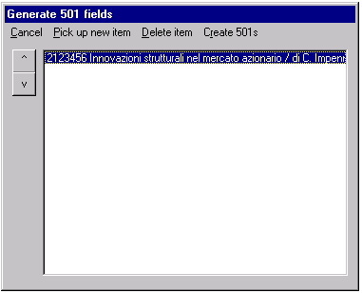

Call up the next item in the series, and either click the 501 button again, or click this little window’s ‘Pick up new item’ menu choice. Proceed in this manner with the other items (if any) in the series: call up each in the Vger cataloging client, and add it to this list.

If you accidentally add the wrong record to this list, highlight the line for that record, and click the ‘Delete item’ menu choice.

If you need to change the order of items, highlight an item in the list and use the ‘v’ or ‘^’ buttons to move the item down and up.

When the list is as you wish it, click the ‘Create 501s’ menu choice. The toolkit calls up the record for the first item in the list, adds to it a 501 field that describes all of the other items in the series, and saves that record to the Vger database. The toolkit retrieves the bibliographic record for each remaining item in the list, and adds to it a 501 field that describes the first item in the series. As it does this work, the toolkit opens the modified records in the Vger cataloging client.

Editing the fixed fields

This button allows you to edit the ‘fixed fields’ in a bibliographic, holdings or authority record. The fixed fields are the Leader, 006, 007 and 008 fields. In addition to modifying existing fields, you can use this button to add and remove 006 and 007 fields. The advantage of this button over similar features offered by the Vger cataloging client, is that you can directly change codes of interest, without necessarily consulting a menu of options. In most cases, this button will save you time and trouble.

Configuration points to keep in mind

This button depends on the following information on the Options panel:

- Everything on the ‘Fixed field editor’ tab. (This panel only allows you to change the fixed field editor’s colors; you can safely leave these at their default values, unless you find them objectionable, or illegible.)
- The owning library on the ‘General’ tab
- The ‘Write UID’ and ‘Write PWD’ for the first connection on the ‘Connections’ tab

In addition, this program assumes that the following three files are present in the folder named in the ‘Files of validation rules’ box on the ‘File locations’ tab.

FfdStanzas.cfg. If this file isn’t present, this probably means that the file VITagTableC.cfg isn’t there, either. These are not files you can modify directly; the toolkit creates both of these files (if they’re not present) when you click the BAM button. To create these two files, make sure that VITagTableC.cfg is not there, then simply click the BAM button. (The toolkit will appear to be stuck for a moment as it reads through your entire set of Vger tag table files and prepares its digested form.) If you change your Vger tag tables, delete VITagTableC.cfg, start up the toolkit and click the BAM button; the toolkit will re-create these files.
FfdLabels.cfg. This file defines the fixed-field elements the toolkit will present for editing, and the labels it will use when presenting them. The toolkit recognizes nine different layouts for the 008 field in a record; these constitute the nine MARC ‘formats’ the toolkit recognizes. Each format is identified by a single upper-case letter:
A: authority
B: ‘books’: printed monographs
D: electronic resources, computer files
F: visual materials; videos and films
H: holdings
M: music; scores and sound recordings
P: cartographic materials
S: serials
U: archival materials
There are stanzas in this file for the elements in the leader of each format, and for the 008 field in each format. The names of these stanzas are ‘Leader’ or ‘008’ plus the format code plus the word ‘Labels’; so the stanza describing elements in the leader for authority records is called LeaderALabels, and the stanza describing elements in the 008 field for holdings records is called 008Hlabels.
Within each stanza, each element to be presented by the fixed field editor is given as a separate line. The label to be used when presenting the element is first on the line, followed by an equals sign. To the right of the equals sign are two numbers; the first gives (in the zero-based form used in MARC documentation) the starting position of the element, the second the length of the element. If an element should be displayed but should not be subject to operator modification, follow the label with an asterisk. To keep the display as compact as possible, the default element labels are very brief, but they can be longer if you wish; they can be several words if you want. The labels are also in upper-case to make them easy to distinguish from the code that follows, but this is also just the convention used in the supplied default file.
Here is a typical stanza:
[LeaderALabels]
STAT*=5 1
RT=6 1
CDG=9 1
E/LVL=17 1
In the authority format, the 5th byte of the leader (the 6th position) is displayed with the label STAT, the 6th byte (the 7th character) with the label RT, the 9th byte (the 10th character) with the label CDG and the 17th byte (the 18th character) with the label E/LVL. All of these elements are 1 character long.
There are two additional stanzas, called 006Names and 007Names, that give information about the 006 and 007 fields. To the left of the equals sign in each line of the 006Names stanza is the single-character code used in byte 0 (the first character) of an 006 field. To the right of the equals sign are the single-character code of the corresponding bibliographic format, the name of the 006 field, and the default value used for a new field of that type. (The last two elements are separated from each other by a double slash.) In the default value, use the underscore for blank spaces, and the vertical bar for the fill character. The 007Names stanza has the same format as the 006Names stanza, except that it does not contain the single-character code for the corresponding bibliographic format.
The fixed-field editor uses the labels defined for the 008 field to display elements in an 006 field. Each different 007 field has a stanza that describes its elements. The names of these stanzas are ‘007’ plus the code that appears in byte 0 (the first character) of the field; the contents of the stanzas are identical in form with those of the stanzas for the leader and 008 field.

FfdStanzasOverride.cfg. When using the fixed-field editor, you can press the F1 or F2 key to see a list of values allowed for any fixed-field element. The toolkit draws this list directly from your Vger tag table files; but in some cases, those files don’t show the actual codes. For example, the Vger tag tables do not list every valid year that may appear in Date 1 or Date 2, but simply contain the code <<<TEXT>>>. The FfdStanzasOverride.cfg allows you to provide a piece of text describing the contents of a fixed field element to be displayed instead of values from the Vger tag tables.
There may be stanzas in this file for each of the 007 formats and each of the 008 formats; the name of each stanza is the code appearing in byte 0 for 007 fields or the single-letter code given above for the 008 format, followed by the tag itself. Each line in the stanza constists of a numeral to the left of the equals sign, and a message to the right. The numeral is the starting position (using the zero-based convention found in the MARC documentation) of one fixed field element whose values are not given properly in the Vger tag tables.

What happens

When you click this button, the toolkit obtains from the Vger cataloging client the number and type of the current record. The toolkit retrieves a fresh copy of this record from Vger, and hands it over to the component that makes possible the editing of fixed fields. This component displays the fixed fields from this record in a small panel. The following illustration shows a typical example.

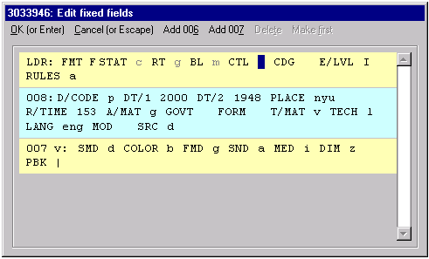

Each field in the record (Leader, 008, etc.) is shown in a different group; alternating field groups have different background colors to make them easier to tell apart. Each defined element in each field is displayed with a brief alphabetic prefix. (You can change these prefixes by changing a configuration file, if you can’t easily tell what is intended.) The color of each element reflects its status. (The default colors are: gray if you can’t actually modify the element, black if the element’s code is valid, red if the element’s code is not valid, and green if the element’s code is obsolete.)

To change a fixed-field code, click the cursor on either the code or its label, and type the code you want. Changing one code automatically advances the cursor to the next box. You can use the up/down arrow keys to move from one field to another, and the tab/reverse tab keys to move from one element to another. If you aren’t sure what codes are available in an element, you can put the cursor on a code and then press the F2 key. (The F1 key does the same thing.) You’ll see a tiny panel naming the code and providing a drop-down list of valid codes. (This tiny panel will appear over the currently-highlighted code.)

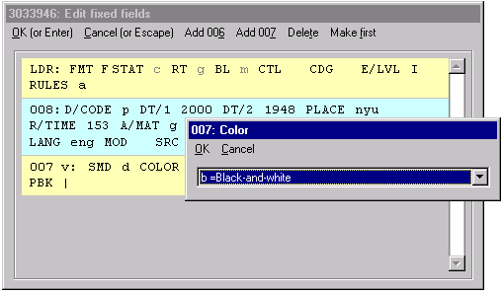

To add a whole new 006 or 007 field, select the type of field in which you’re interested from the panel’s menu, and modify the codes as appropriate. (The default values for each type of 006 and 007 field are in one of the configuration files, which you can of course change as you wish.) You can’t add an 006 field to a record if it’s of the same ‘type’ as the basic record itself. (For example, you can’t add a ‘book’ 006 to a ‘book’ record.)

To delete an 006 or 007 field, place the cursor anywhere in the field, then click the ‘Delete’ menu choice. (You can’t delete the leader or the 008 field.)

If you wish to make any one of the 006 or 007 fields the first field of that type, place the cursor anywhere in the field, and then click the ‘Make first’ menu choice.

When you’re all done working with the fixed fields, click the ‘OK’ menu choice (or, if you’ve enabled this on the Options panel, press the Enter key) to save your work. Click the ‘Cancel’ menu choice (or, if you’ve enabled this on the Options panel, press the Escape key) to abandon your work on the fixed fields.

Reviewing and printing item records

Use this button to view all parts of an item record. You can use this button to view a single item record, all item records linked to a single holdings record, or all of the item records linked to all of the holdings record linked to a single bibliographic record. You can print the display.

There several basic problems with the display of item records provided by the Vger cataloging client:
- It is not possible to view all parts of an item record at once (some parts are concealed behind icons, which must be selected individually)
- It is not possible to create a print of the item record (except via third-party screen-capture software)
- Circulation history is not available (you have to use the circulation client to find the number of times an item has circulated)
This button attempts to remedy all these problems.

Configuration points to keep in mind

If you request a printout of an item record display, the toolkit sends it to the printer named on the ‘Printer’ tab of the Options panel. Otherwise, the settings on the Options panel have no effect.

What happens

The display you see depends on the active record displayed by the Vger cataloging client.
- If the active record is an item record, the toolkit shows you information about this one item record
- If the active record is a holdings record, the toolkit shows you information about all of the item records attached to this holdings record
- If the active record is a bibliographic record, the toolkit shows you information about all of the item records attached to each of the holdings records attached to this bibliographic record.

The following illustration shows a typical display generated by this button. The operator requested this display when the active record displayed by the Vger cataloging client was a holdings record, to which 13 item records (only the first visible here) are attached.

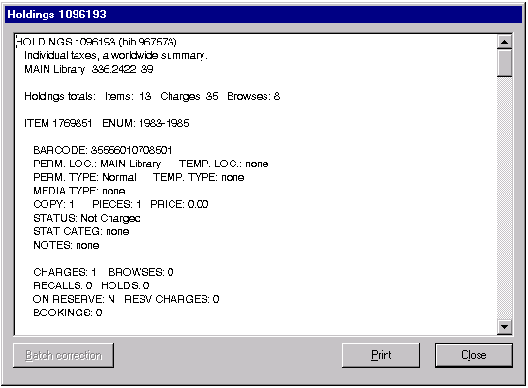

The display begins with information from the holdings record, followed by a summary of circulation information from all of the item records attached to the holdings record. This is followed by details for each of the item records.

To receive a printout of the entire item summary, click the ‘Print’ button.

Searching Vger

Use this button to search Vger in ways not necessarily allowed by Vger.

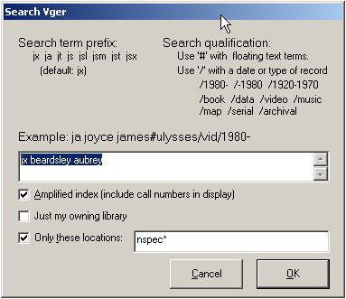

Exiting the program

Click this button when you’re done working with the cataloger’s toolkit. The toolkit saves its settings to its initialization file, and then disappears.

You can also use the little ‘X’ button in the toolkit’s upper righthand corner to cancel the toolkit.

Appendix A: What gets verified, and how

Text

Appendix B: Inspection of headings

Appendix B: headings inspected and heading breakup (in just the most general way)

Appendix C: Handling of diacritics, etc.

The toolkit is not able to display text containing many MARC21 characters in its native form, and it provides no direct method for operators to edit or modify these exceptional characters. The toolkit instead employs a set of substitutes for MARC21 diacritics and special characters. (For example, you must use these substitute characters when using the BIG RED CROSS and SPLIT HEADINGS buttons to work with the definitions of ‘batch’ corrections. Operators must be able to recognize, and employ, this same set of substitutes as they review and modify correction requests.

Equivalent | Vger MARC (hex) | Name
| | 1F | subfield delimiter
\/ | 5C | backslash
\1 | A0 | script-l
\L | A1 | slash-L
\O | A2 | slash-O
\D | A3 | slash-D
\P | A4 | uppercase Thorn
\A | A5 | ligature AE
\E | A6 | ligature OE
\t | A7 | myagkii znak
\x | A8 | centered dot
\b | A9 | flat sign
\r | AA | registered trademark symbol
\Q | AC | hook-O
\U | AD | hook\U
\, | AE | alif
\X | AF | alpha
\h | B0 | ayn
\l | B1 | slash-l
\o | B2 | slash-o
\d | B3 | slash-d
\p | B4 | lowercase thorn
\a | B5 | ligature ae
\e | B6 | ligature oe
\y | B7 | tvyerdi znak
\i | B8 | undotted Turkish ‘i’
\# | B9 | British pound
\s | BA | eth
\o | BC | hook-o
\u | BD | hook-u
\Y | BE | beta
\Z | BF | gamma
\\p0 to \\p9 | C0 to C9 | superscript 0 to superscript 9
\\p+ | CA | superscript +
\\p- | CB | superscript -
\\p( | CC | superscript (
\\p) | CD | superscript )
\\b0 to \\b9 | D0 to D9 | subscript 0 to subscript 9
\\b+ | DA | subscript +
\\b- | DB | subscript -
\\b( | DC | subscript (
\\b) | DD | subscript )
\? | E0 | pseudo question mark
` or \! | E1 | grave accent
\’ | E2 | acute accent
^ or \¢ | E3 | non-spacing circumflex
~ or \( | E4 | non-spacing tilde
\- | E5 | macron
\) | E6 | breve
\f | E7 | superior dot
\: | E8 | umlaut
\v | E9 | hacek
\% | EA | angstrom
\$ | EB | ligature, left half
\& | EC | ligature, right half
\z | ED | high comma, off center
\’ | EE | double acute accent
\* | EF | candrabindu
\j | F0 | cedilla
\c | F1 | right hook
\. | F2 | dot below
\_ | F3 | double dot below
\@ | F4 | circle below
\= | F5 | double underscore
_ | F6 | non-spacing underscore
\; | F7 | left hook
\k | F8 | right cedilla
\w | F9 | upadhmaniya
\n | FA | double tilde, first half
\m | FB | double tilde, second half
\g | FE | high comma, centered

Since the toolkit works with the record as found in Vger, it won’t know about any changes you’ve made to the record but haven’t yet saved.
The toolkit works with the bibliographic, authority or holdings record as found in the Vger databse, not as shown in the cataloging client. The toolkit doesn’t know about any changes you may have made to the record but haven’t yet saved. You should always save a modified record before you click the BAM button.
With a few exceptions, you cannot change the manner in which the toolkit performs MARC validation by changing any of the toolkit’s options; instead, you must use a text editor to modify one or more configuration files. This extremely complicated process is described in the document validit.doc, available from Northwestern University Library.
Delete the file VITagTableC.txt; this causes the toolkit to recreate the file from your modified Vger tag tables. This is also described in the document validit.doc (see preceding note).
Most of the options available for validation are controlled through a configuration file, described in the document verifit.doc, available from Northwestern University Library.
It is possible that the toolkit will one day acquire additional matching logic that will allow it efficiently to search for near matches when it cannot find an exact match.
The headings shown here are normalized according to a set of system-independent ‘generic’ rules, and do not necessarily show the term exactly as used to search Vger.
If the heading being verified is a geographic name pulled from another heading, the tag will be the first digit of the original field’s tag, plus ‘51’; this pseudo-tag will not always correspond to a ‘real’ MARC tag. (A geographic heading created from an indirect subdivision in a topical heading will be tagged ‘651’, but a geographic heading created from the place name in a conference name added entry will be tagged ‘751’.)
Used when a combination of the 1XX+245 field matches an authority 4XX field, and the 1XX+240 from the same bibliographic record matches that authority record’s 1XX field. The ‘heading’ being searched matches a 4XX field, but the match is in fact to be expected.
If the operator has checked the ‘Bypass MARC validation’ box on the Validation tab of the Vger cataloging client’s Options|Preferences panel, the client will allow the operator to save records that contain coding errors. The operator should never check this box.
After you’ve used the panel once, it will show you the choices for heading type and call number type you selected most recently.
After you’ve used the panel once, it will show you the choices for heading type and call number type you selected most recently.
The toolkit uses the most-recently-assigned-number in the matching definition as a starting point, and does a series of call number searches, with increasing sequential numbers, until it finds a stretch of 10 numbers that have not yet been used. The toolkit uses the lowest number in this stretch of 10 numbers in the holdings record.
The SACO participant’s manual requires the inclusion of the bibliographic 1XX in all cases. For headings that may only be used as subjects, the toolkit includes the bibliographic 1XX in subfield $a of the 670 field regardless of the setting of this option.
The toolkit will not be able to modify the authority record unless you supply a Write UID and Write PWD in the definition of the first connection on the Connections tab, select a cataloging location on the General tab, and supply a path to voyager.ini on the File locations tab.
The toolkit will not be able to modify a record at any time unless you supply a Write UID and Write PWD in the definition of the first connection on the Connections tab, select a cataloging location on the General tab, and supply a path to voyager.ini on the File locations tab.
The business of severity levels, and an explanation of why there are two different codes, is described in much detail in the documentation for the toolkit component that performs MARC validation: validit.doc, available from Northwestern University Library.
The toolkit will not be able to save the modified record unless you also supply a Write UID and Write PWD in the definition of the first connection on the Connections tab, select a cataloging location on the General tab, and supply a path to voyager.ini on the File locations tab.
If it is later necessary to change this toolkit’s configuration for some reason, you will have to modify the toolkit’s initialization file, ctkv.ini. In this file, delete the “ButtonCorners” line in the General stanza. When you start up the toolkit, all of the buttons will again be visible.
The toolkit will not be able to save the modified holdings record unless you also supply a Write UID and Write PWD in the definition of the first connection on the Connections tab, select a cataloging location on the General tab, and supply a path to voyager.ini on the File locations tab.
In other words, the first connection defined here must correspond to the database to which your Vger cataloging client is connected. At several points in its work, the toolkit will look at the Vger cataloging client to get a record number, and then (via the first connection defined on this tab) retrieve that record in order to perform some operation. If the data sources used by the cataloging client and the toolkit are not identical, the results will be unpredictable, and possibly unfortunate.
You define this connection using tools provided by Microsoft and Oracle. See the note at the end of the description of this tab regarding this name. The value of this field is almost certainly not ‘LIBR’.
This should be set to the correct value for the sake of form, but CTKV now asks the Voyager installation itself for the version number. In some future version of CTKV, this space will be removed.
The MS ODBC applet is found in the Control Panel. Different versions of Windows call it by different names, and use different icons; sometimes it’s called ‘Data sources’. In Windows 2000, this applet is located in the ‘Administrative tools’ folder of the Control Panel.
A few ‘simple’ requests actually operate on more than one field. For example, a change to a bibliographic 440 field may result in the retagging of that field to 490, and the addition of an 8XX field. Also note that the replacement text can consist of nothing. For example, it is possible to use this suite of programs to remove the subdivision ‘Addresses, essays, lectures’ from LCSH headings.
As the name the button’s name, and its icon, imply, the button was originally designed to deal with single headings that have become two or more. However, its capabilities have grown beyond their original scope.
Notice in these examples that the bibliographic heading being changed does not necessarily match the ‘old’ heading exactly, but may instead contain additional subfields. These examples are constructed in this way for one special reason: to show the difference between this set of programs and the heading change programs supplied as part of the Vger system. Northwestern University Library’s batch correction suite is able to change headings both when a reference tracing matches the entire bibliographic heading and when a reference tracing matches only part of a larger heading. While the programs have been written with every possible attention to detail, you may occasionally have questions about what will happen to a request. In case of doubt, the best thing to do is to define a correction and perform it as a test. A review of the report of fields changed by the programs should indicate whether or not the programs can successfully perform a given request.
These programs do not require that an authority record representing a change be present. (This is another important difference between Northwestern’s programs and the Vger programs.) The examples given here are stated in terms of authority records only for simplicity. The document Making changes to headings referred to elsewhere in this section contains additional examples, including one that hints at the elaborate scheme available for changing series headings. Because the Northwestern University Library programs do not require the presence of an authority record, you can also use this set of programs to make changes to headings that are not and would not in the normal course of things be represented by reference tracings in authority records.
Again, an authority record is not required; reference is made to the existence of an authority record for simplicity’s sake.
Entries arrive at the heading change queue whenever the 1XX field in an authority record is modified. They stay in this queue until the queue is flushed, or until the Vger heading change jobs are run.
The active record is the record at the top of the pile of records displayed in the Vger cataloging client’s window.
This is a crude, left-anchored search that doesn’t take the time to determine whether tags and/or subject heading systems correspond properly. If the toolkit finds the text of a 4XX field in the Vger headings table, it assumes that there’s a match. But don’t worry: the program that actually makes corrections to records does check things like tags, and the second indicators of subject fields, and the full text of subfields, so that only the proper things actually get changed.
If the toolkit can’t find any 4XX fields in the record that might match headings in your database, it tells you so, and leaves this dialog box empty.
The program’s routine for doing this work is at best rudimentary. Carefully check any information in both of the ‘indirect subdivision’ boxes.
The program takes the indirect subdivision form for the ‘new’ heading from the authority record’s 781 field, if there is one.
The toolkit doesn’t do any of the work mentioned here if the active record is something other than an authority record.
The circumstances under which information on the ‘Files, etc.’ tab might be of use are described only in Making changes to headings. One of the more common of these rare circumstances involves the conversion of 490 fields into traced series fields.
Follow this convention even if an authority record does not lie behind the correction request. Think of the correction request as a virtual authority record.
That is, assuming this is a ‘normal’ correction in which the program substitutes one piece of text for another. See below for other types of changes the program can make.
The program that performs the correction knows how to add punctuation to the end of the new heading, depending on the finished field’s tag, and any following subfield, but it does not remove terminal punctuation from the heading you supply. The program will assume that any punctuation you include here is an integral part of the heading; if you include here any unnecessary terminal punctuation, the program may produce instances of dreaded ‘double punctuation.’ Examples of integral punctuation are: full stops at the end of abbreviations and hyphens at the end of open dates in personal name headings.
For example, consider the change of heading from ‘Java Sea’ to ‘Java Sea (Indonesia)’, with the implied change in indirect subdivision form from ‘|zJava Sea’ to ‘|zIndonesia|zJava Sea’. If this box were not checked for this request, the heading change program might try to change an existing heading such as ‘Fishing $z Indonesia $z Java Sea’ to ‘Fishing $z Indonesia $z Indonesia $z Java Sea’. (The correction program actually contains some primitive logic to help prevent accidents of this type: it will not change a geographic subdivision if the resulting heading contains three occurrences of subfield $z in a row.)
This option was added to handle headings for places in Micronesia, although it will no doubt find application elsewhere. Some databases contain indirect subdivision for places within Micronesia in the following form: “ … $z Micronesia $z Kosrae.” Headings in this form need to be changed to show the correct form (“… $z Micronesia (Federated States) $z Kosrae”) and that, in and of itself, wouldn’t be difficult. The hard part comes when one notes that “Micronesia” is itself a valid geographic heading (for the region) which means that “$z Micronesia” is in its own right a valid geographic subdivision. This means that a simple batch correction replacing “$z Micronesia” with “$z Micronesia (Federated States)” wouldn’t be proper, because it would also change headings for the region. Checking the ‘Change if NOT whole geog. subdiv.’ line allows indirect subdivisions for places within Micronesia (the federated states) to be changed without affecting indirect subdivisions for Micronesia (the region).
That is, if the authority record for the subdivision contains ‘d’ or ‘i’ in byte 06 of the 008 field, or if, for LCSH subdivisions, the designation ‘(May Subd Geog)’ appears after the subdivision in Subject cataloging manual: subject headings.
The program will not change the position of a geographic subdivision that appears to the right of the changed subdivision.
If a subdivision changes from one that does not allow geographic subdivision to one that does allow geographic subdivision, you can define a request that will cause the correction program to move the geographic subdivision to the proper place; and you can do this even if the text of the subdivision does not change. For example: 480 |x Race identity 180 |x Race identity
For example, given this correction definition: 430 0 $a Wen hsing tsung kan 130 0 $a Wen xing cong kan The program will change this field: 440 0 $a Wen hsing tsung kan, $v 79 To this: 440 0 $a Wen xing cong kan, $v 79
You can employ this technique in other situations, if you wish a correction to produce the same result (swap one 440 field for another, instead of creating a 490/830 pair of fields). For example, you could use this definition to remove the final comma from a 440 series heading: 430 0 $a International series on X, Y, and Z 130 0 $a International series on X, Y and Z
For subject headings as for everything else, the tags and indicators of the reference tracing and the candidate bibliographic field must correspond.
For example, in some cases you might want to change the heading “Afghanistan $x History $y 1973- $x Bibliography.” to the new heading “Afghanistan $x History $y 1973-1989 $x Bibliography.” and at the same time create a new heading “Afghanistan $x History $y 1989-2001 $x Bibliography.”
The toolkit first performs a crude, left-anchored search for the old heading. It takes each bibliographic record retrieved by this search and passes it to the tool that performs corrections. (This is just a quick method of determining whether or not the ‘old heading’ is present in the record—i.e., whether or not the record is actually a candidate. The toolkit does not at this point actually save the results of this work; it’s only interested in finding out if a correction is possible or not.) The bibliographic records listed are the only ones in your database that are subject to the currently defined correction. Because the toolkit is doing quite a bit of work for you when you select ‘Search old heading’, it may take some amount of time before you see any results.
Holding down the shift key as you click on headings allows you to select a contiguous group; holding down the control key as you click allows you to select multiple individual lines.
If the deleted heading is part of a group of headings assigned to a bibliographic record, the program removes the notation for the deleted heading from each bibliographic record’s line, but does not remove the line from the bottom box unless the record is now not assigned any headings.
In a given queue review, you might start with 405 entries pulled from the Voyager changed heading queue. If you should happen to re-visit the same part of the queue later, the toolkit will continue to report that there are 405 entries in the queue. (If in your first review you actually changed some bibliographic records, then the report you see the second time should be different from the report you see the first time.)
The toolkit also does a search for any ‘old heading’ it can extract from the 667 and 688 fields; but because these fields contain free text, its extraction will often be less than perfect. Whenever this section refers to ‘4XX’ fields, you should keep in mind that the category of fields inspected is slightly broader. The toolkit assumes that the old heading extracted from one of these fields is the same as the tag of the 1XX field.
This crude test is based on a comparison of text in 4XX fields in the record to text in entries in a Vger table, without consideration of such details as tag and subfield coding.
This more detailed test is identical to the test made by the program that perform corrections; it identifies only bibliographic records that would actually be changed if the correction is approved.
Actually, the toolkit fills out more of the split heading form when you start from the button on the queue review panel.
As is the case with some of its other operations (such as heading verification and MARC validation) the toolkit’s editing of fixed fields is handled by a generic component that itself does not know anything about Vger—it knows only about MARC records.
This character is a ‘one’.
This character is an ‘el’.
This is ASCII character 136.

