Summary of RDA-related toolkit options for NUL catalogers
Gary L. Strawn
March 5, 2013

Options for the BAM button, "General, pt. 3" tab: Check all 3 boxes in the "RDA 33X fields" frame at lower left.

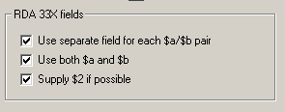

Options for the BAM button, "Authority-related" tab, "Get started" sub-tab. Check these three boxes:

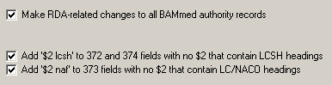

Options for the BAM button, "Authority-related" tab, "RDA" sub-tab: Check everything at the top except the 336 box, the 377 box for series, and the "Convert 530" box. At the bottom, check both boxes to coerce AACR2 records into RDA records.

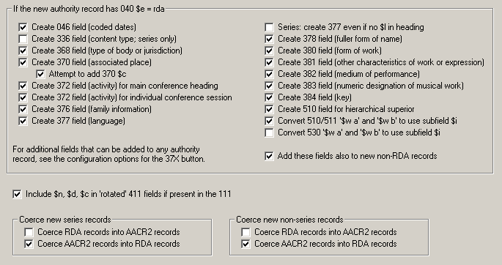
Options for the BAM button, "Make changes, pt. 2" tab.

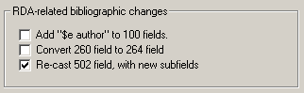

- If you wish, check the box to add subfield $e with "author" to all bibliographic 100 fields. (Default: not checked)
- If you wish, check the box to convert 260 fields to 264 fields. (Default: not checked.)
- Always check the box to add subfield codes to 502 fields. (Default: checked.)

Options for the BAM button, "Make changes, pt. 2" tab: In the "Linking fields" frame, check the "Add local Voyager number in $w if possible" box.

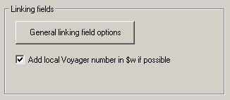

Click the button to see linking field options. In the options panel that you see when you click this button, make sure that the box for subfield $7 is not checked for both serials and non-serials.

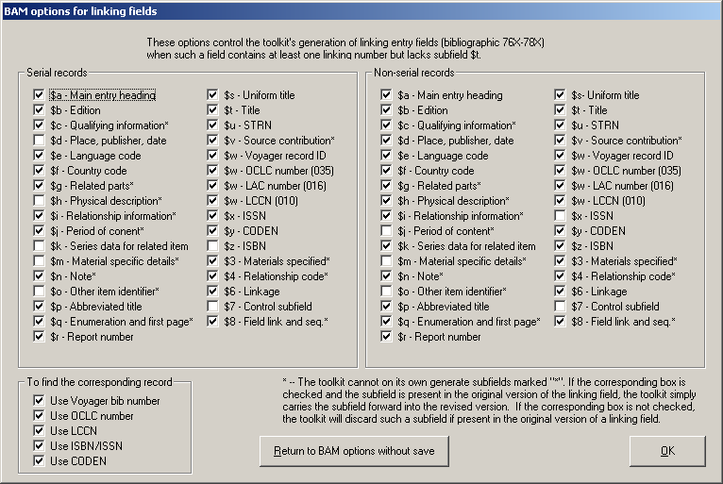

Options for the BAM button, "Make changes, pt. 3" tab: Check all of the boxes in the "Expand pre-RDA abbreviations, etc. in bib records" frame. These boxes are by default not checked. People in ARC should not check the "Supply 336-338 fields" box at this time.

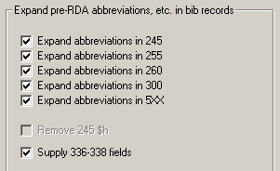

Options for the RDA button: In the "Generate these fields" frame, check all of the boxes except the 336 field; do not check the box to add subfield $5 to these fields.

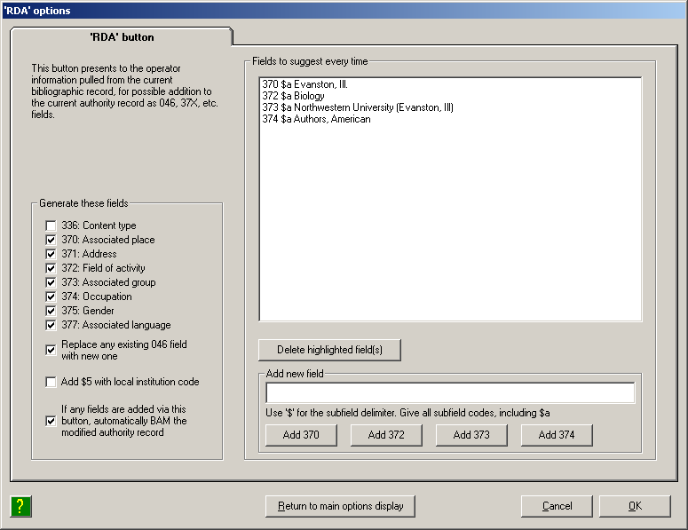

You can use the "Fields to suggest every time" part of this panel to define fields that will appear in the list of suggested additions every time you use the RDA button.

Options for the "linking fields" button: For each field, check all of the available boxes except for subfield $7:

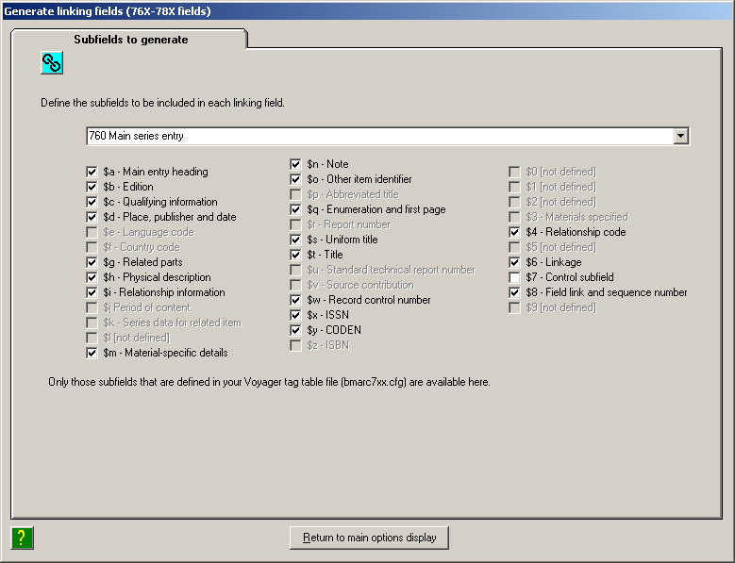

Options for the 4XX, 643 and 670 buttons

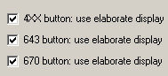

These boxes are by default not checked. If you leave them unchecked, these buttons behave as they have always behaved. If you check these boxes, the toolkit uses the new elaborate editing form (with many tabs) instead.

